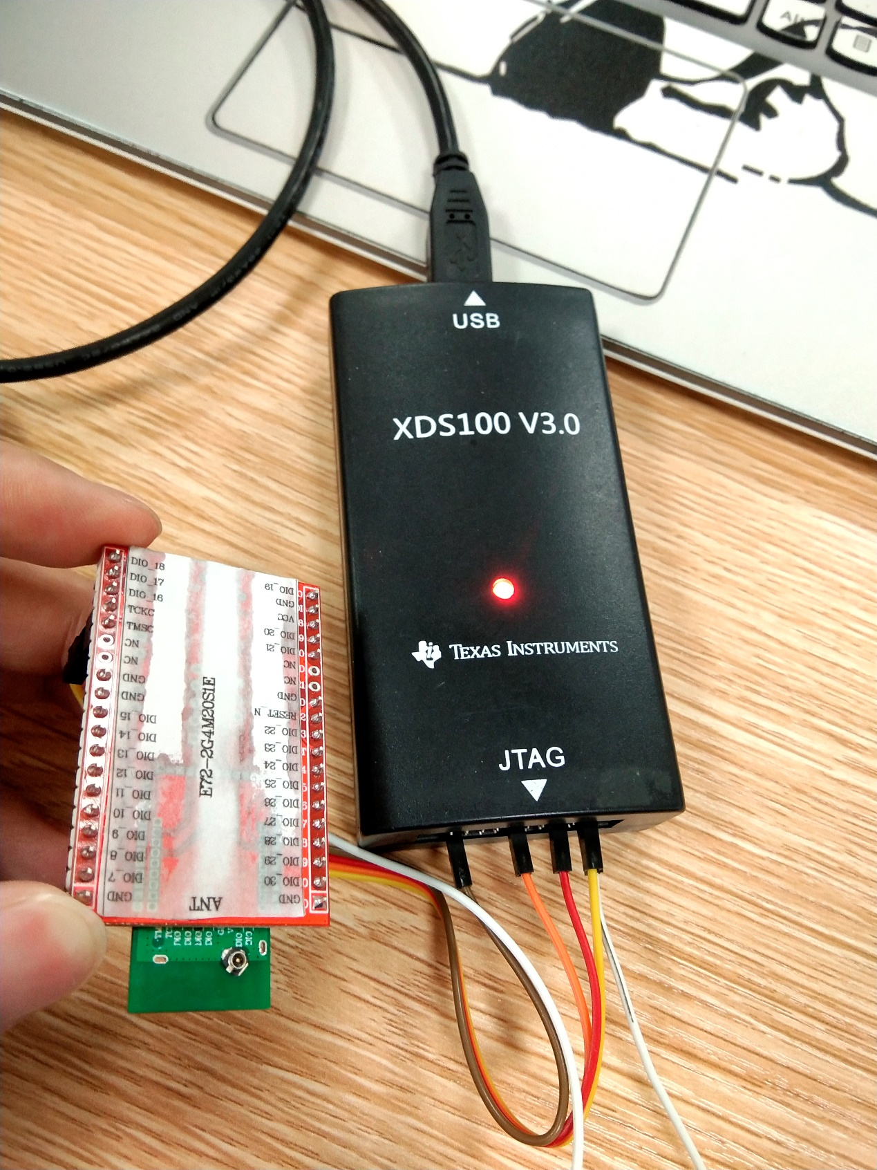

figure 1 my hardware

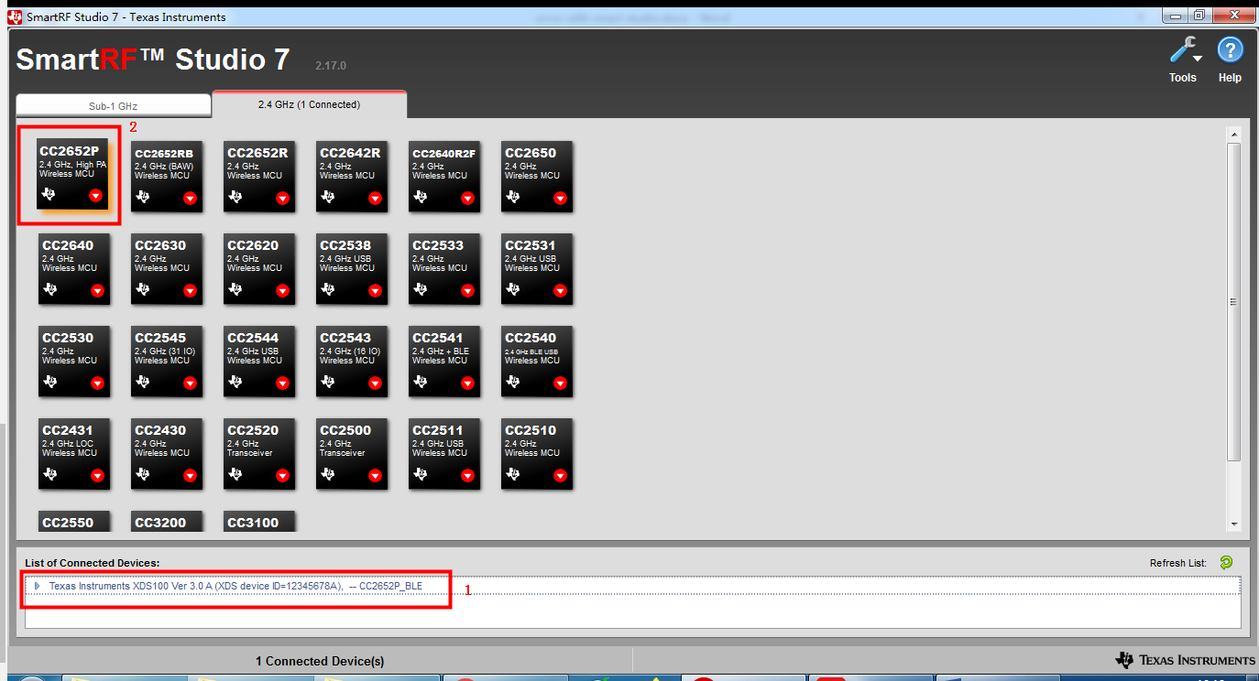

figure 2 the smarts tudio interface

in the figure 2 the number 1 indicates that the device has been identified by the smarts tudio.

Then I click on the CC2652P device(number 2) as figure 3 a,b,c steps.

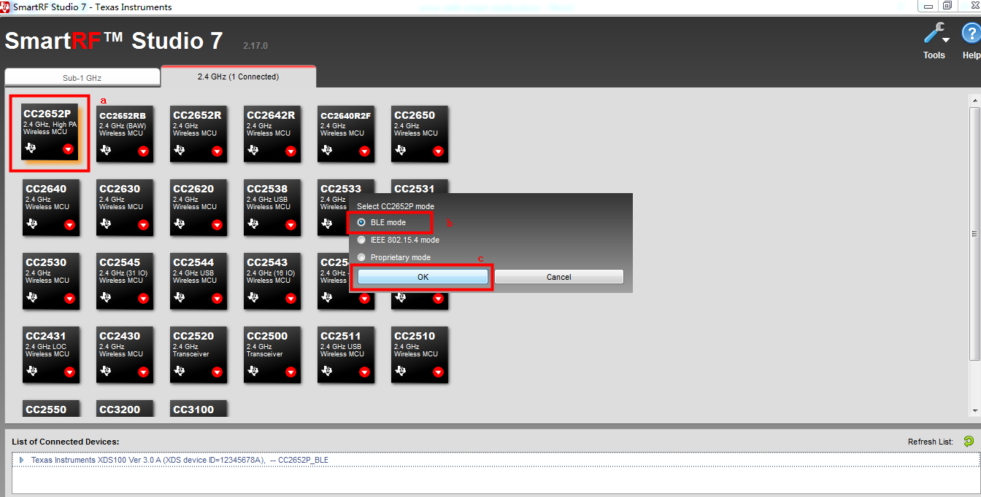

figure 3 open my cc2652P device

And then this error occurs as follow figure 4.

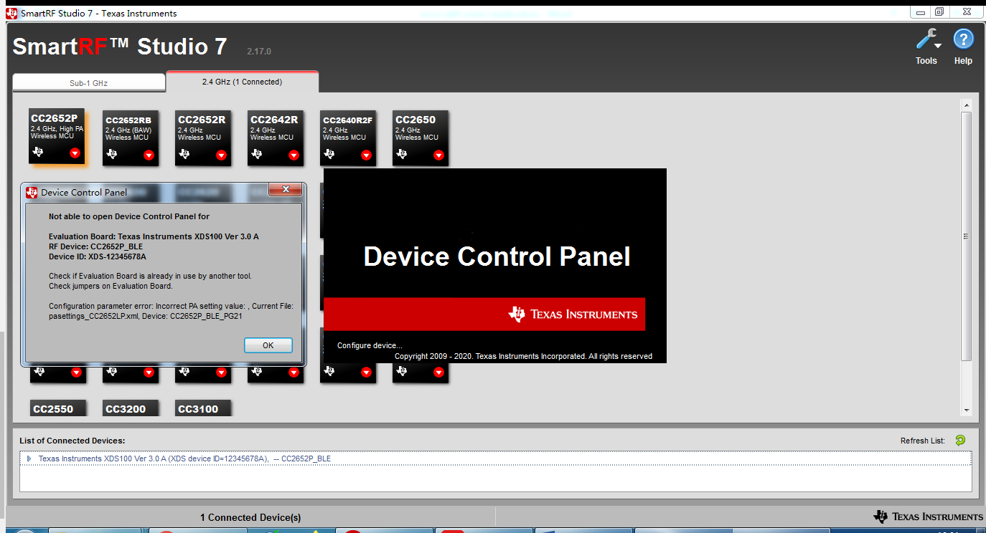

figure 4 error

This error occurs no matter which device I use.

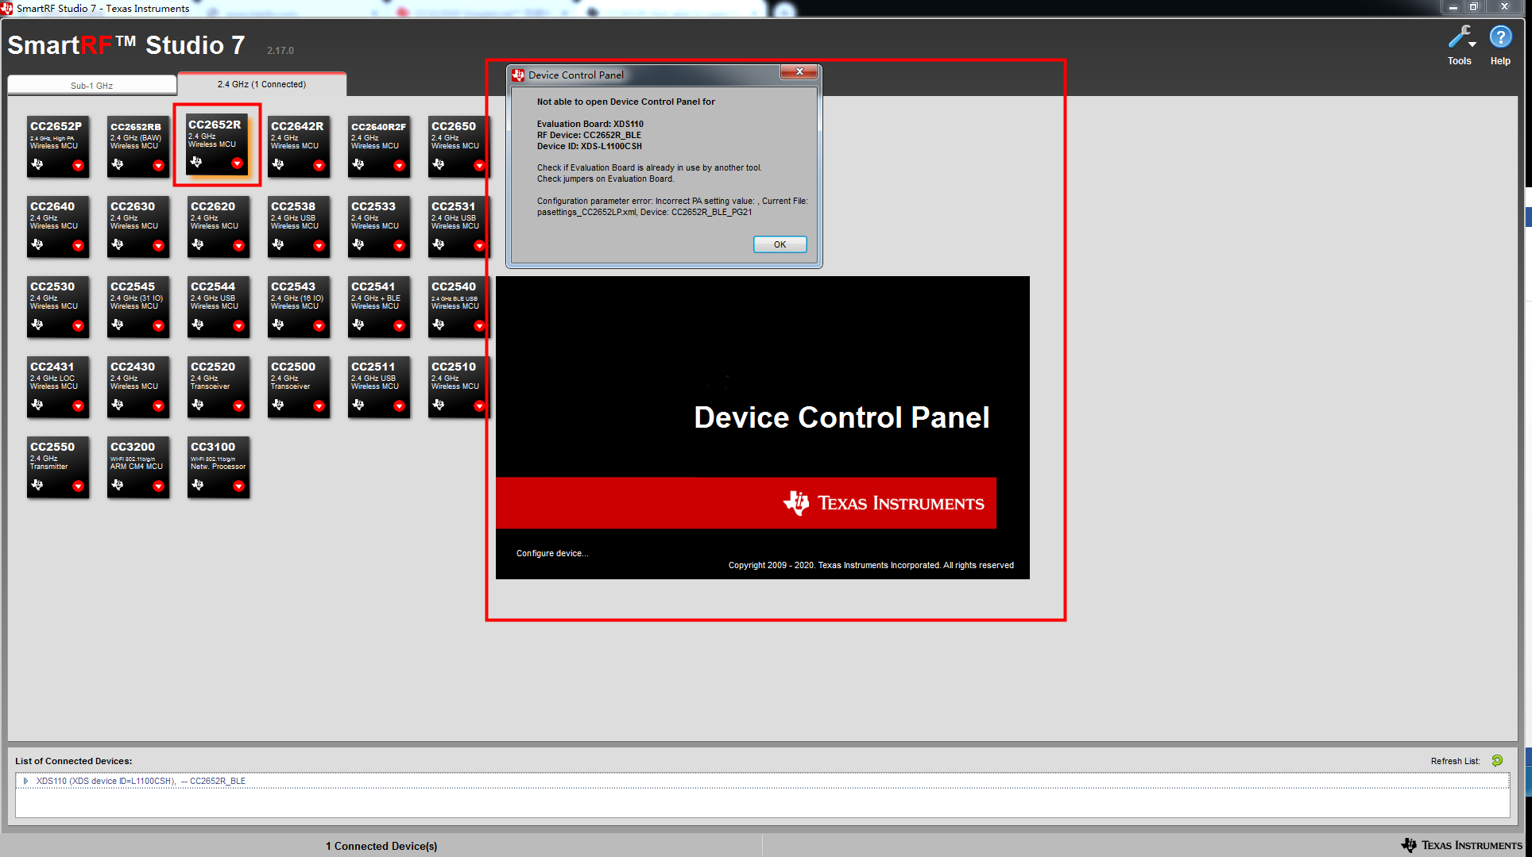

figure 5 error with CC2652R