Used standard HCI command，see below picture:
TRM-LE-CA-BV-03-C Item: test process follow Bluetooth test spec (page.19)。
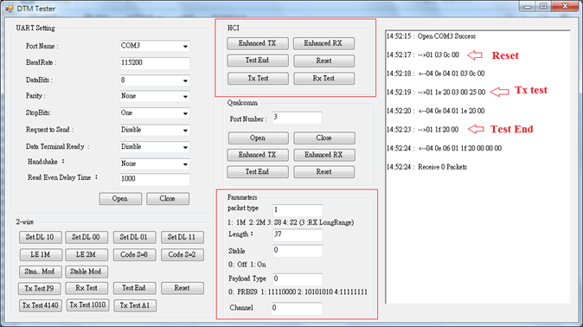
Test result:R&S FSV13 Spectrum capeture
