1. Remove the USB cable from the board.
2. Short SDA and SCL by connecting pins 1 and 3 of J6 on the USBMOD EVM
3. Connect the EVM board to the USB socket.
4. After 5 seconds, remove the short.
5. Run DFUTEST.exe. This is found inside the USBfirmware files. If the message below appears, repeat steps 2-6.
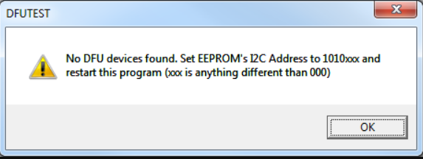
6. Click the Program EVM button. Browse for the DFUEE.bin file located in the "USBfirmware_V0304_Portable\USBfirmware_v0304_Portable\image\" directory. Click Open.
7. The following message will appear. Click OK.
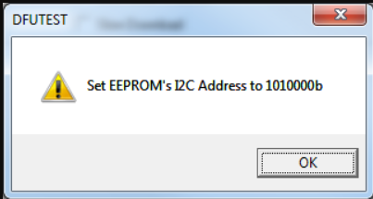
8. A "Download completed" message will appear. Click OK.
9. A "Device was succesfully reset. Please..." message will appear. Wait 2-3 seconds before clicking OK. If a "Found new hardware wizard appears, install the DFU driver as explained in Step 6.
10. A "Detach call succeeded. Please..." message will appear. Wait 2-3 seconds before clicking OK. If a "Found new hardware wizard appears, install the DFU driver as explained in Step 6.
11. Browse for the desired firmware image file (e.g. USB-xxxx_441KHZ.bin) located in the "image\" directory. Click Open.
12. Click OK for the next two windows. The last window will look like the one below.
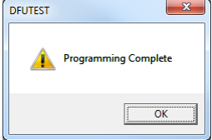
13. Click OK and close the DFUTEST program.
14. Run "remove-miniEVM.exe" as administrator (right click option). This is found inside the USBfirmware files obtained above.
15. Remove and re-connect the USB cable.
16. The EVM is now ready for use.

