MCR Verification

Section 1 - MCR Installation Check
- Goto ‘Uninstall or change program’ at “Control Panel\All Control Panel Items\Programs and Features”
- Check for MCR v7.16 (32-bit). 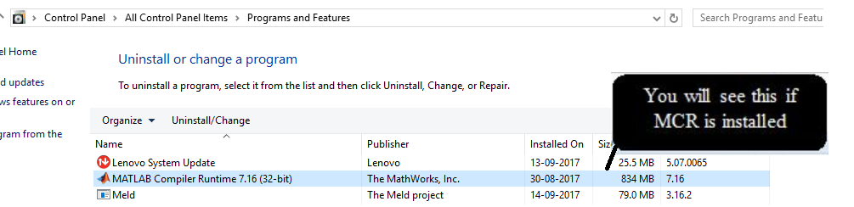
- If MCR is not installed, please install from Link - http://software-dl.ti.com/hpa_aip/non-esd/MCR_Installer/MCR-1.0-windows.exe?tracked=1

Section 2 - MCR added in environmental variable
- Open system environmental variable.
- Check if MCR path is included as variable under PC user name.
- Verify path added as “C:\Program Files (x86)\MATLAB\MATLAB Compiler Runtime\v716\runtime\win32” in ‘System Variables’.
