MCR Verification****

## Section 1 - MCR Installation Check

1. Goto ‘Uninstall or change program’ at “Control Panel\All Control Panel Items\Programs and Features”
2. Check for MCR v7.16 (32-bit). 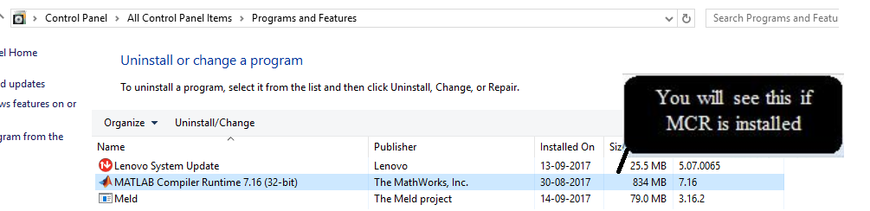
3. If MCR is not installed, please install from Link - <http://software-dl.ti.com/hpa_aip/non-esd/MCR_Installer/MCR-1.0-windows.exe?tracked=1>

## Section 2 - MCR added in environmental variable

1. Open system environmental variable.
2. Check if MCR path is included as variable under PC user name.
3. Verify path added as “C:\Program Files (x86)\MATLAB\MATLAB Compiler Runtime\v716\runtime\win32” in ‘System Variables’.

