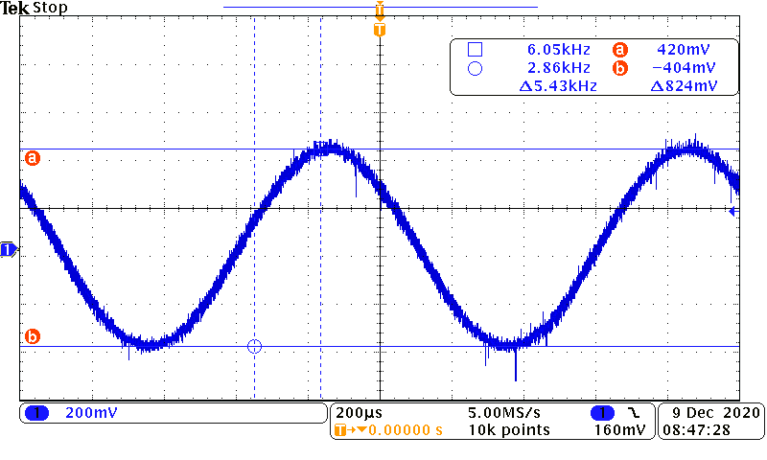
Input sinewave from Function Generator (824mVppk) which measures 290mV(rms) on
the digital volt-meter

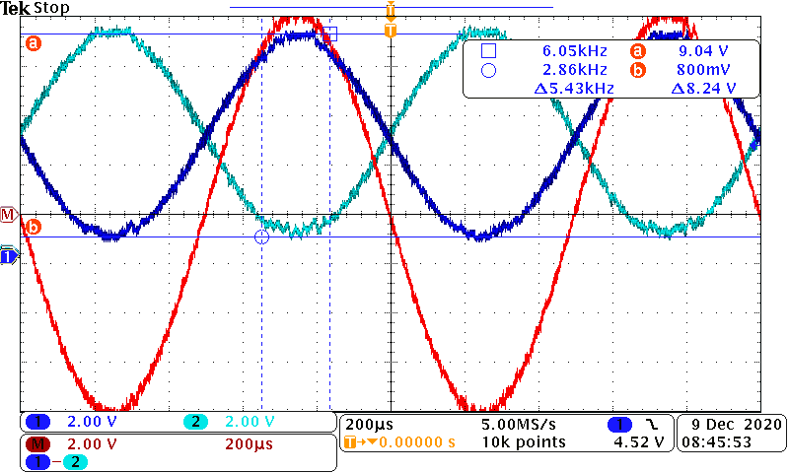
Output at the LC (speaker connections)
Using a digital volt meter to measure Vrms across the speaker (+ to - wires) measured 5.73Vrms. 5.73vrms / 0.707 = 8.1Vpk or 16.2Vppk.
Input = 0.824v Output = 16.2 GAIN = 19.6X
CASE CLOSED :0)

