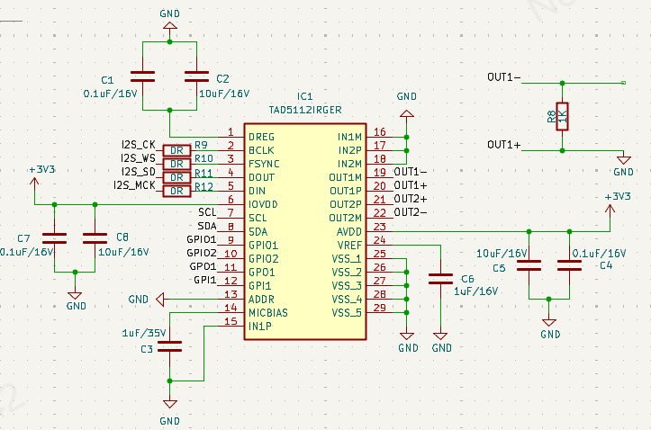
Hello, this is my current circuit diagram. I want to use the MCU to input I2S data to this TAD5112 chip to make it output a waveform. I'm not using it on headphones or microphones. I just want to output a waveform centered around 0V (for example, a sine wave). I want to use the differential output mode, with OUT1- outputting the waveform and OUT1+ grounded. As you can see in the upper right corner, I don't know how to connect this part of the circuit and what the resistance should be. I'm not sure if this idea is correct.
I referred to the differential output circuit in the chip manual: Do we need a capacitor when connecting a resistor in parallel? How should it be connected?
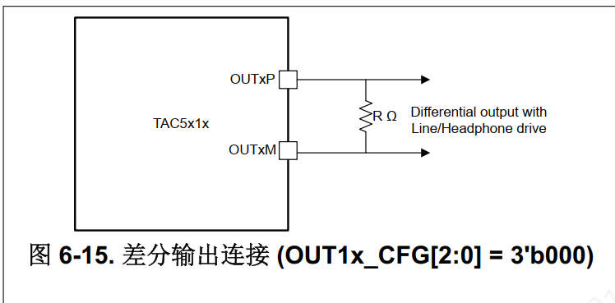
If a single-ended output is used, what should be the value of this capacitor-resistor?