Device Configuration:

1. Using PCM6260Q1EVM-PDK and PPC3, device is configured for:
   1. Line Input
   2. AC-coupled, differential input
2. The 6 channel outputs are routed to TDM slots 0-5 (default)

APx555 Configuration:

1. Output configuration – Analog balanced (for differential input): The input is connected differentially across INxP/INxM pins of the device from the APx555 “ANALOG OUTPUT 1/ANALOG OUTPUT 2” ports; Input full-scale voltage for line differential AC-coupled input = 10Vrms

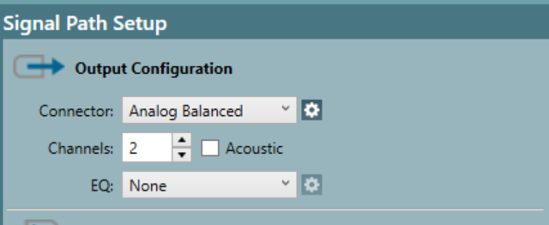

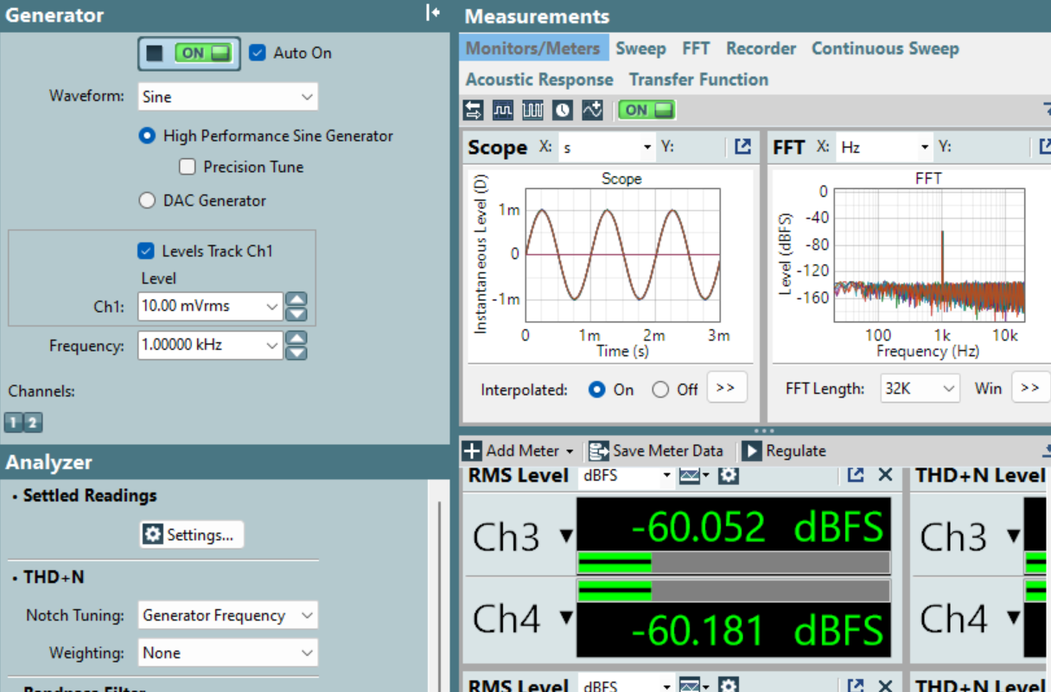

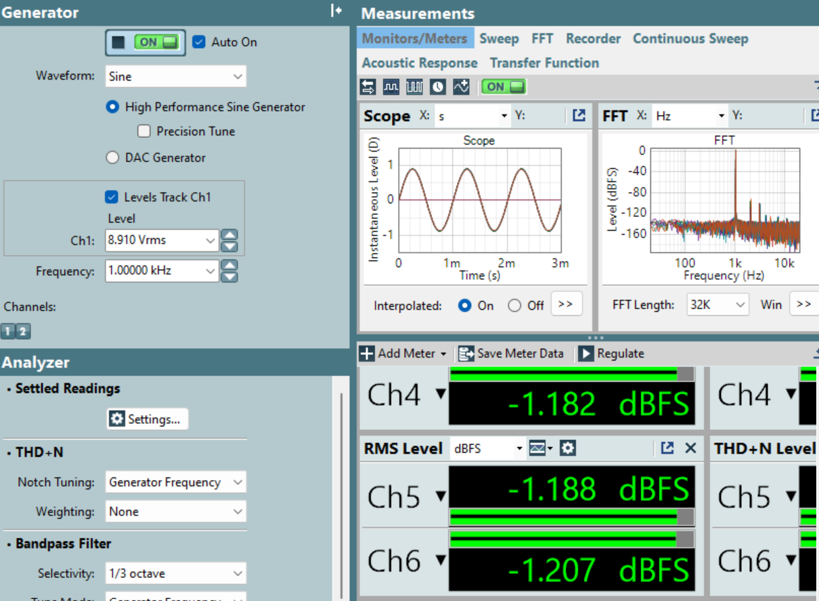

1. Input Configuration –
   1. ASIO/Texas Instruments USB Audio – When capturing through XMOS

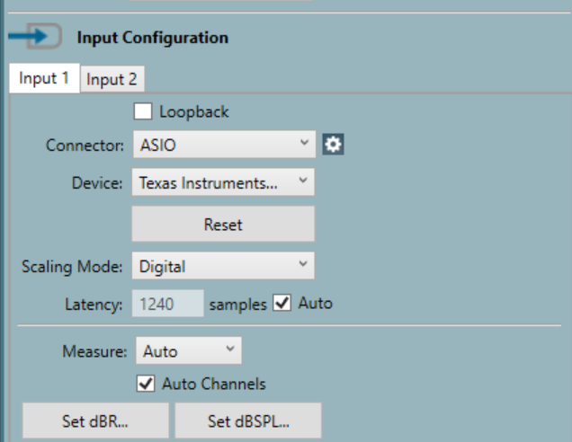

* 1. Digital Serial configured for 8-channel, 32-bit TDM – When using APX555 “Digital Serial Receiver” Port.

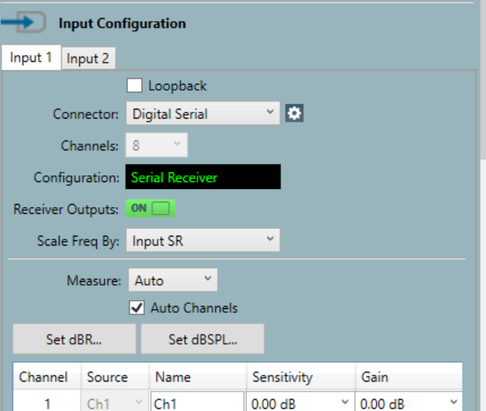

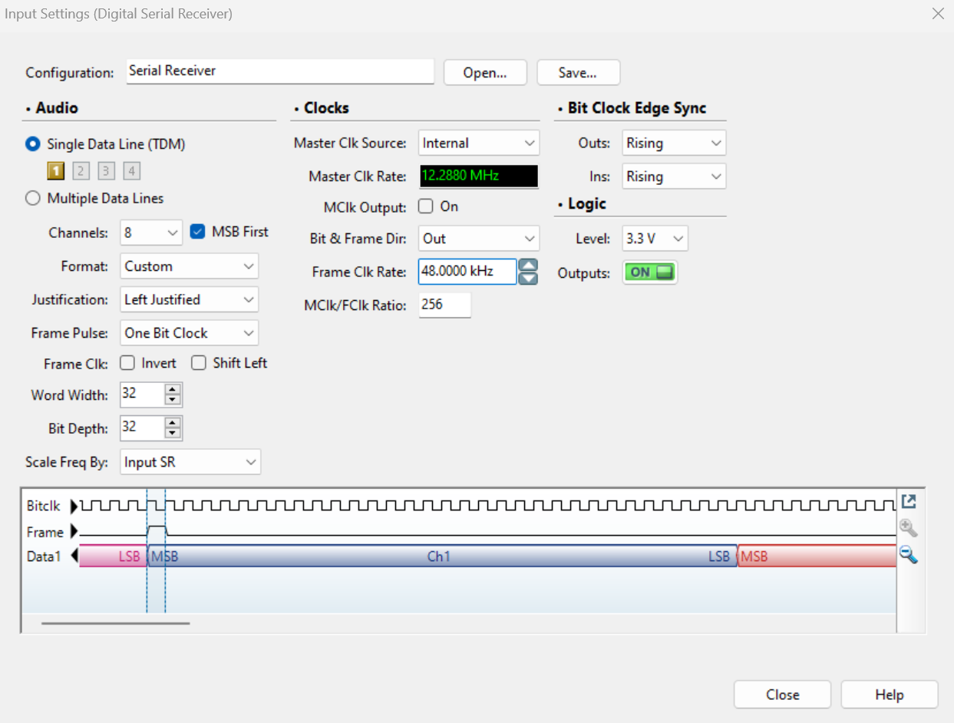

* 1. Filter can be set for audio band (20Hz-20kHz); A-weighting can be enabled based on measurement requirement