Query to resolve Codec tlv320ADC3140 PCM Data capture which is interface via STM32F745IET6 SAI_A controller

Following are the steps followed to acquire the PCM data from interfaced digital PDM microphone VM3000 and the observations are noted.

STM32CubeMX settings
The SAI 1 in SAI A block used in Master mode and below image depicts the STM32CubeMX parameters :
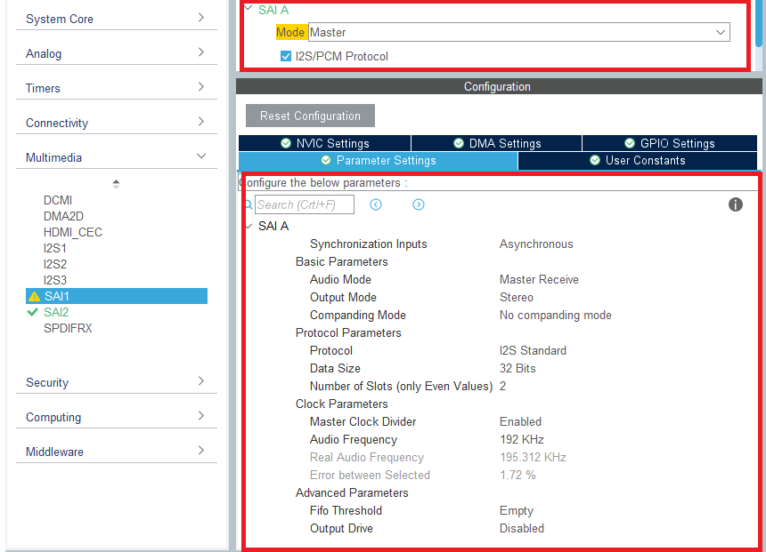

Observation of signals between SAI_A and TLV Audio CODEC
The captured images below depicts the BCLK and FSYNC on the codec TLV320ADC3140 are as follows

- The FSYNC clock with 195.3 KHz in the master mode
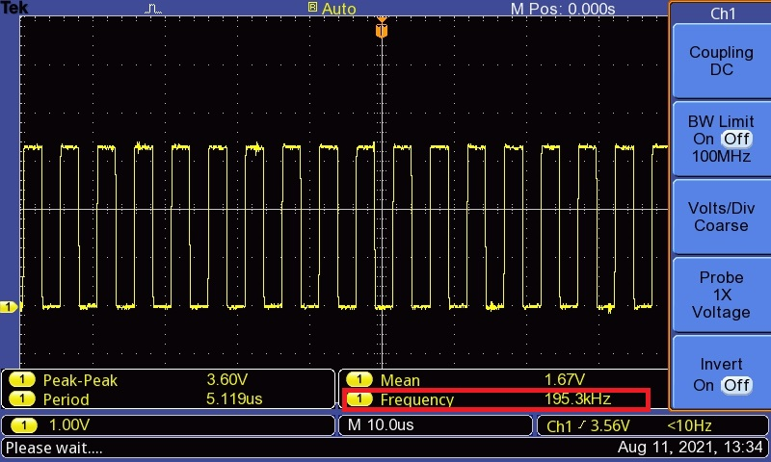

- The BCLK captured with 12.34 MHz in the master mode
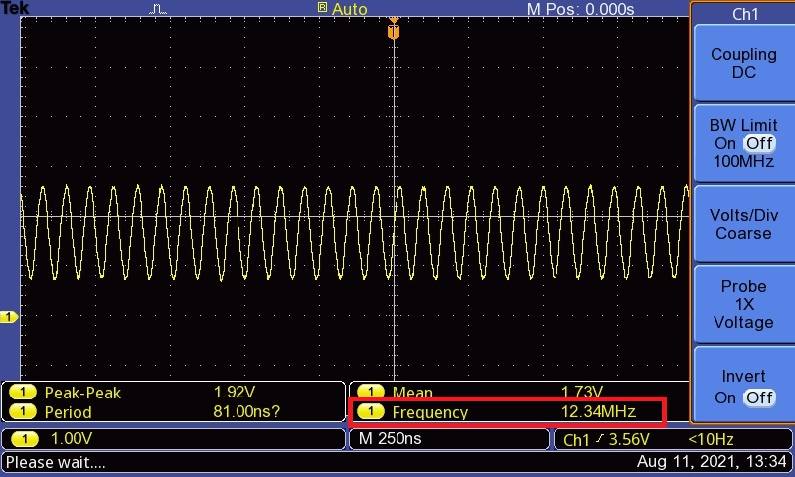

3) Questions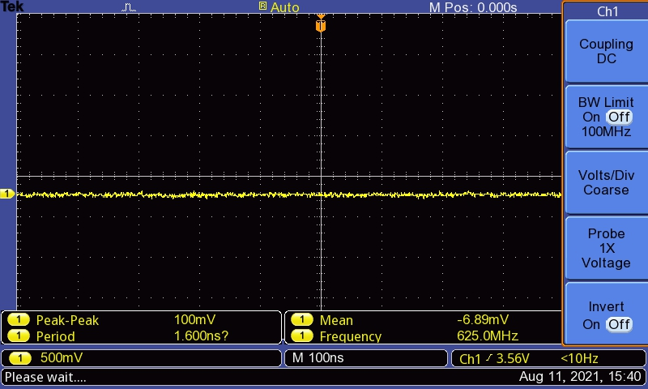
Codec is not putting on any clock onto the MEMS for the data to be received.

Initialisation Program
The initialization sequence of the codec TLV320ADC3140 is as follows
- As per the Datasheet of codec TLV320ADC3140 in page from 110 to 112 reference the same steps of initializing is followed and below are the codes attached

- TLV320ADC3140.h file as follows

#define TLV320_NUM_REGS 20

#define TLV320_RESET_REG 0x01

void TLV320_Init(I2C_HandleTypeDef *);

- TLV320ADC3140.c file as follows

The initializing steps and registers values to write are as followed in the datasheet reference page of 110 to 112 of tlv320adc3140
/**************************************************************************
* Global Definitions
***************************************************************************/

I2C_HandleTypeDef *hi2cCODEC;

//static const uint8_t TLV320_ADDR = 0x98 << 1; //I2C ADDRESS CODEC 8 CHANNEL DIGITAL RECORD
static const uint8_t TLV320_ADDR = 0x4C << 1; //codec_slave address

void TLV320_Init(I2C_HandleTypeDef *hi2c)
{
hi2cCODEC = hi2c; //i2c2 for audio codec
uint8_t i;
// Reset
TLV320_Reset();
HAL_Delay(10);
// Configure registers
//for (i = 0; i < TLV320_NUM_REGS; i++)
{
_tlv320_write8(0x2, 0x81);//TLV320_init_data[i]);
_tlv320_write8(0x3C, 0x40);
_tlv320_write8(0x41, 0x40);
_tlv320_write8(0x46, 0x40);
_tlv320_write8(0x4B, 0x40);
_tlv320_write8(0x22, 0x41);
_tlv320_write8(0x23, 0x41);
_tlv320_write8(0x24, 0x41);
_tlv320_write8(0x25, 0x41);

_tlv320_write8(0x2B, 0x45);
_tlv320_write8(0x2C, 0x67);
_tlv320_write8(0x73, 0xFF);
_tlv320_write8(0x74, 0xFF);
_tlv320_write8(0x75, 0x60);
}
}

void TLV320_Reset(void)
{
_tlv320_write8(TLV320_RESET_REG, 0);
}

void _tlv320_write8(uint8_t reg, uint16_t data)
{

// stuff the output buffer
//reg = ((reg << 1)&0xFE) | ((data >> 8)&0x01); // append data MSB to reg
uint8_t val = data % 0xFF;

// Send it
// i2c_write(wdata, 3);
HAL_I2C_Mem_Write(hi2cCODEC, TLV320_ADDR, reg, 1, &val, 1, 10);
}

For reference the audio codec schematics
