* **问题描述（ Problem description）：**

1.测试发现USB和蓝牙底噪超标，信号分离度超标（**The test found that the USB and Bluetooth background noise exceeded the standard, and the signal separation exceeded the standard**.）

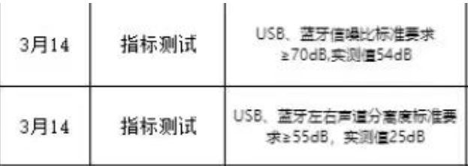

**3.14-Indicator testing：The standard requirement for USB and Bluetooth signal-to-noise ratio is ≥ 70dB, and the measured value is 54dB.**

**3.14-Indicator testing：The standard requirement for left and right channel separation of USB and Bluetooth is ≥ 55dB, and the measured value is 25dB.**

2.抓取USB播放1khz 喇叭端输出波形在1khz的波形中叠加一个130Khz左右的杂波（幅度在300mV左右），如下图 蓝色和绿色为喇叭端波形（**Grab the USB and play the output waveform of the 1 khz speaker terminal, and add a clutter of about 130 khz (with an amplitude of about 300 mV) to the 1 khz waveform. As shown in the figure below, blue and green are the speaker terminal waveform**s）

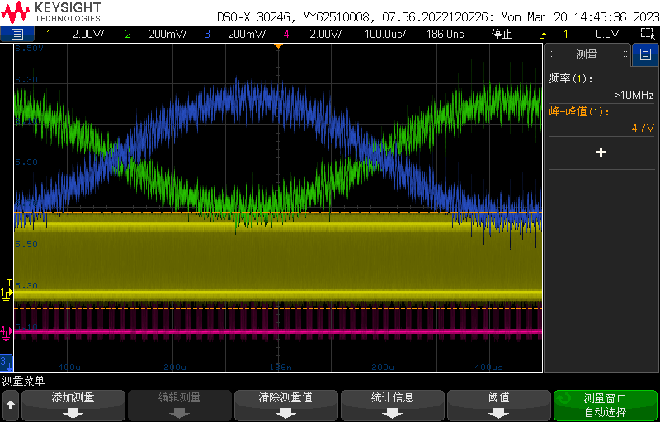

* **音频框图（Audio Block Diagram）：**

TAS6424L为主音频输出功放，TAS6422为AVAS功能，测试为TAS6424L出现异常，TAS6422未测试。**（The TAS6424L is the main audio output power amplifier, and the TAS6422 is an AVAS function. The test indicates that the TAS6424L is abnormal, but the TAS6422 is not tested.）**

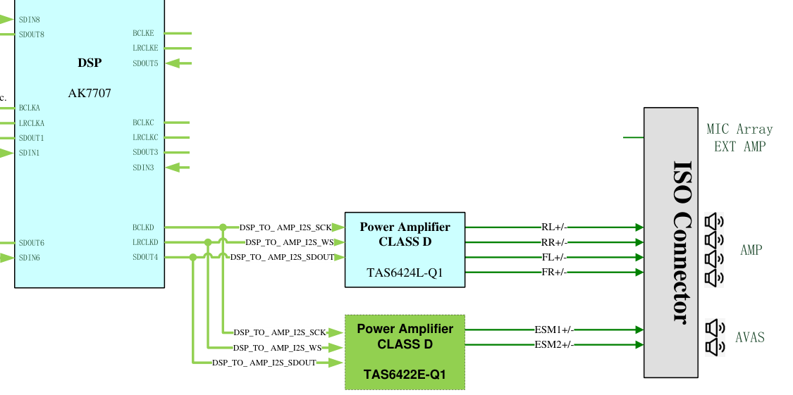

* **参数配置（Parameter configuration）：**

MCU通过I2C配置的寄存器**（Registers configured by MCU through I2C）**：

REG 0x00 : 0x00

REG 0x01 : 0x32

REG 0x02 : 0x62

REG 0x03 : 0x46

REG 0x14 : 0xFF

REG 0x04 : 0x00

DSP端 TDM通道和参数配置**（DSP TDM channel and parameter configuration）**:

---PCM short，32bit/32bit，TDM8，48k

* **问题分析（Problem analysis）：**

测试发现，整机上电前几秒功放无输出，当DSP端有时钟输出无数据输出时，功放端出现130Khz左右杂波，持续十秒左右，杂波消失。当整机上电完成，播放USB 1khz音乐时杂波叠加1khz波形再次出现。**（The test found that the power amplifier had no output a few seconds before the entire machine was powered on. When the DSP terminal had a clock output and no data output, a clutter of about 130 Khz appeared at the power amplifier terminal, lasting for about ten seconds, and the clutter disappeared. When the entire machine is powered on and USB 1 khz music is played, the clutter superimposed 1 khz waveform reappears.）**

**抓取DSP到功放输入端波形（Capture the waveform from the DSP to the power amplifier input）：**

1.TDM波形放大图**（Enlarged TDM waveform）**：

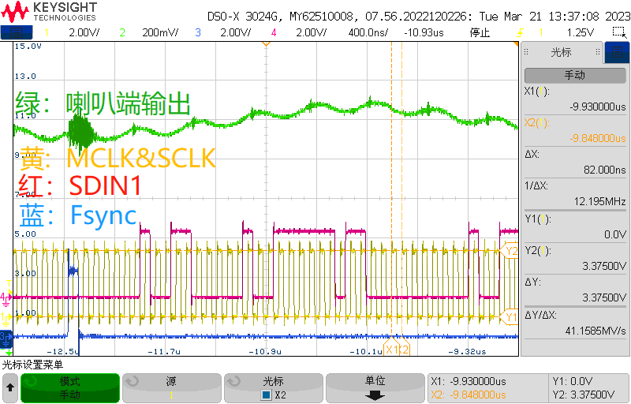

**Green：Speaker output；**

**Yellow：MCLK&SLCK;**

**Red：SDIN1:**

**Blue：Fsync**

2.TDM波形缩小图：（播放1khz音乐，红圈处为杂波）**（Reduced TDM waveform: (Play 1 khz music, with clutter in the red circle)）**

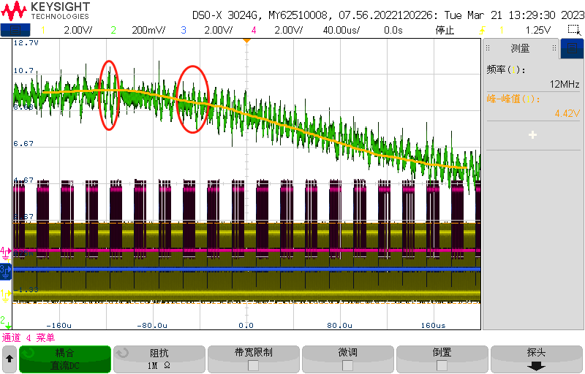

3.TDM 1*Fsync wave form：

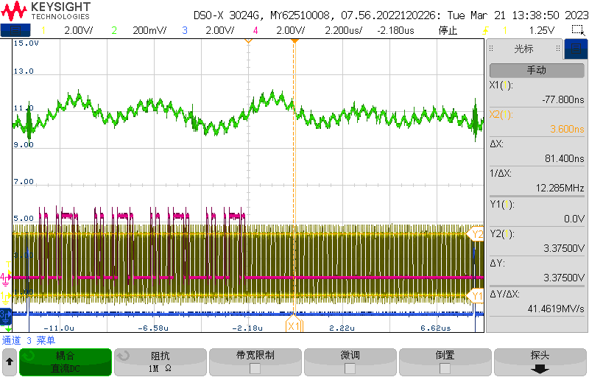

**抓取功放输出端到喇叭的波形：**

1. 没有播放没有杂波时波形

（黄色：靠近功放输出OUT_1P，蓝色：靠近喇叭负载端,LR滤波器后端）

**Grab the waveform from the amplifier output to the speaker:**

**1. Waveform without playing and clutter**

**(Yellow: near the power amplifier output OUT_1P, blue: near the horn load end, LR filter rear end)**

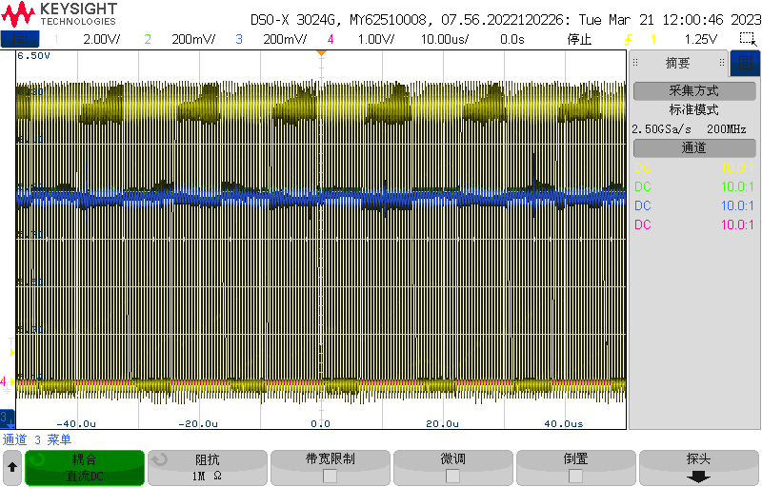 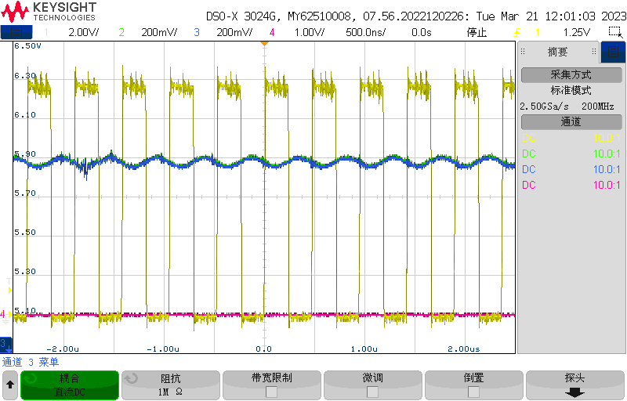

1. 播放1khz,有杂波时波形

（红色：靠近功放输出OUT_1P，绿色：靠近喇叭负载端,LR滤波器后端）

**2. Play 1 khz, waveform with clutter**

**(Red: near the power amplifier output OUT_1P, green: near the horn load end, LR filter rear end)**

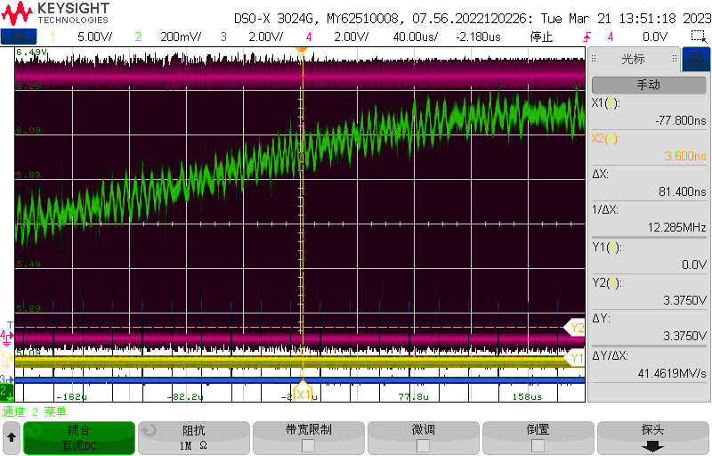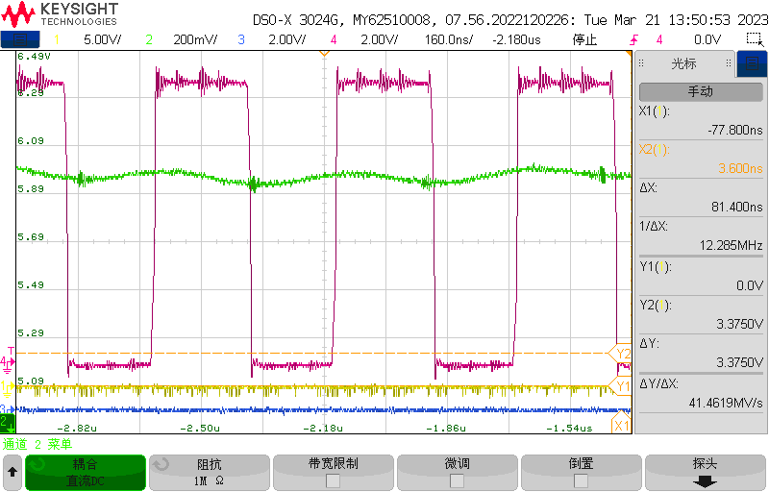

测量发现上电时Fault脚异常，抓取寄存器数据如下：(抓取时只接了一个喇叭)

**During the measurement, it was found that the Fault pin was abnormal when powered on. The data of the capture register is as follows: (Only one speaker was connected during the capture)**

