Table of Contents

Procedure 2

Audio Codec Program register settings 3

Audio Data Input/output Timing PCM3002 5

Audio Codec Clock settings 6

Procedure

1. Reset audio Codec PCM3002 manually
2. Program audio codec registers using bit banging. Please refer to Audio Codec register settings section
3. Play audio file using command: aplay <filename.wav>
4. Observe the waveform on DSO for below outputs:
   1. SYSCLK
   2. BCLK
   3. LRCIN
   4. DIN
   5. DOUT

Please find attached sample audio file being used:



Audio Codec Program register settings

Below are the audio codec register settings used:

Register0: 0x01FF

Register1: 0x03FF

Register2: 0x0442

Register3: 0x060C

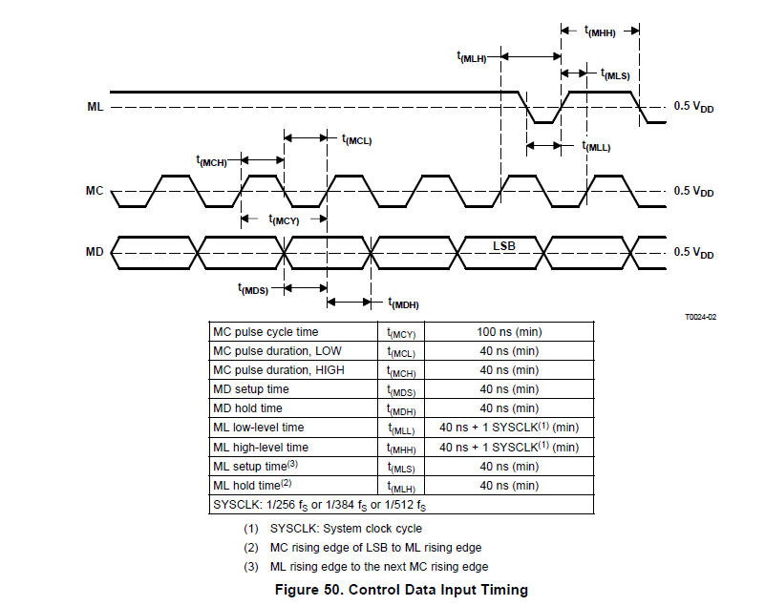

|  |  |  |
| --- | --- | --- |
|  | **Expected (minimum)** | **Actual** |
| MC pulse cycle time | 100 ns | 72 ms |
| MC pulse duration, LOW | 40 ns | 36 ms |
| MC pulse duration, HIGH | 40 ns | 36 ms |
| MD setup Time | 40 ns | 40 ms |
| MD hold time | 40 ns | 56 ms |
| ML low-level time | 40 ns + 1 SYSCLK | NA (ML is set to low during start) |
| ML high-level time | 40 ns + 1 SYSCLK | 156 ms |
| ML setup time | 40 ns | 228 ms |
| ML hold time | 40 ns | 64 ms |

**Program Registers Waveform:** 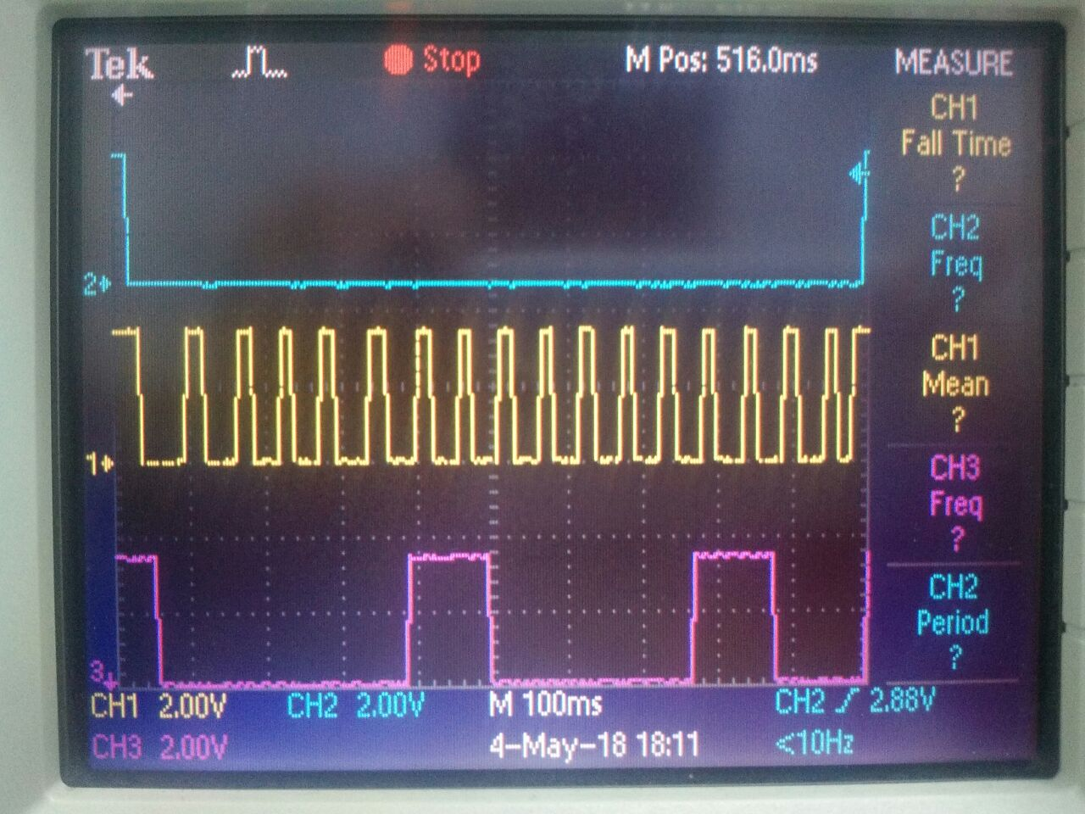

MC

ML

MD

Audio Data Input/output Timing PCM3002

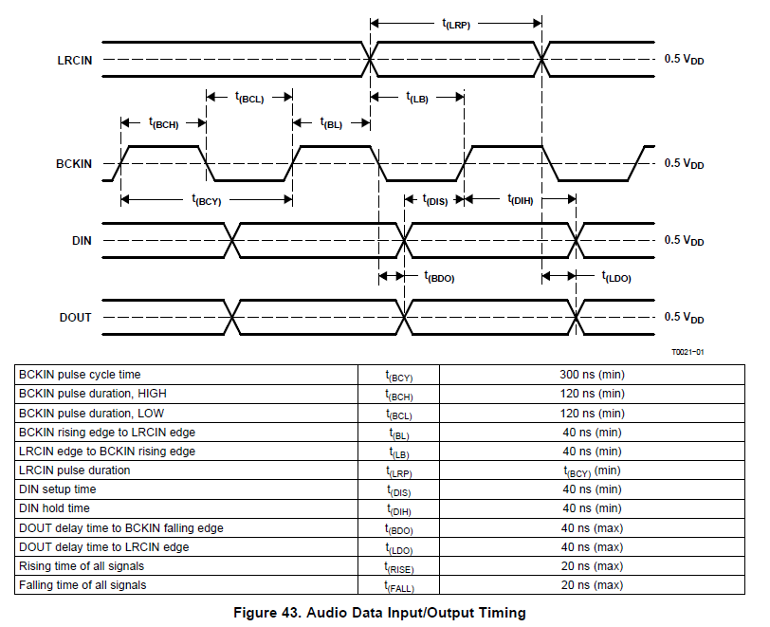

Observations:

|  |  |  |
| --- | --- | --- |
|  | **Expected** | **Actual** |
| BCKIN pulse cycle time t(BCY) | 300 ns | 320 ns (3.125Mhz) |
| BCKIN pulse duration, HIGH t(BCH) | 120 ns | 160 ns |
| BCKIN pulse duration, LOW t(BCL) | 120 ns | 160 ns |
| BCKIN rising edge to LRCIN edge t(BL) | 40 ns | 160 ns |
| LRCIN edge to BCKIN rising edge t(LB) | 40 ns | 160 ns |
| LRCIN pulse duration t(LRP) |  | 10.50 us (47.61Khz) |
| DIN setup time t(DIS) | 40 ns | 160 ns |
| DIN hold time t(DIH) | 40 ns | 160 ns |

Audio Codec Clock settings

Audio clock frequencies are measured as below:

Example: Audio file sampling frequency 48 KHZ

Bit Clock frequency: 3.072 MHZ {32*2*fs}

System Clock: 512 * fs = 24.57 MHZ

LRCIN clock: 48 KHZ

**Audio input/output waveform**

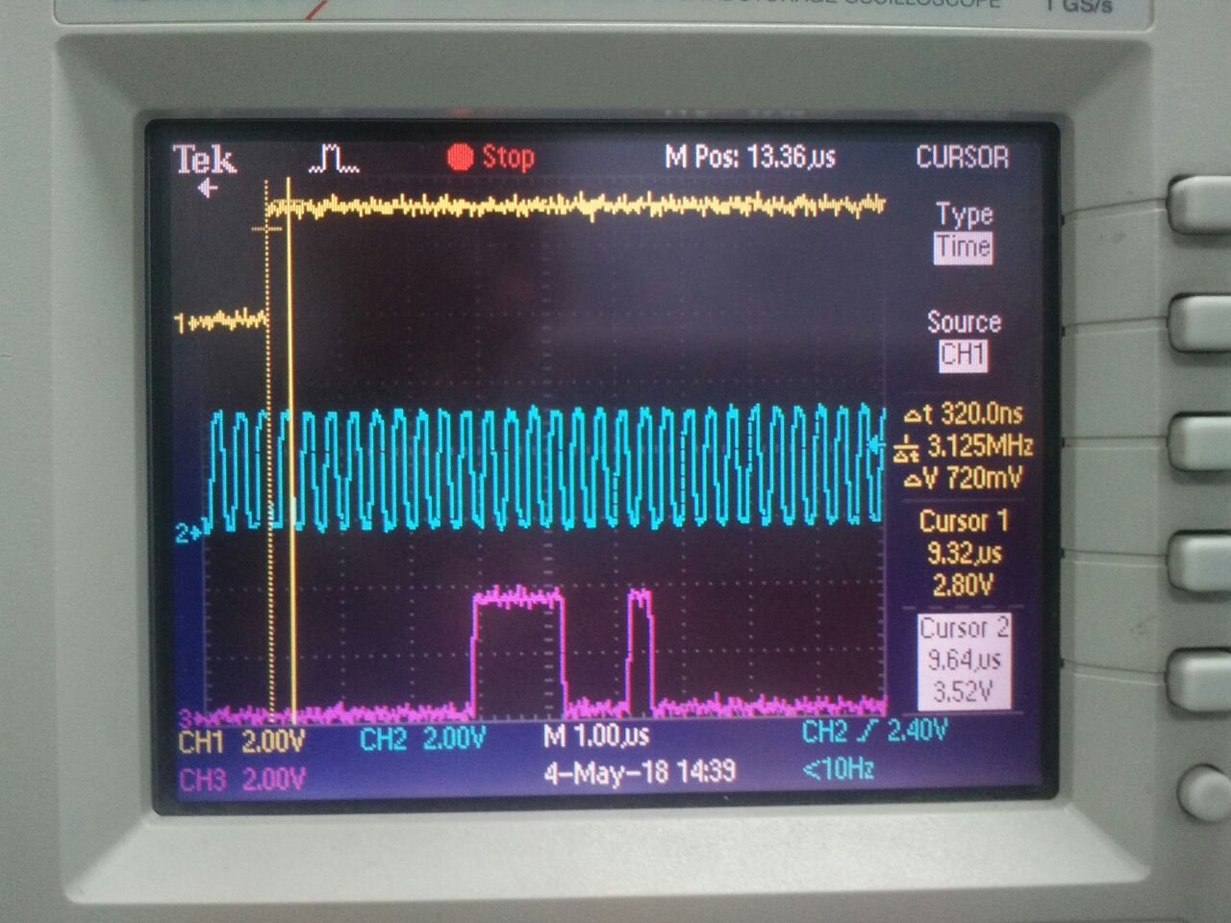

**BCLK**

**LRCIN**

**DIN**

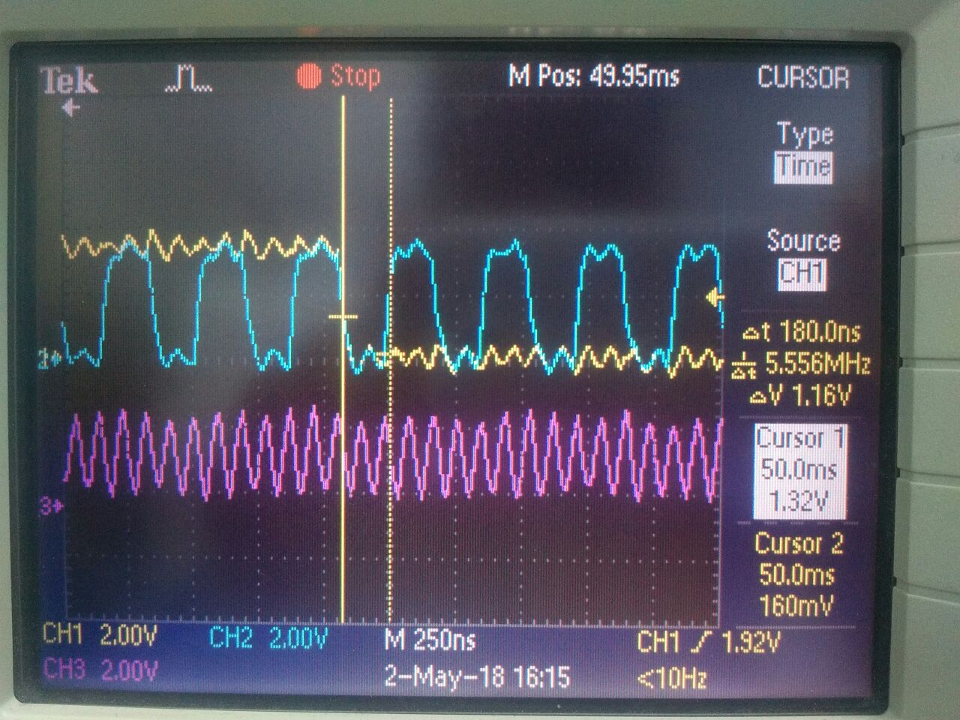

**LRCIN**

**SYSCLK**

**BCLK**