**Codec Circuit:**

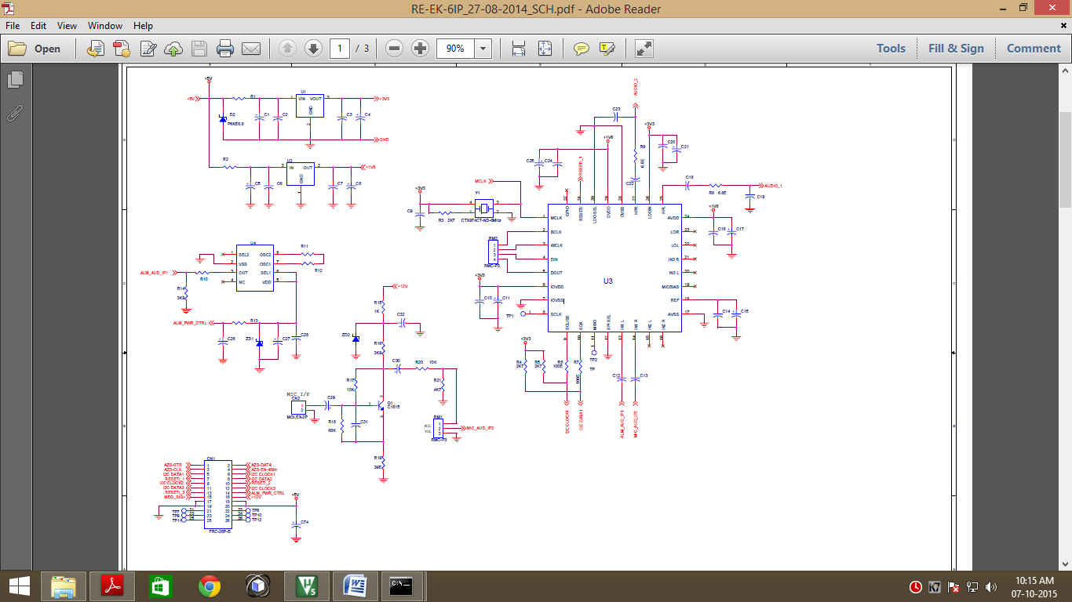

**Capacitor:**

C1,c4,c5,c8,c27,c74,c11,c25,c29,c32,c30 C15,c17,c21=22 $μfd$

Alarm signal

HPL

Amplifier

Speaker

IN1L

**Problem:**

Alarm signal is played continuously via speaker through audio codec. When I switch ON the other panel power (Like Power supply/PC power etc…) audio codec is affected and audio signal is not received to speaker.

**Test1:**

LDO select pin connect to ground. Apply the power to DVDD=1.8v and, LDOIN & IOVDD =3.3v

**Test2:**

LDO select pin connect to 3.3v and IOVDD=3.3v. No power in DVDD.