
Application Note

TAS6584-Q1 AC Diagnostics Introduction and User Guidance

Xxx xx
ABSTRACT

Audio amplifier AC diagnostics is a valuable tool to identify an incorrect connection from the amplifier speaker output pin to the speaker and within the speaker itself. This protects the amplifier from delivering energy into a potentially unsafe load. This application note provides insight into the working principle and application of AC diagnostics in the TAS6584-Q1.

1 Introduction

TAS6584-Q1 AC load diagnostics function is used to test and calculate the value of speaker load. The device employs unique internal circuits and algorithms to measure the real part and the imaginary part of the load impedance. It generates sine current stimulus to the load and captures voltage on the load for impedance calculation. Users can determine the impedance threshold which indicates the load faults based on their system design. Through comparing the calculation result with the threshold, TAS6584-Q1 can identify whether the speaker is properly connected.

2 AC Load Diagnostics

2.1 What is AC Diagnostics

The AC load diagnostic is used to test and calculate the speaker load, then compare it with the threshold which should be set by users, to determine whether the load is connected properly. This can be used in many load types, such as traditional Dynamic Speaker, Piezoelectric Speakers (Piezo), Capacitive Coupled speaker and so on. The AC load diagnostic is controlled through I2C. The TAS6584-Q1 provides a required signal source to determine the AC impedance and reports the detection result back to I2C registers. The I2C selected test frequency should create current flow through the desired speaker for proper detection.
2.2 The Test principle of AC Diagnostics

Figure 2-1 illustrates the simplified block diagram for AC load diagnostics. The device drives a self-generated 10mA sine current stimulus through the speaker load. The current is applied across OUTP and OUTM and the voltages on OUTP and OUTM are captured for impedance calculation. The device measures the impedance of the path between the OUTP and OUTM pins, including the LC filter.

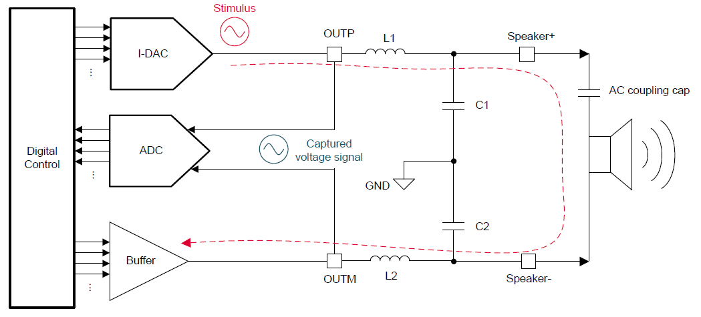
Figure 2-1. Diagram for AC Load Diagnostics
Some features of the stimulus can be set by registers.
Use AC_LDG_Ctrl1 (Address = 0xB5) bit 4 (AC DIAG GAIN) to set the gain to increase the reported result resolution. For the low load impedances, it is recommended to the set the gain=8.
Use AC LDG FREQ Ctrl Register (Address = 0xB8) to set the stimulus frequency from 93.75 Hz to 23.91 kHz, in step of 93.75 Hz.

Table 2-1 lists the settings for AC load diagnostics.
Table 2-1. AC Load Diagnostic Set Registers -1
Register | Control Bits | Options | Description | Function
AC_LDG_Ctrl1  (0xB5) | AC DIAG GAIN<4> | 0 | Gain = 1, range = 0–100 Ω | Set the gain.
AC_LDG_Ctrl1  (0xB5) | AC DIAG GAIN<4> | 1 | Gain = 8, range = 0–25 Ω | Set the gain.
AC LDG FREQ Ctrl (0xB8) | STIMULUS FREQUENCY <7:0> | / | Frequency = 93.75 Hz * bit value  0000 0000: Reserved  0000 0001: 93.75 Hz  0000 0010: 187.5 Hz  ....  1100 1000: 18.75 kHz  ....  1111 1111: 23.91 kHz | Set the stimulus frequency

2.3 The Calculation of AC Diagnostics

Figure 2-2 illustrates the General Class-D BTL connection diagram. L₁, L₂ are filter inductances, C₁, C₂ are filter capacitances. Z₁ is the impedance of load with L C filter, Z₂ is the impedance of load.
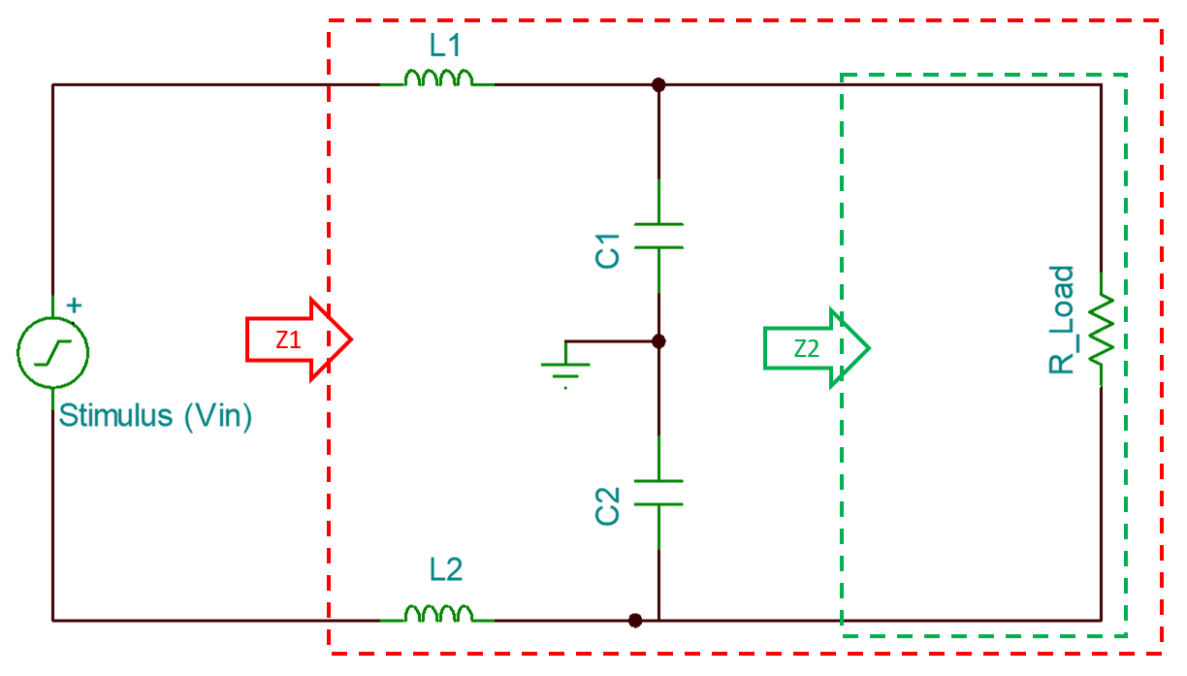
Figure 2-2. General Class-D BTL connection Diagram
2.3.1 The Calculation of Z₁
Use the node voltage equation to calculate the Z₁:
Current loop 1: V_{in}, L₁, L₂, R _{Load}
Current loop 2: C₁, C₂, R _{Load}
i₁ is the current flowing through L₁ and L₂, i₂ is the current flowing through the load, i₃ is the current flowing through C₁, i₄ is current through C₂, in this case, we got L₁ = L₂ = L, C₁= C₂ = C, R _{Load} =R, then, we can have the following equations with Laplace transfer,
$$\left\{\begin{aligned}V_{in}-Lsi_{1}-Lsi_{1}-Ri_{2}=0 ① \\ i_{1}=i_{2}+i_{3} ② \\ i_{1}=i_{2}-i_{4} ③ \\ -i_{2}R+\frac{i_{3}}{Cs}-\frac{i_{4}}{Cs}=0 ④ \\ \end{aligned}\right.$$
Then, i₃ + i₄ = 0，
According to Eq.④,
$$i_{2}=\frac{2i_{1}}{CsR+2} ⑤$$
Use Eq.⑤ – Eq.①:
$$V_{in}-Lsi_{1}-Lsi_{1}-R\frac{2i_{1}}{CsR+2}=0$$
Z₁ can be calculated by,
$$Z_{1}=\frac{V_{in}}{i_{1}}=2Ls+\frac{2R}{CsR+2}$$
Then, Fourier transform, we have $s=jω=j2πf, f$ is audio frequency, we have output impedance with its real and imaginary part,
$$Z_{1}=\frac{4R}{4π^{2}f^{2}C^{2}R^{2}+4}+j\left(4πLf-\frac{4πfCR^{2}}{4π^{2}f^{2}C^{2}R^{2}+4}\right)$$
2.3.2 The Calculation of Z₂
For AC Diagnostics, the detect result is Z₁, users can calculate Z₂ from Z₁.
$${ Z}_{1}=Z_{2} // \frac{1}{jω2C} + jω2L ⑥$$
Use Eq. ⑥ can get:
$$Z_{1}= \frac{{2Z}_{2}}{2+ jωCZ_{2}} + jω2L$$
So, we can get Z₂:
$$Z_{2}= \frac{j8πfL{ - 2Z}_{1}}{8π^{2}f^{2}LC+ j2πfC{·Z}_{1}-2} ⑦$$

3 How to use the AC Load Diagnostics results
3.1 The usage of AC Load Diagnostics results
After load calculation, Z₁ will be represented as complex impedance with real and imaginary parts, and the real and imaginary parts are reported by registers as shown in Table 3-1.
Table 3-1. AC Load Diagnostics Complex Impedance Report Registers
Channel | Real part of complex impedance | Imaginary part of complex impedance
1 | AC LDG Rprt CH1 R Register (Address = 0xC3) | AC LDG Rprt CH1 I Register (Address = 0xC4)
2 | AC LDG Rprt CH2 R Register (Address = 0xC5) | AC LDG Rprt CH2 R Register (Address = 0xC6)
3 | AC LDG Rprt CH3 R Register (Address = 0xC7) | AC LDG Rprt CH3 R Register (Address = 0xC8)
4 | AC LDG Rprt CH4 R Register (Address = 0xC9) | AC LDG Rprt CH4 R Register (Address = 0xCA)

3.1.1 Calculate the value of Z₁ and to identify whether an AC coupled speaker is properly connected
Uses can use AC diagnostic to determine the proper connection of AC coupled speaker or tweeter when used with a passive crossover (For more information about this calculation methods: Application Note: TAS6584-Q1 DC and AC Load Diagnostics). TAS6584-Q1 has a built-in magnitude estimator and tweeter detection report to perform the desired tweeter detection test, which are controlled by I2C registers. As shown in Table 3-2.
Table 3-2. AC Load Diagnostic Set Registers-2
Register | Control Bits | Options | Description | Function
AC LDG Ctrl 2 (0xB6) | TW DET CALC TYPE <1> | 0 | AC pass/fail judgment type 2  Calculate magnitude of impedance as Re(Z)+0.5*Im(Z) | Estimate the impedance magnitude of the load.
AC LDG Ctrl 2 (0xB6) | TW DET CALC TYPE <1> | 1 | AC pass/fail judgment type 1  Calculate magnitude of impedance as Re(Z) | Estimate the impedance magnitude of the load.
TWEETER DET THRESH (0xB7) | TW DET THRESHOLD  <7:0> | / | Set the reference value for AC load diag pass/fail judgment.  0.8 Ω/code if AC DIAG GAIN = 0  0.1 Ω/code if AC DIAG GAIN = 1 | Set the threshold.
TWEETER DET  (0xCB) | CH1 TW DET<3>  CH2 TW DET<2>  CH3 TW DET<1>  CH4 TW DET<0> | 0 | 0: No tweeter detected on channel x | Report the test result.
TWEETER DET  (0xCB) | CH1 TW DET<3>  CH2 TW DET<2>  CH3 TW DET<1>  CH4 TW DET<0> | 1 | 1: Tweeter detected on channel x | Report the test result.

User can use TWEETER DET THRESH (0xB7) to set the threshold. After diagnosis, AC LDG Ctrl 2 (0xB6) used to estimate the impedance magnitude of the load. Through comparing the threshold and the calculation value, user can judge whether the load is connected properly. The diagnostics result is marked accordingly in the TWEETER DET Register (0xCB).

3.1.2 Use Z₂ to calculate the value of Z₂ to determine the proper connection of load
Uses can use the value of Z₁ to calculate Z₂. Z₂ is the value of load, so this can detect the load more accurately and it can also be used to determine the proper connection of load.
The calculation method is Eq. ⑦ in 2.3.1.
This calculation has been integrated in TAS6584-Q1 PPC3 GUI, as shown:
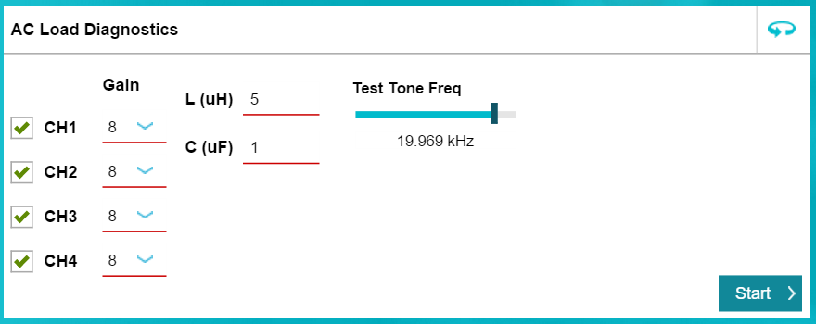
Figure 3-1. AC Load Diagnostics Setting
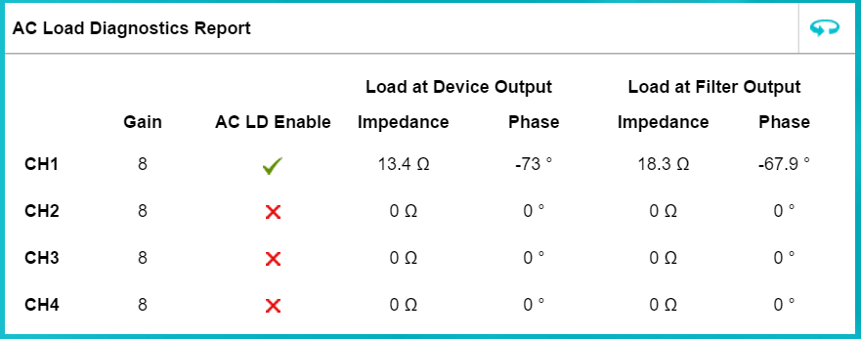
Figure3-2. AC Load Diagnostics Results
In Fig. 3-2, Z₁ is “Load at Device Output”, Z₂ is “Load at Filter Output”. The impedance results are represented as magnitude and phase angle
3.1.3 User-defined calculation mode
Besides Using the built-in magnitude estimator or the PPC3 GUI calculation method, users can also define the calculation criterion by reading the impedance results from the corresponding registers based on the real or imaginary impedance measuring results of Z₁.
3.2 AC Load Diagnostics Example
This section gives an example of applying the AC load diagnostic on 4Ω Resistance, Dynamic Speaker and Piezo Speaker. Set the stimulus frequency is 19.969kHz.
3.2.1 Features of the tested Dynamic Speaker and Piezo Speaker
Fig. 3-3 is Dynamic Speaker impedance characteristic curve. Fig. 3-4 is Piezo Speaker impedance characteristic curve. Table 3-3 shows the basic information of the test loads.
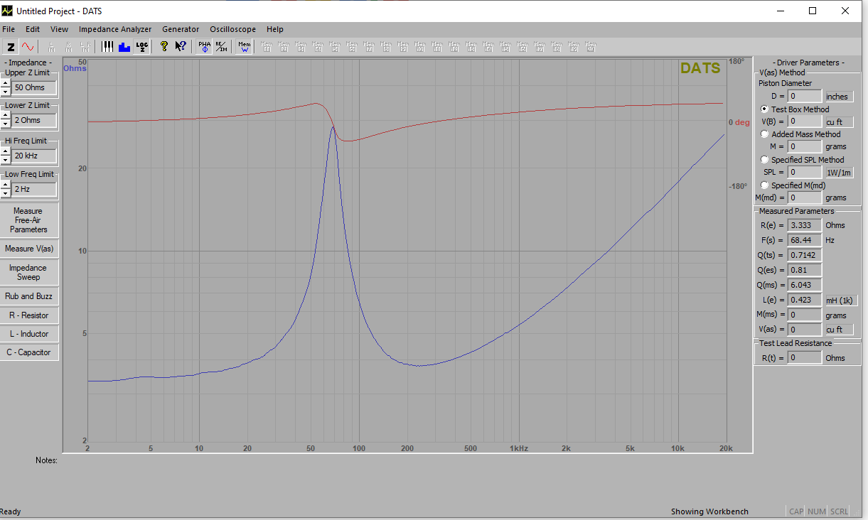
Figure3-3. Dynamic Speaker Impedance Characteristic Curve
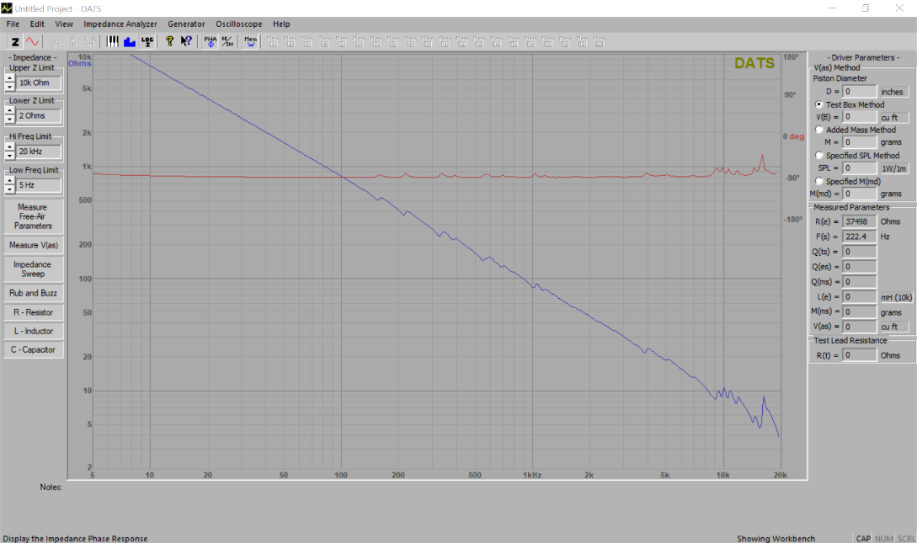
Figure3-4. Piezo Speaker Impedance Characteristic Curve

Table 3-3. Basic Information of the Test Loads
Test Loads | Test Channel | Gain | Test Frequency (kHz) | LC Filter | Impedance at the Test Frequency (Ω)
Piezo Speaker | CH1 | 1 | 19.969 | L = 5uH  C = 1uF | 4
Dynamic Speaker |  |  |  |  | 28
Resistance |  |  |  |  | 4

3.2.2 Test data and results
For the three type loads: 4Ω Resistance, Dynamic Speaker and Piezo Speaker. The test results are shown in Table 3-4.
Table 3-4. Test Results
load | Real Part |  | Ima Part |  | load at Device output（Z1） |  | Impedance by AC pass/fail judgment |  | load at Filter output(Z2)
load | 0xC3 | Result | 0xC4 | Result | Z ∠ζ° | a + bj | Type1 | Type 2 | Z ∠ζ°
Dynamic SPK | 0x0f | 12 | 0xec | -16j | 20∠-53° | 12-16j | 12 | 20 | 27.7∠41°
Piezo SPK | 0x02 | 1.6 | 0xfd | -2.4j | 2.9∠-56° | 1.6-2.4j | 1.6 | 2.8 | 5.1∠-58.6°
4 Ω Resistance | 0x04 | 3.2 | 0x00 | 0 | 3.2∠0° | 3.2 | 3.2 | 3.2 | 3.6∠-9.1°
Open Load | 0x01 | 0.8 | 0xef | -13.6j | 13.6∠-86° | 0.8-13.6j | 0.8 | 7.6 | 161.4∠-46°
Short Load | 0x00 | 0 | 0x1 | 0.8j | 0.8∠90° | 0.8j | 0 | 0.4 | 0.5∠-90°

Take the Dynamic SPK diagnostics as example:
- Calculate Z₁
The real and imaginary parts measured by the power amplifier are in complementary format.
Real part: 0xC3 register reading: 0x0f = binary (0000 1111) (complementary form), MSB = 0 (Mean positive), 0x0f = binary (0000 1111) (true form) => code = 15. As setting AC DIAG GAIN<4> = 0, so Gain = 1, it means 0.8 Ω/code, so the Real Part result = 12.
Ima part: 0xC4 register reading: 0xec = binary (1110 1100) (complementary format), MSB = 1 (Mean negative), 0xee = binary (1001 0100) (true form) => code = -20 , As setting AC DIAG GAIN<4> = 0, so Gain = 1, it means 0.8 Ω/code, so the Real Part result = -16j.
So, the impedance = 12-16j = 20∠-53°.
- Impedance Calculation by AC pass/fail judgment method
AC pass/fail judgment type 1: Calculate magnitude of impedance as Re(Z)
So, impedance = 12.
AC pass/fail judgment type 2: Calculate magnitude of impedance as Re(Z)+0.5*Im(Z)
So, impedance = 12 + 8 =20.
- Calculate Z₂
Use Eq.⑦ and Table 3-3, can calculate Z₂ = 27.7∠41°, the magnitude is 27.7Ω, which is near actual value 28Ω. The error between the two is due to the accuracy of internal sensors.
Through analyzing Table 3-4, using the value of Z₂, user can detect whether the load is connected properly, open load, or short load.

4 Summary
This application note provides detailed information on the use of AC load diagnostics. This is a valuable tool in the system design for safe operation of an automotive audio system.

