Step 1. Connect PCM5242EVM and launch PPC2
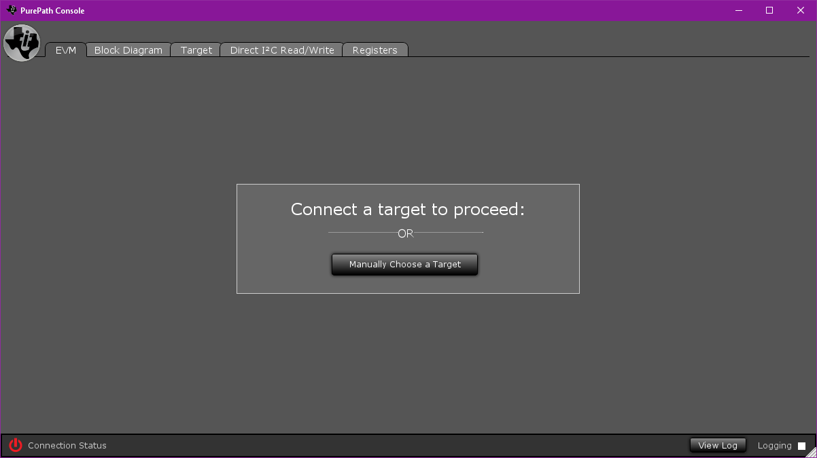
Step 2. Select Manually Choose a Target, select PCM5242
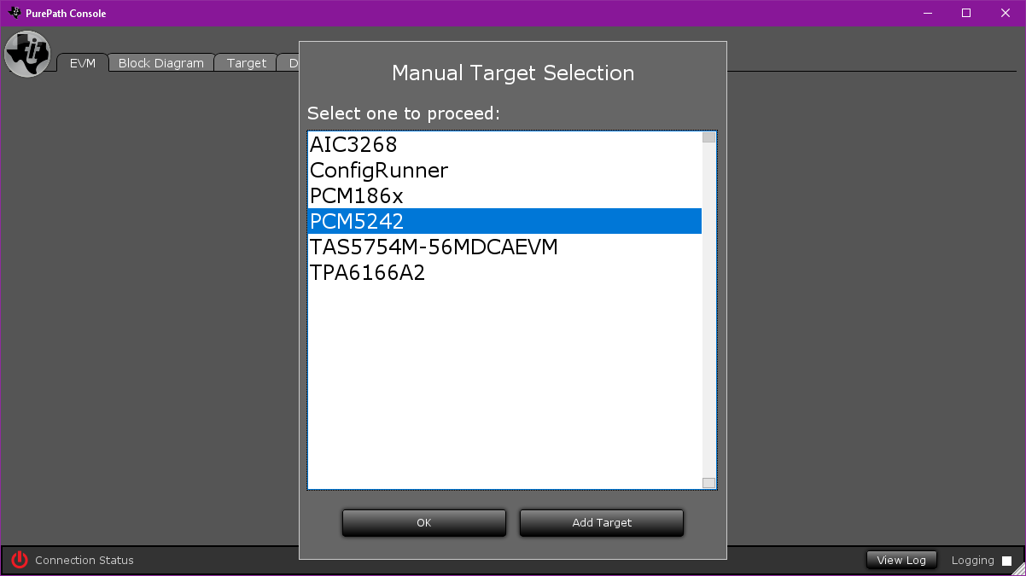
Step 3. Select ‘Connect as PCM5242’
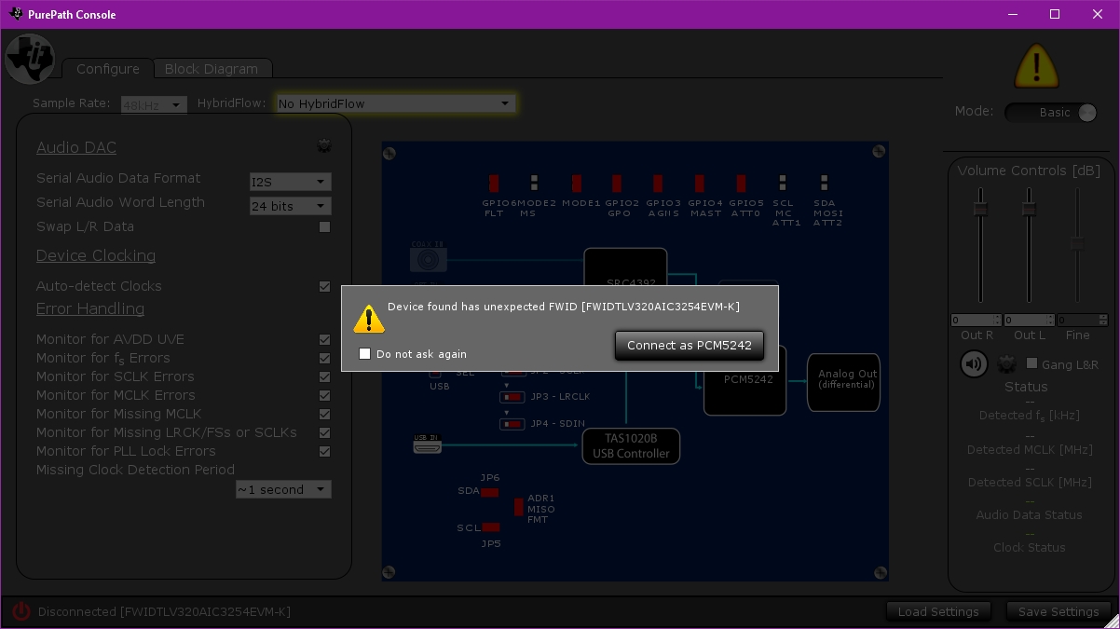
Step 4. Switch to “advanced mode”
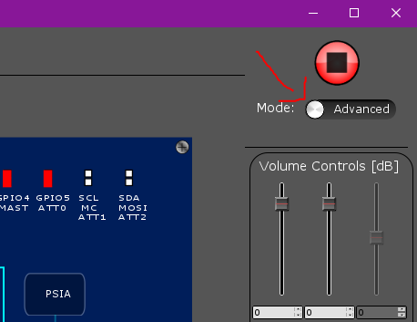
Step 5. Select the ‘Direct I2C Read/Write’ tab and press the FWID button
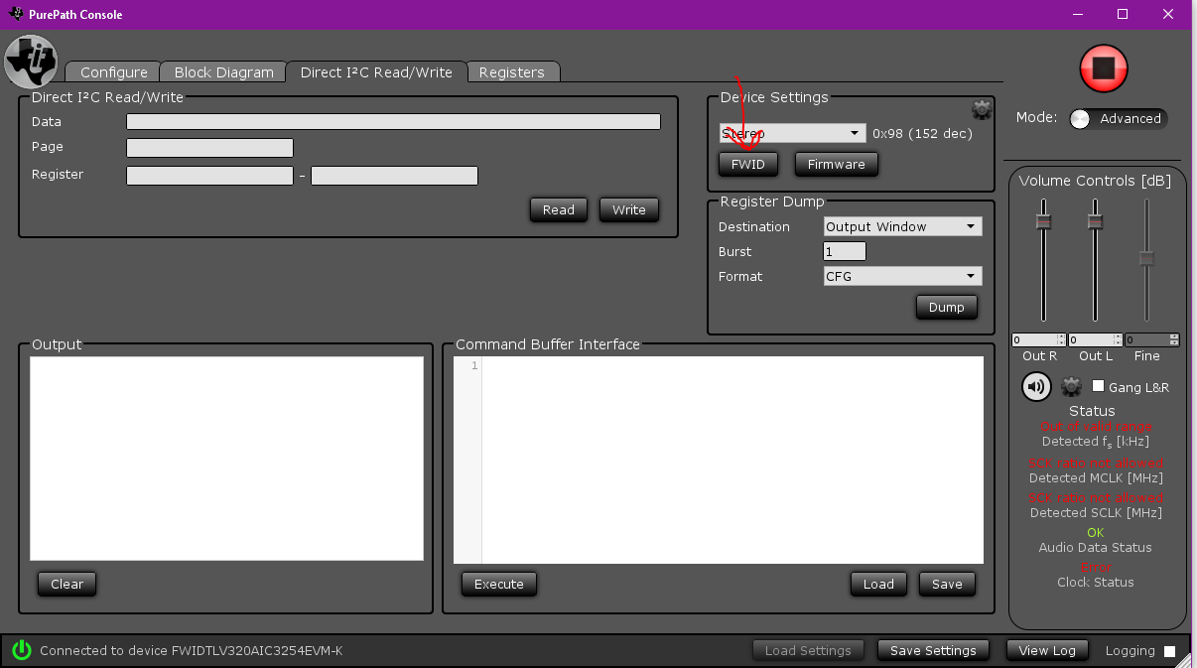
Step 6. Enter “FWIDPCM5242EVM” in the write field and then press “Write”. Then press close.
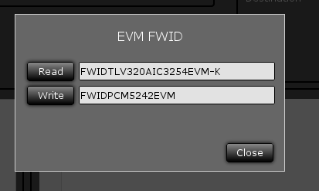
Step 7. Now close PPC2 and unplug the device for a few seconds. Plug it back in and re-launch PPC2. It should now detect the EVM without issue.

