I have a DRV595 in a known working circuit. It is a board that has been in production for a year.

On a new batch of 10 production boards we have a strange problem that we have been finding difficult to resolve.

The FAULTZ pin goes low to indicate a fault (over temperature or short circuit output).  I have checked everything external to the IC and cannot find a problem on the external components or any shorts, open circuit etc.

What I did notice is the IN- voltage on pin 5 should be about 0.8V but seems to creep up to a value of about 1.0V over the first few seconds of starting up. Although the voltage being supplied to it through a voltage divider remains static at 2.5V. Would there be any reason why this input pin voltage would creep up to 1.0V from some internal fault?

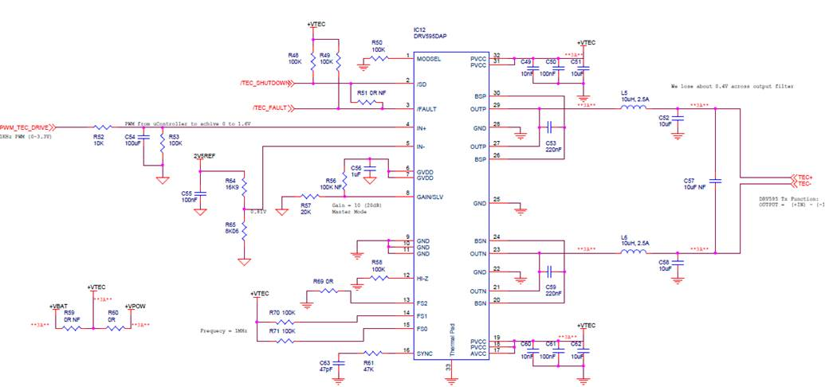  
Thanks a lot in advance for your help