I2C Master App Installation Guide

- Download I2CMaster.ppc3app provided by TI
- Open PPC3
- From App Center page, select File -> Open, as shown in the below screenshot
  - 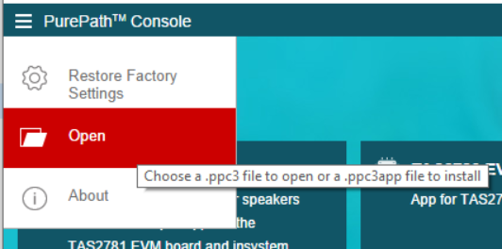
- Select the downloaded I2CMaster.ppc3app in the File Open popup
- Click Ok in the popup as shown below,
  - 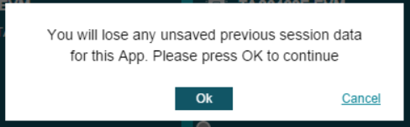
- I2CMasterApp will be installed in 30-60 seconds and will be available in the installed EVM apps section. You can click on the app and start using it.

