**TI TPA3106D1 Audio Power Amplifier EVM output power test**

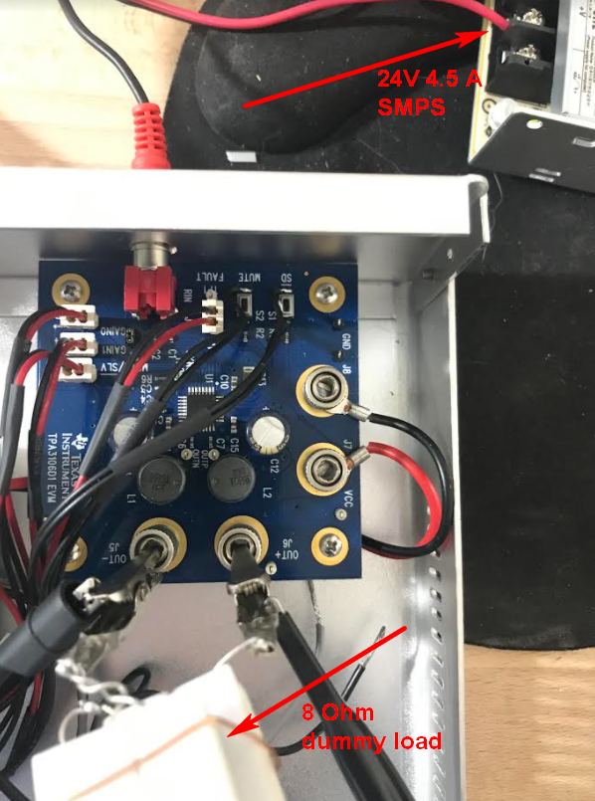 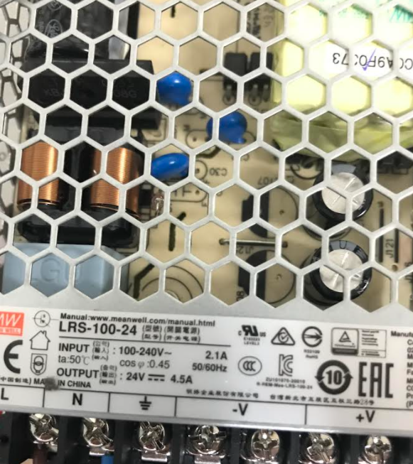

TPA3106D1EVM is powered with DC 24V 4.5A power supply. The output voltage on 8 Ohm 50 W dummy resistor load is observed with oscilloscope. The power supply is checked, output shown NO notable pulsation under TPA3106D1EVM operation in loaded state.

**TEST 1**. Input signal (form waveform generator) is 3 kHz. Amplifier gain is set to **36dB**.

Corresponding output voltage (oscilloscope probe X10) becomes clamped starting from input voltage 0.8V p-p. Measured output voltage is ~ 44V p-p (~ **29 W**).

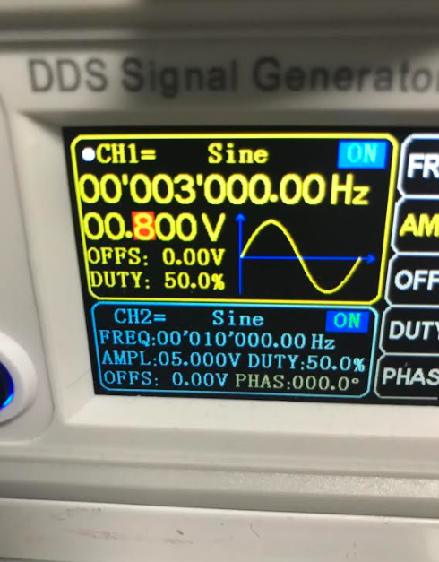 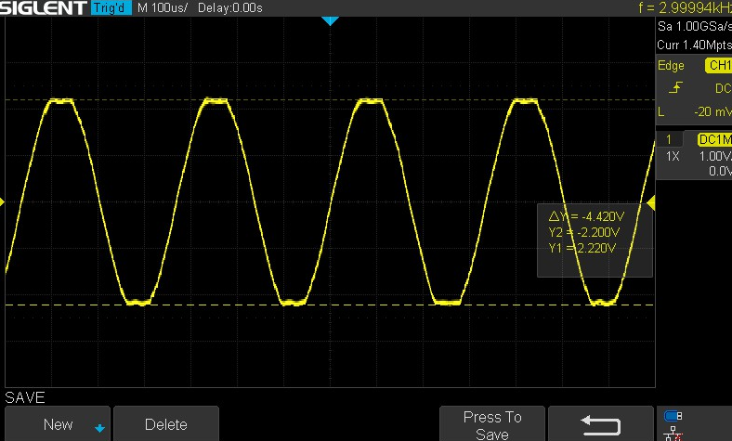

**TEST 2**. Input signal (form waveform generator) is 3 kHz. Amplifier gain is set to **20dB**.

Corresponding output voltage (oscilloscope probe X10) becomes clamped starting from input voltage 0.8V p-p. Measured output voltage is again ~ 44V p-p (~ **29 W**).

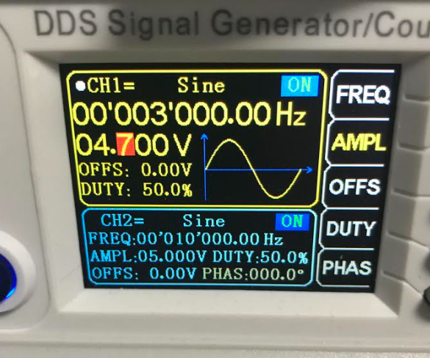 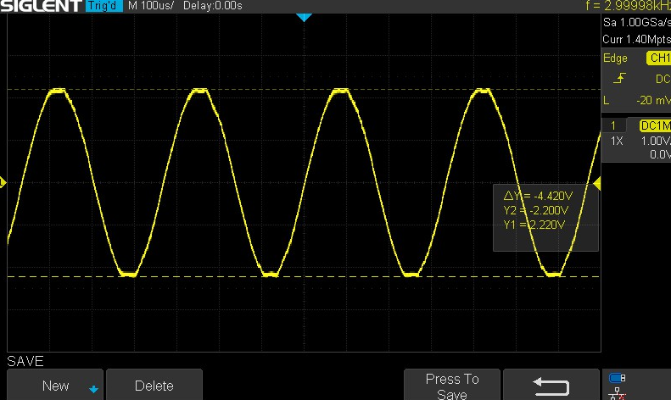

The DC current consumption is ~ 1.5 A. The temperature of chip is low enough.

