低音量失真问题
样件原始状态，使用1kHz标准音频作为测试音频，设置多媒体音量＜8时，使用音频分析仪测试左前和右后模拟输出通道，失真度超过10%

根据6424规格书建议，把SDIN2从与SDIN1短接改为接地后，失真情况无变化

此失真问题还会影响信噪比，开机后仪表通过左前通道播放提示音结束后，不再播放其他声音时，左前通道VRMS=3.221mV，右后通道VRMS=210.8uV，左前通道信噪比不达标
此时测量DSP输出给6424的SDIN信号为0
Low volume distortion problem
In the original state of the sample, 1kHz standard audio is used as the test audio. When the multimedia volume is set to <8, an audio analyzer is used to test the left front and right rear analog output channels. The distortion exceeds 10%.

According to the recommendation of the 6424 specification, after changing SDIN2 from short-circuiting with SDIN1 to grounding, the distortion situation does not change.

This distortion problem will also affect the signal-to-noise ratio. After the instrument plays the prompt tone through the left front channel after the power is turned on, and no longer plays other sounds, the left front channel VRMS=3.221mV, the right rear channel VRMS=210.8uV, and the left front channel signal-to-noise ratio is not good. Meet the standard
At this time, the SDIN signal output by the DSP to the 6424 is measured to be 0.
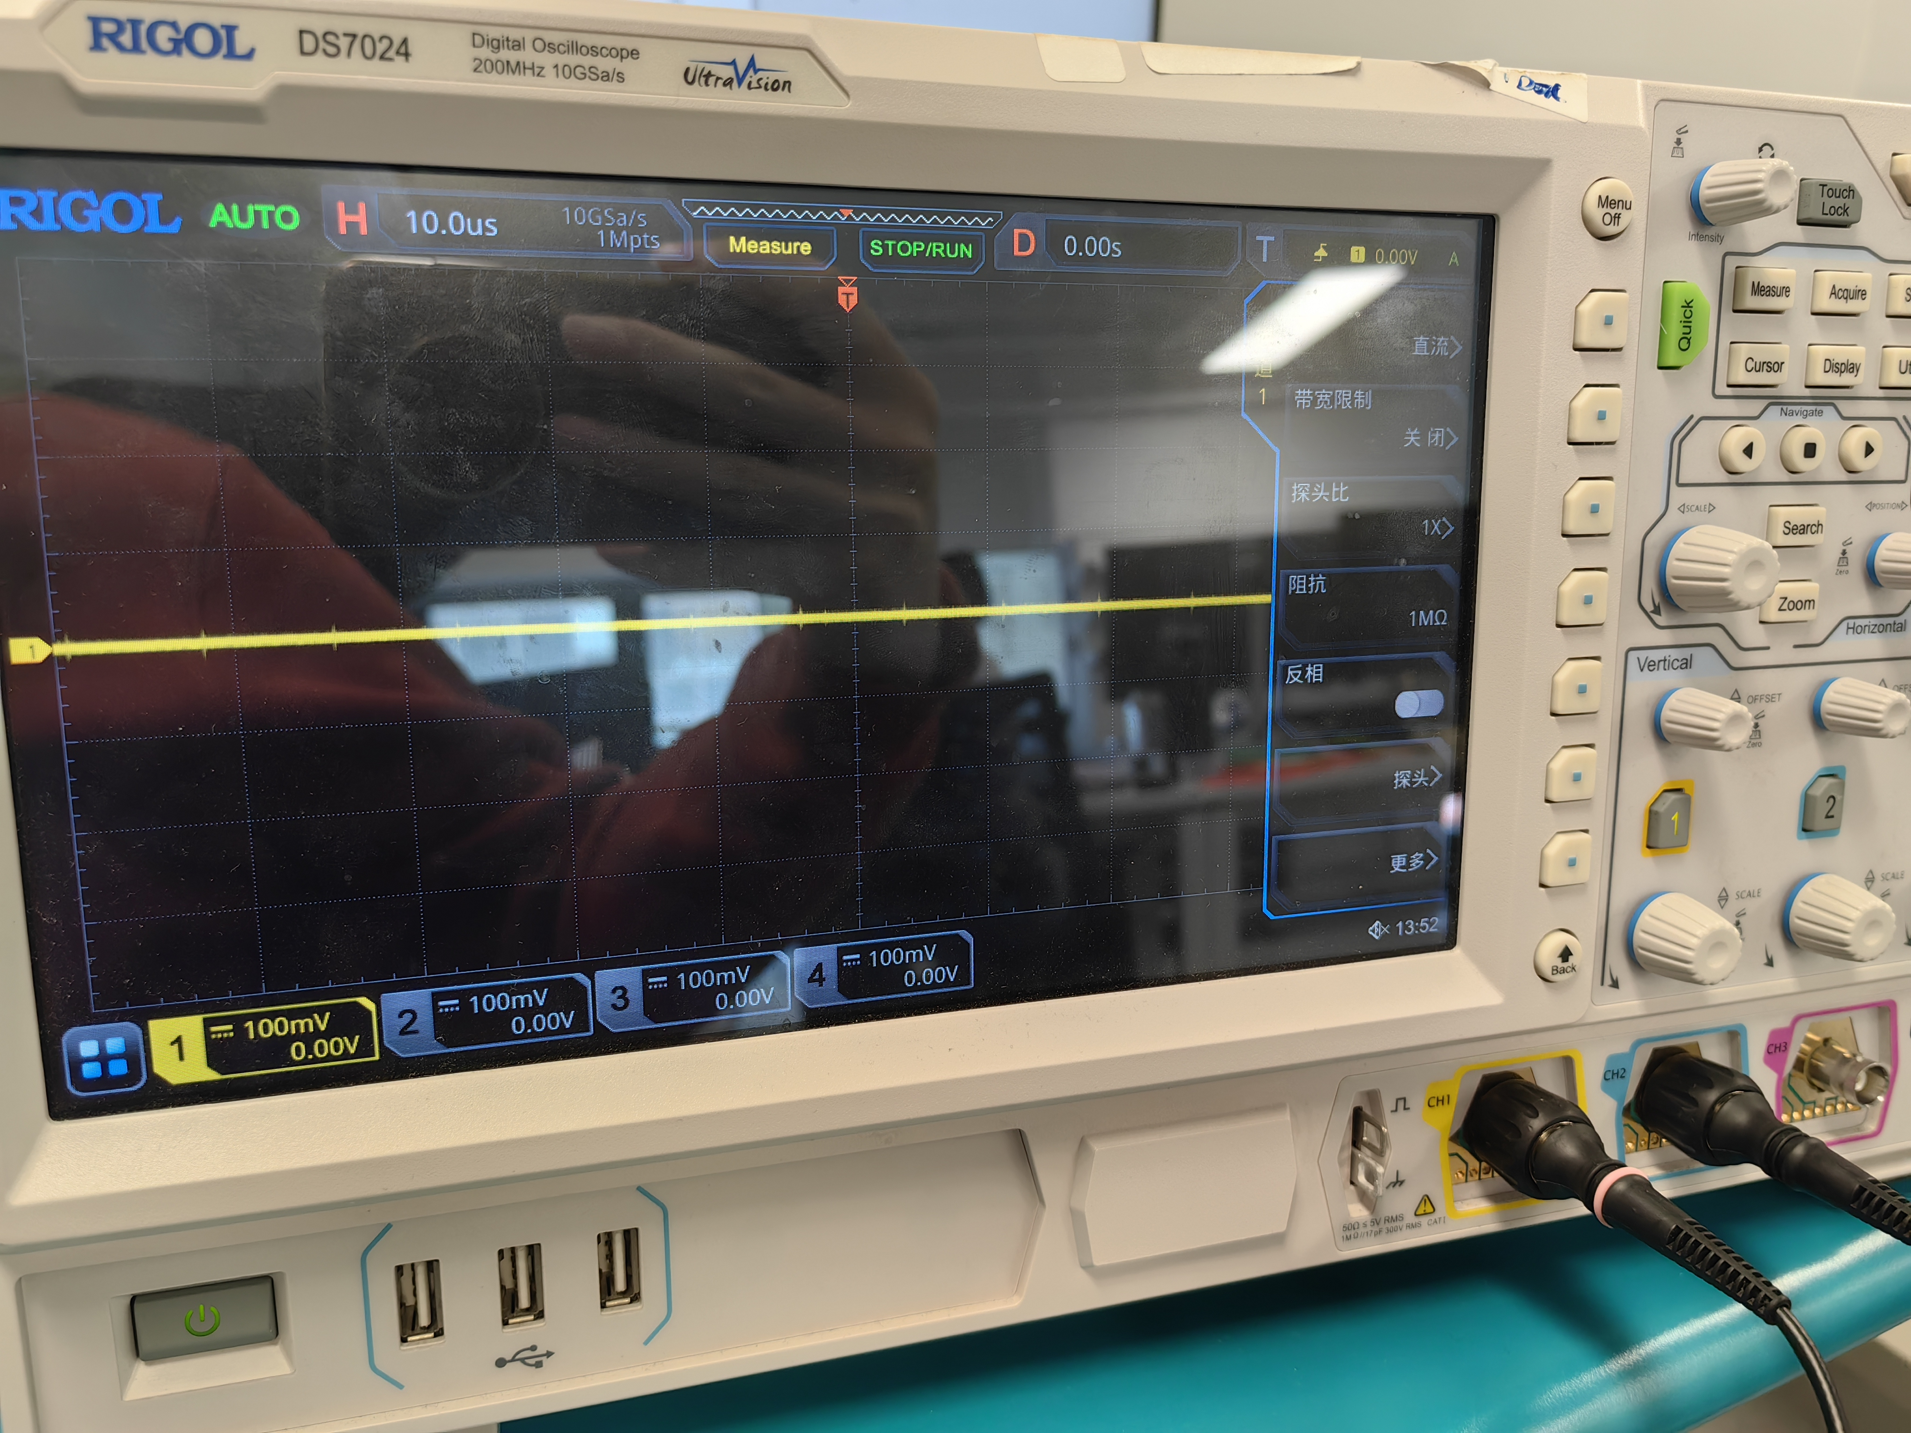
随后播放多媒体1kHz正弦波，设置满音量40
测量SDIN信号如下
Then play the multimedia 1kHz sine wave and set the full volume to 40
Measure the SDIN signal as follows
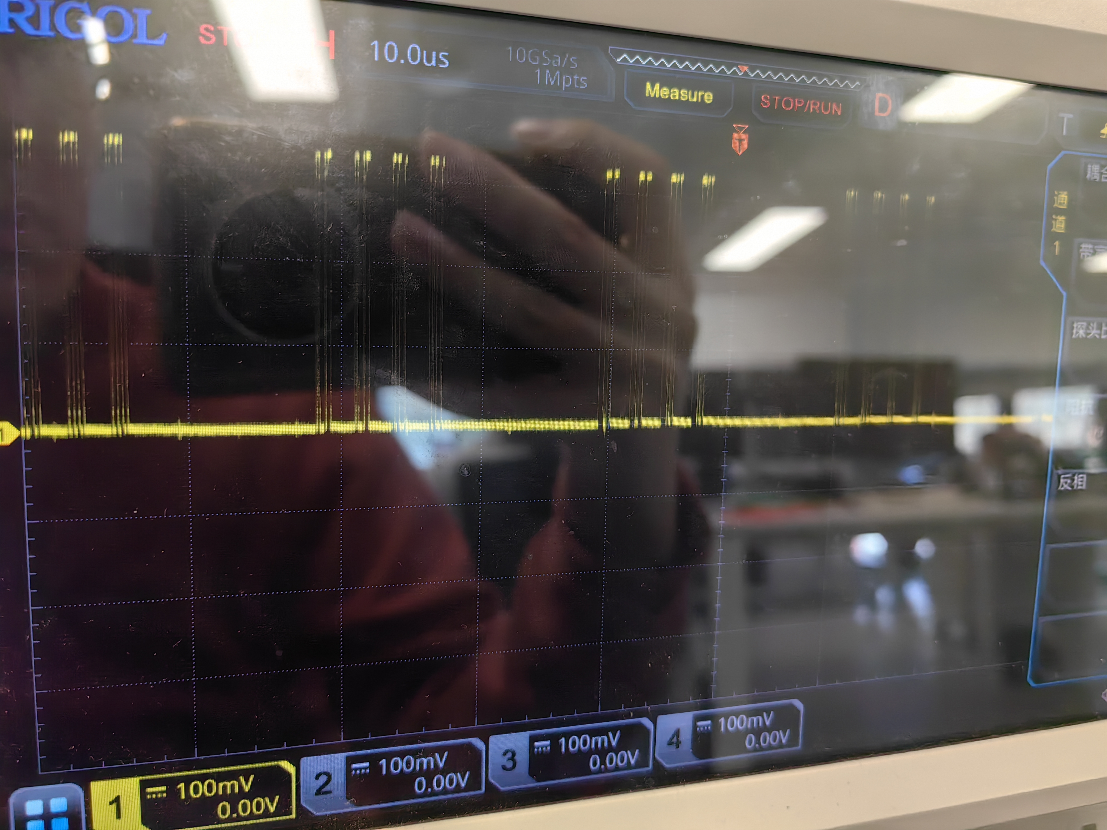
再播放静音文件，满音量40，左前通道VRMS=3.543mV，右后通道VRMS=2.985mV，两个通道信噪比都不达标
此时测量SDIN信号如下
Play the silent file again, the full volume is 40, the left front channel VRMS=3.543mV, the right rear channel VRMS=2.985mV, the signal-to-noise ratio of both channels is not up to standard.
At this time, the SDIN signal is measured as follows:
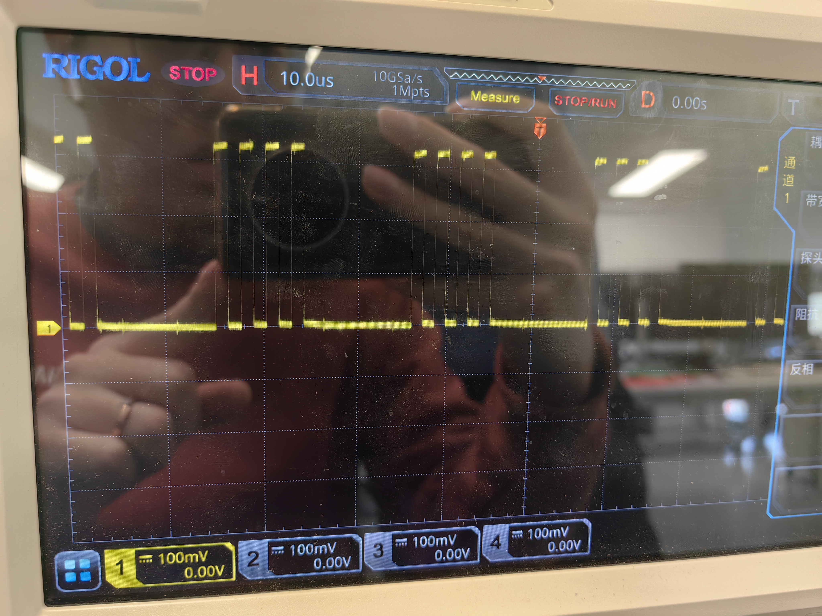
尝试暂停播放和把音量调到0也无法降低有效值，SDIN波形保持不变
修改MCU软件使DSP在播放静音文件，设置音量40时SDIN不输出波形，此时两个通道信噪比依然不达标，情况如下
Trying to pause the playback and adjust the volume to 0 cannot reduce the effective value, and the SDIN waveform remains unchanged.
Modify the MCU software so that the DSP plays a silent file. When the volume is set to 40, SDIN does not output a waveform. At this time, the signal-to-noise ratio of the two channels still does not meet the standard. The situation is as follows
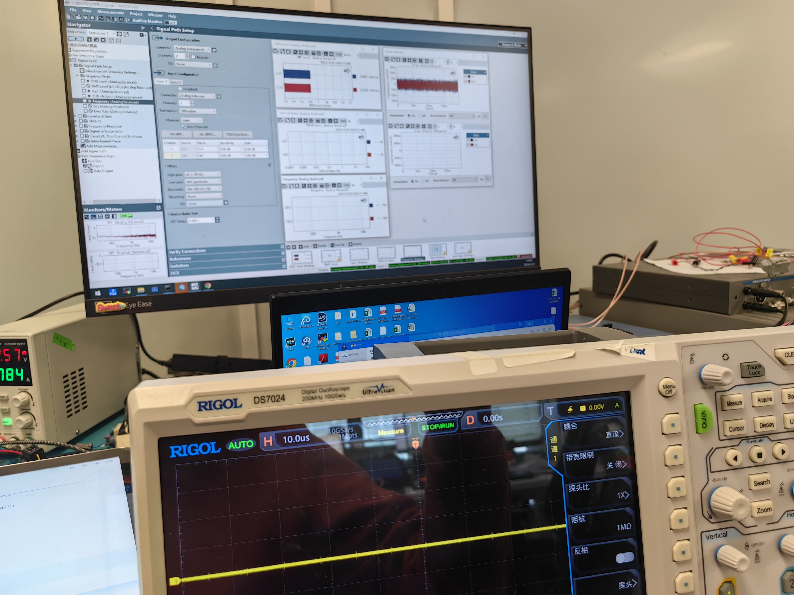
在此基础上把6424 MUTE直接接地，模拟输出情况没有任何变化

目前已知仪表提示音通过左前右前通道发出，左后右后通道开机时不发声，推测可能是播放声音后才会发生，模拟通道静音时输出VRMS仍有4mV左右
On this basis, the 6424 MUTE is directly connected to ground, and there is no change in the analog output.

It is currently known that the instrument prompt sound is emitted through the left and right front channels, and the left and rear right channels do not sound when the power is turned on. It is speculated that it may occur after the sound is played. When the analog channel is muted, the output VRMS is still about 4mV.

