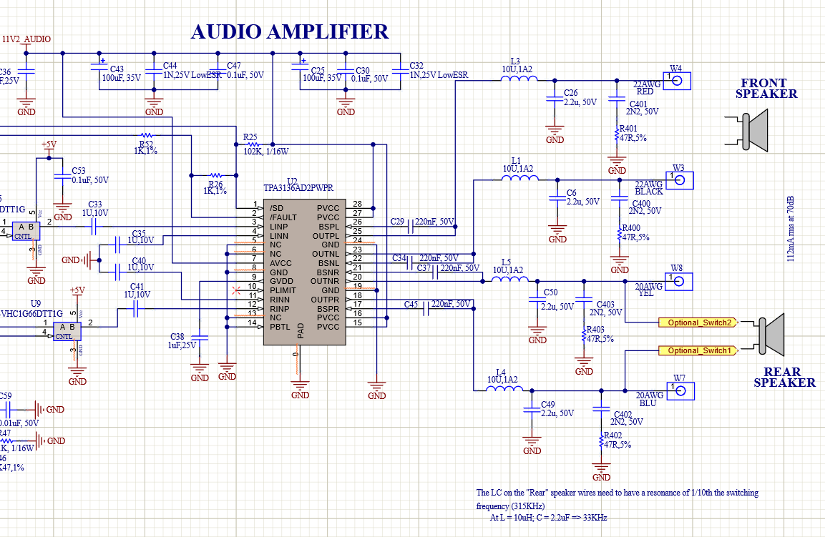

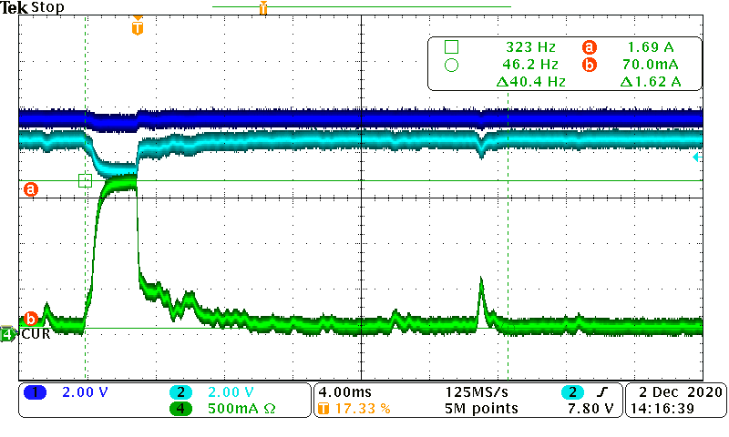

@Vsupply 9.3vdc => channels 1:Vsupply (9.3vdc) ; channel 2: VPFET drop ; Current probe of current going into PCA - Audio Clicking occurs with that 1.6Amp spike

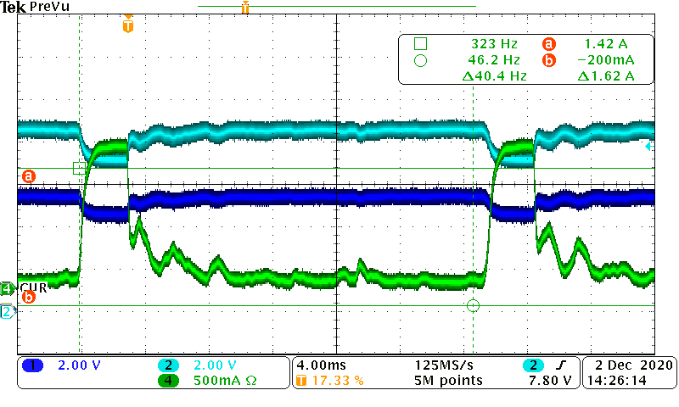

@Vsupply 9.3vdc => channels 1: /SD; channel 2: VPFET drop (PVCC) ; Current probe of current going into PCA - Audio Clicking occurs with that 1.6Amp spike

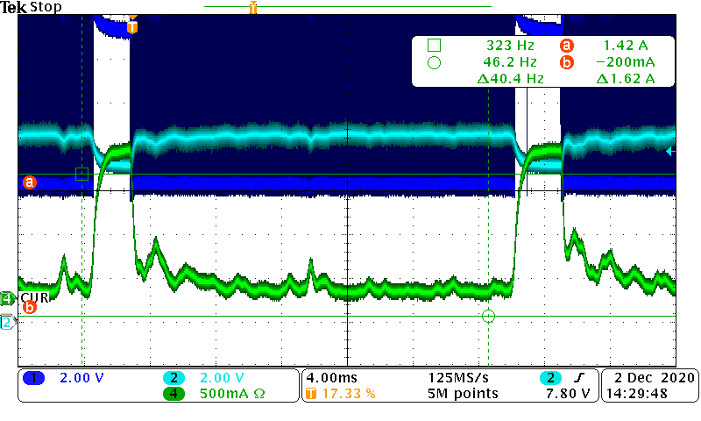

@Vsupply 9.3vdc => channels 1: AudioOutput(OUTPL); channel 2: VPFET drop (PVCC) ; Current probe of current going into PCA - Audio Clicking occurs with that 1.6Amp spike

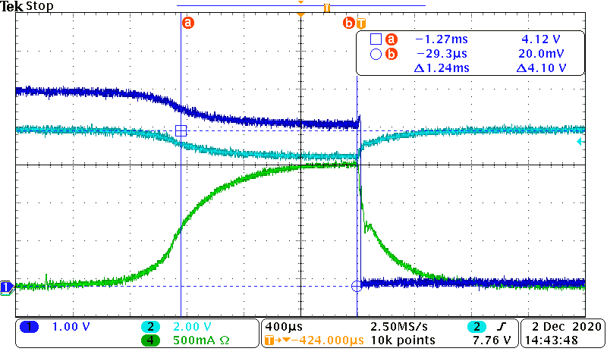

@Vsupply 9.1vdc => channels 1: /SD; channel 2: VPFET drop (PVCC) ; Current probe of current going into PCA - Audio Clicking occurs with that 1.6Amp spike

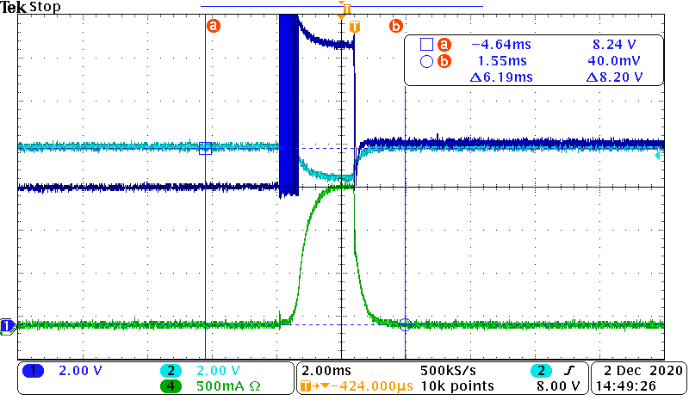

@Vsupply 9.1vdc => channels 1: OUTPL; channel 2: VPFET drop (PVCC) ; Current probe of current going into PCA - Audio Clicking occurs with that 1.6Amp spike

Note: The Audio starts after the /SD timeout (1.8sec interval)…runs for a bit then the OUTPL goes to DC level which is effectively a dead-short to the speaker which results In the 1.6A spike at which point the /SD goes LOW which shuts the output OFF and then repeats at that 1.8sec rate.

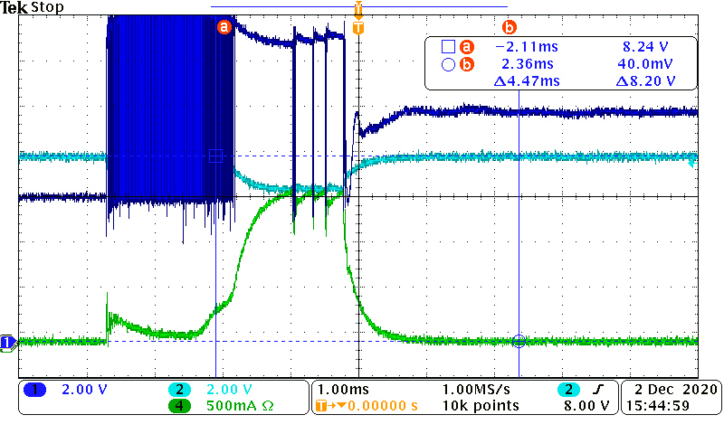

Reconnected C6 and C26 (LC filter caps). Tied to GND in center of the board

@Vsupply 9.1vdc => channels 1: OUTPL; channel 2: VPFET drop (PVCC) ; Current probe of current going into PCA - Audio Clicking occurs with that 1.6Amp spike