PCM5100EVM no output waveforms

**Test condition: Used 3-wire I2S mode, LRCK=48KHz, BCK(SCK)=3.072MHz.**

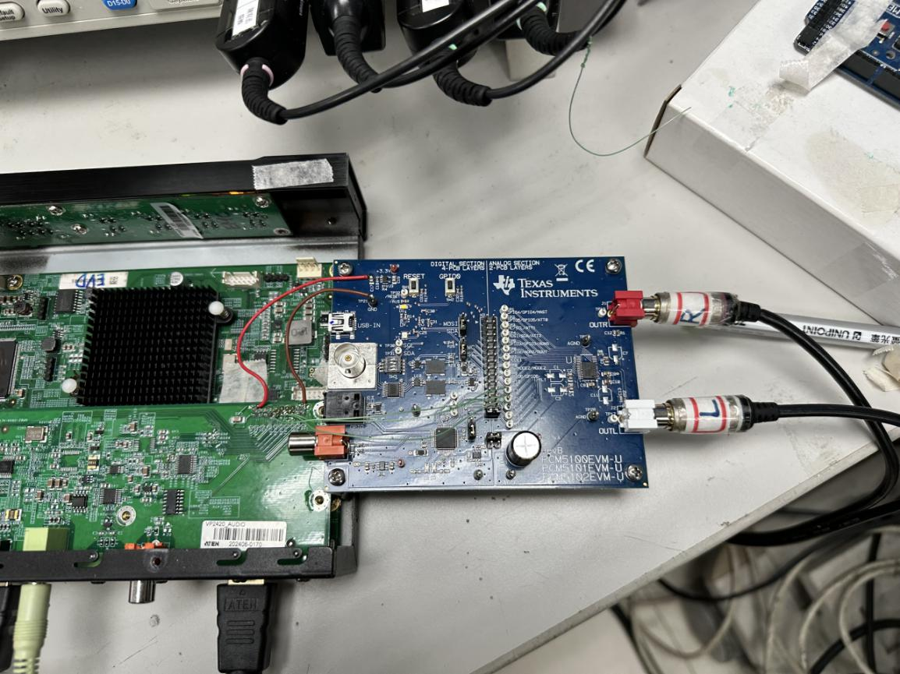

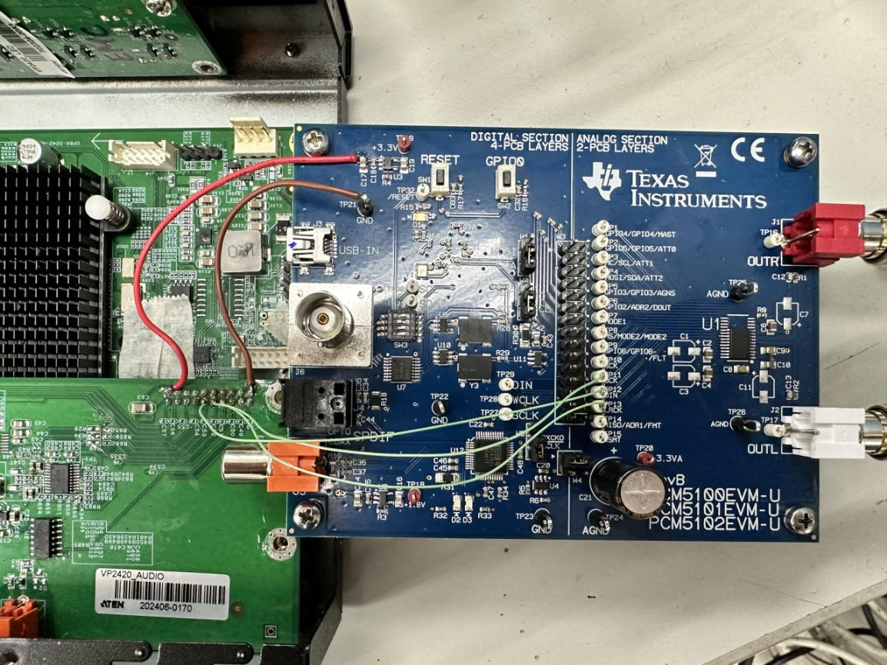

**Ch1: BCK(SCK)=3.072MHz, Ch2: DIN, Ch3: LRCK=48KHz**

Description: pin-CAPP and pin-CAPM have the 899.8kHz without normal sound.

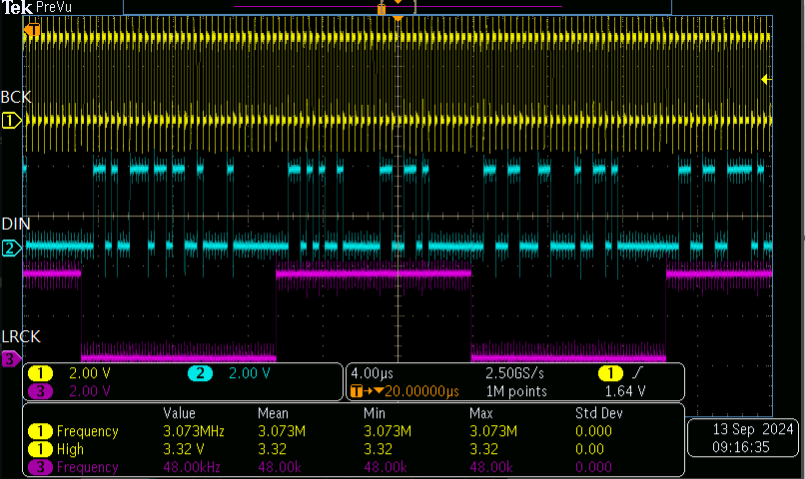

**Ch1: BCK(SCK)=3.072MHz, Ch2: DIN**

Description: pin-CAPP and pin-CAPM have the 899.8kHz without normal sound.

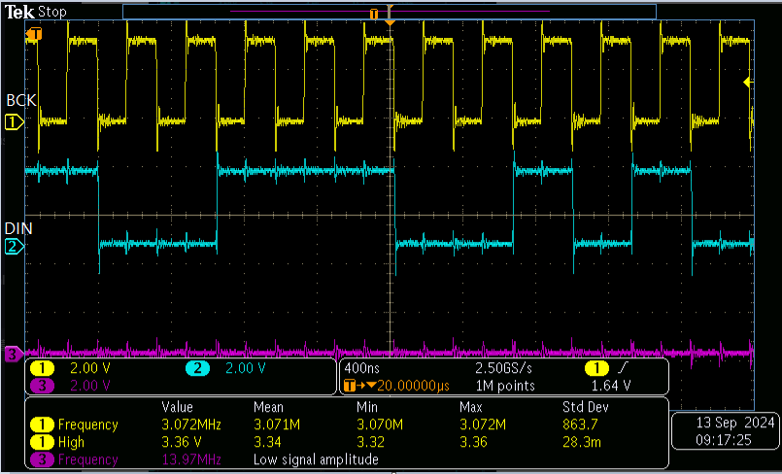

**Ch1:CAPP = 863.2kHz**

Description: pin-CAPP and pin-CAPM have the 863.2kHz without normal sound

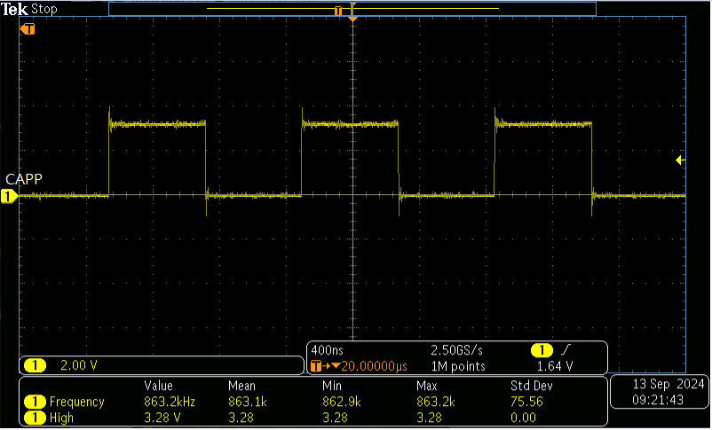

**Ch1:CAPM = 863.2kHz**

Description: pin-CAPP and pin-CAPM have the 863.2kHz without normal sound

