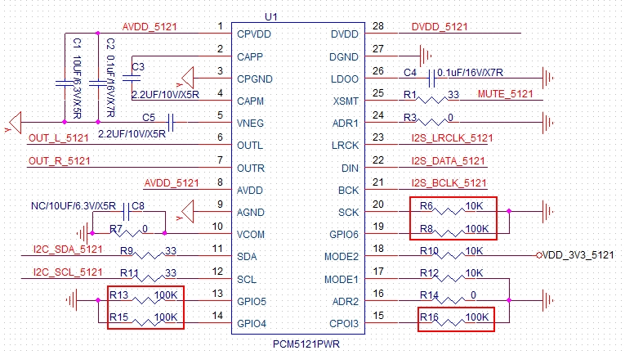

Can R13/R15/R16/R8/R6 be removed, and then connect those pins of GPIO3/4/5/6 and SCK pin to GND directly?