**PCM5142 Evaluation Module at 96kHz**

1. I initially set up the evaluation board to work the the SPDIF input with the following settings. (for this test I used an optical signal).  
   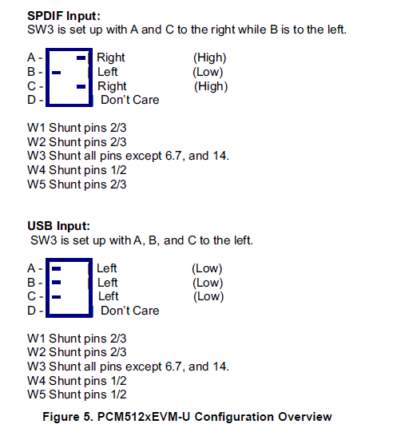
2. Connect the eval board to PC via USB
3. Open PurePath Console and go into Direct I2C access

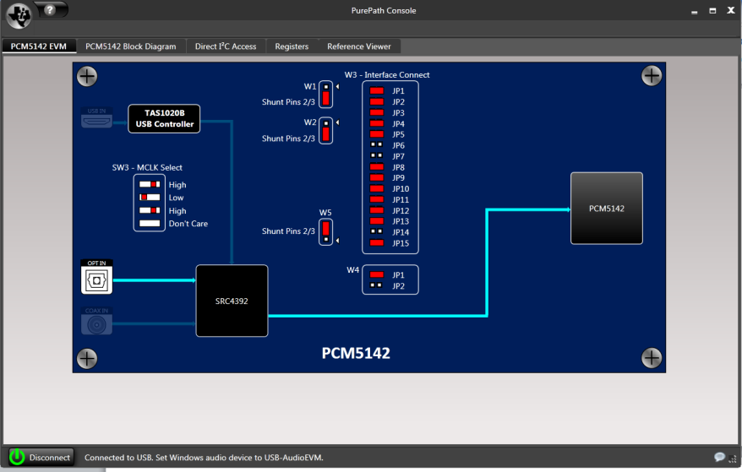

Make sure the board is connected

1. Load the following file into the Command Buffer Interface  
     
   

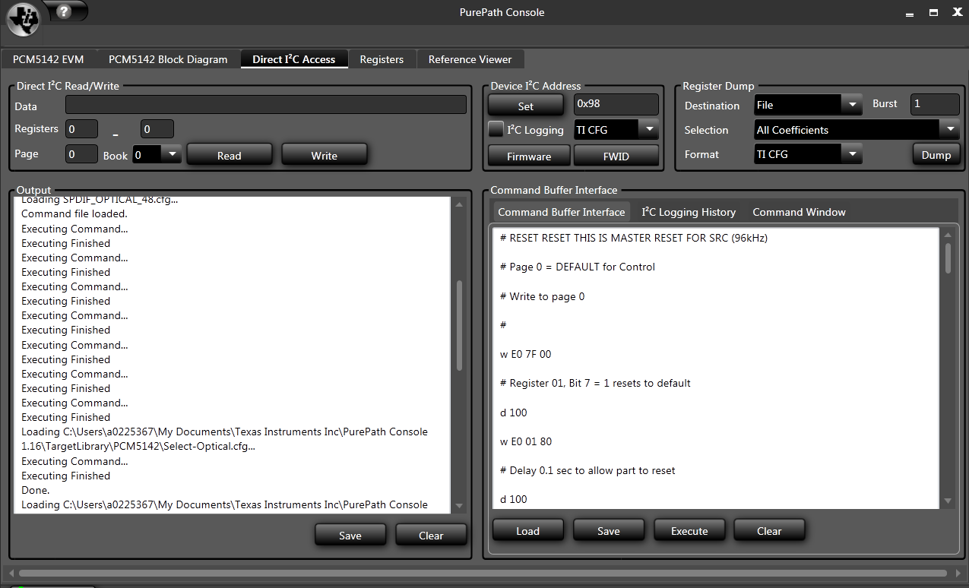

1. Click Execute
2. Open up PurePath studio.
   1. I used this setup: 
      1. This involves an input, output, and biquad (acting as a bandpass at 1kHz)

Note: The purpose of my setup was to verify the biquad was acting correctly as a bandpass filter. The PCM5142 was functioning correctly at the set sample rate if the filter functioned correctly.  
My Setup:  
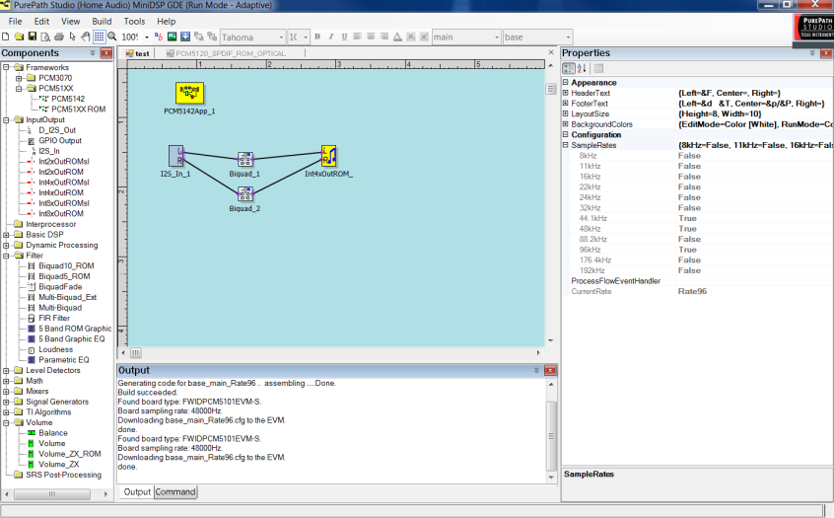

1. Set PurePath studio settings to 96kHz using the properties window  
   a. Set the 96kHz box under sample rate to true  
   b. Select Rate96 from the CurrentRate dropdown menu  
   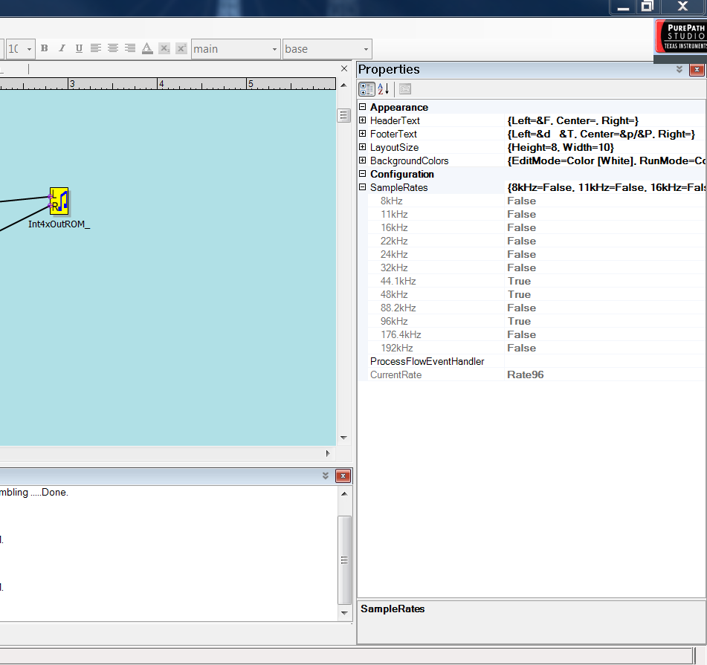
2. Build and download the code to the evaluation board

**Additional file for reference:**

The registers of my HPA5142



The device should now be operating correctly. Below is my test procedure to verify:

1. Connect an optical cable into the evaluation board
2. Connect BNC connectors to one of the eval board outputs to an analog analyzer
3. Set the sample rate of the optical signal to 96kHz
4. Sweep input frequency range (20Hz to 20kHz)
5. Ensure the biquad was operating at the correct frequency. (Verified: See plot below)

