Some analysis on the OPA134 MFB filter in PDS section 8.2
Michael Steffes, 3/18/2019
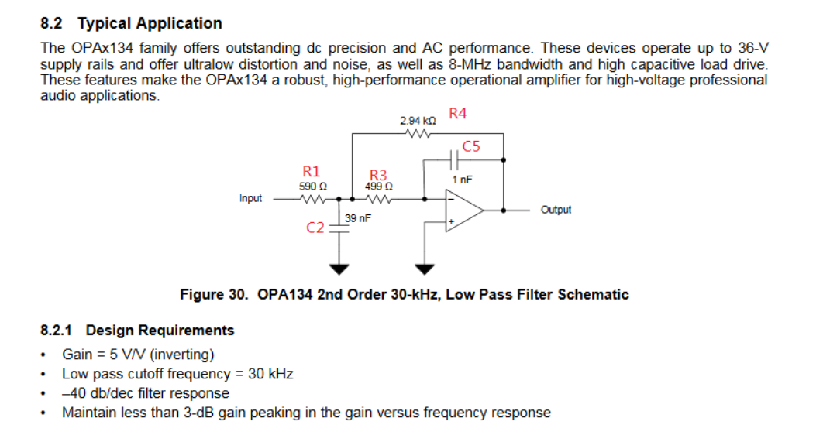

Putting those RC values into an extraction tool shows they are set for a Q=1.27 – probably trying to get a 3dB peaking,
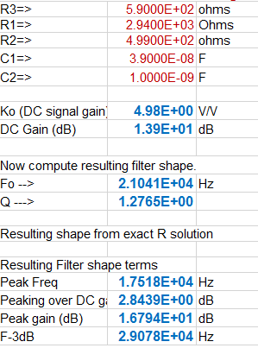

To update the design RC, the first thing is to check the model Aol – looks like 9.8Mhz GBP. PDS spec it 8Mhz, so probably using the Aol=0dB point which is not the GBP for MFB design purposes.
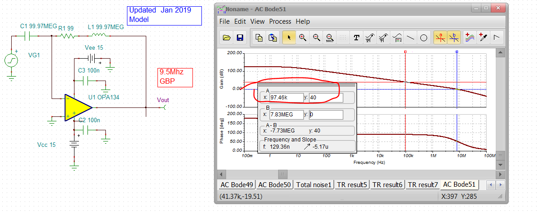

If I wanted a modern 30kHz butterworth response with the OPA134, I would do these values – the green numbers if you put into the ideal equations would match what you are trying to get. The blue ones are adjusted for GBP and closest e96 fit.
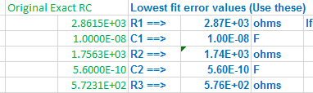
Fitting perfectly,
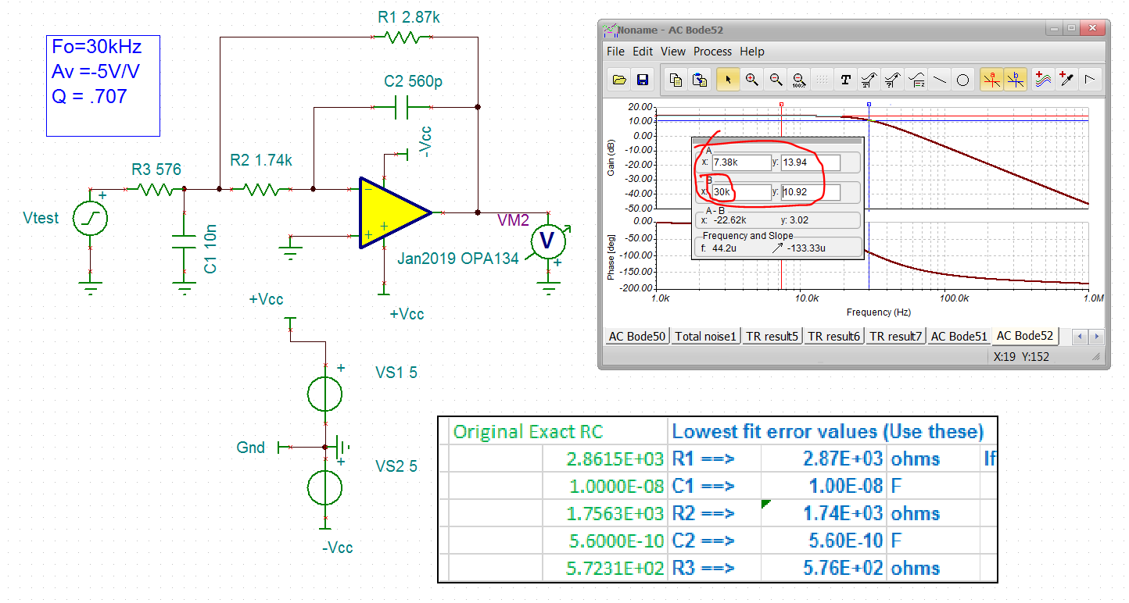

A lot of this solution flow is coming from this,
http://www.ti.com/lit/an/sboa114/sboa114.pdf
Also, the gain of 1 BW is much higher than the 7.8Mhz LG=0dB frequency due to the 53deg phase margin. This 1.7X multiplier from Fxover to F-3dB agrees with figure 4 in this article while the 1.7dB peaking is pretty close to the prediction of Fig. 2 in this article.
https://www.planetanalog.com/author.asp?section_id=3404&doc_id=565056&

