Hi TI,
We recently ordered and received a TAS2555YFEVM. I also downloaded and installed PurePath Console with the TAS2555 plugin.
I've applied power to the board and connected via USB. The device enumerates correctly as a Device called "Line". I checked the settings and they match the user guide. I wasn't sure if I should be hearing windows audio through it, but I cannot.
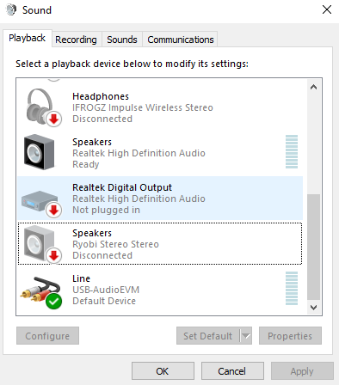
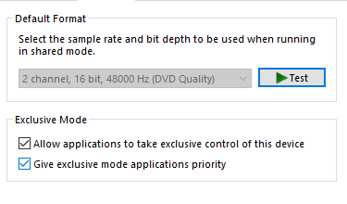
I'm able to connect to the device through PurePath Console, although it does give me a warning dialog; "You have a different version of the Device - supported version REV B. I did just order the board.
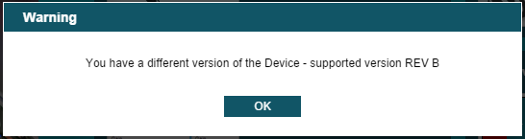
I am able to connect manually, indicated by the green circle next to TAS2555 at the lower left.
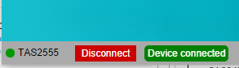
When I execute system check everything passes until the end. Checking audio playback and record fails. "Unable to playback audio".
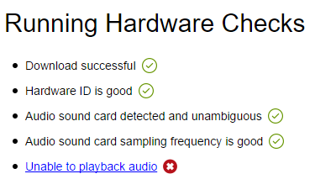
I checked the jumpers and they seem to be positioned correctly.
Any suggestions?
Thanks!

