Just to be clear, we're currently testing with a 1K audio source

1. Register configuration is as follows，other registers remain the default Settings

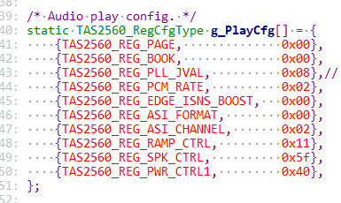

1. When L3 and L4 are resistors with 0R, use the oscilloscope clip at both ends of the horn to see the waveform as follows

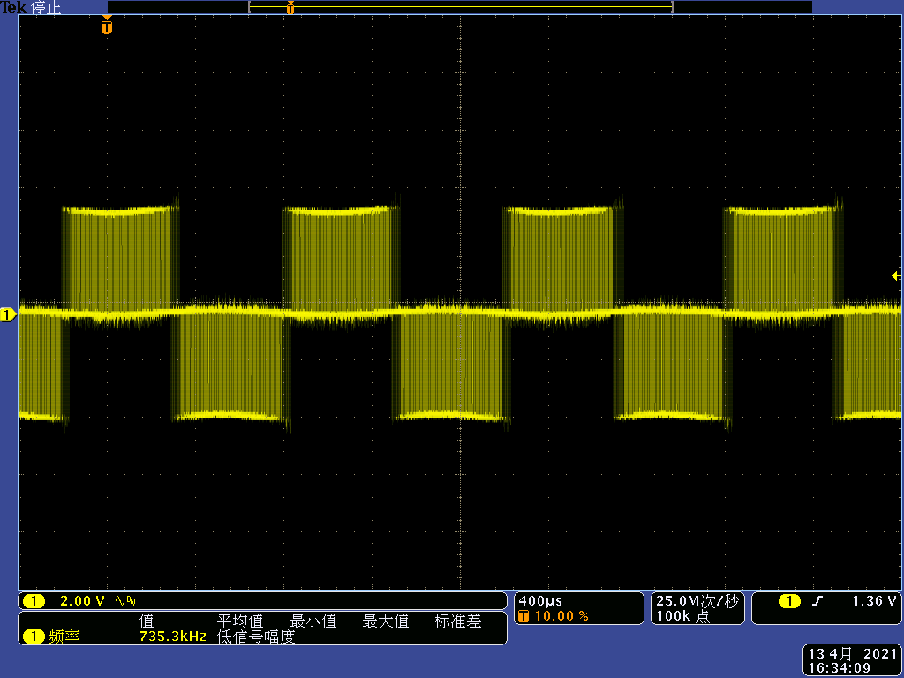

The image below is a magnified view of the image above

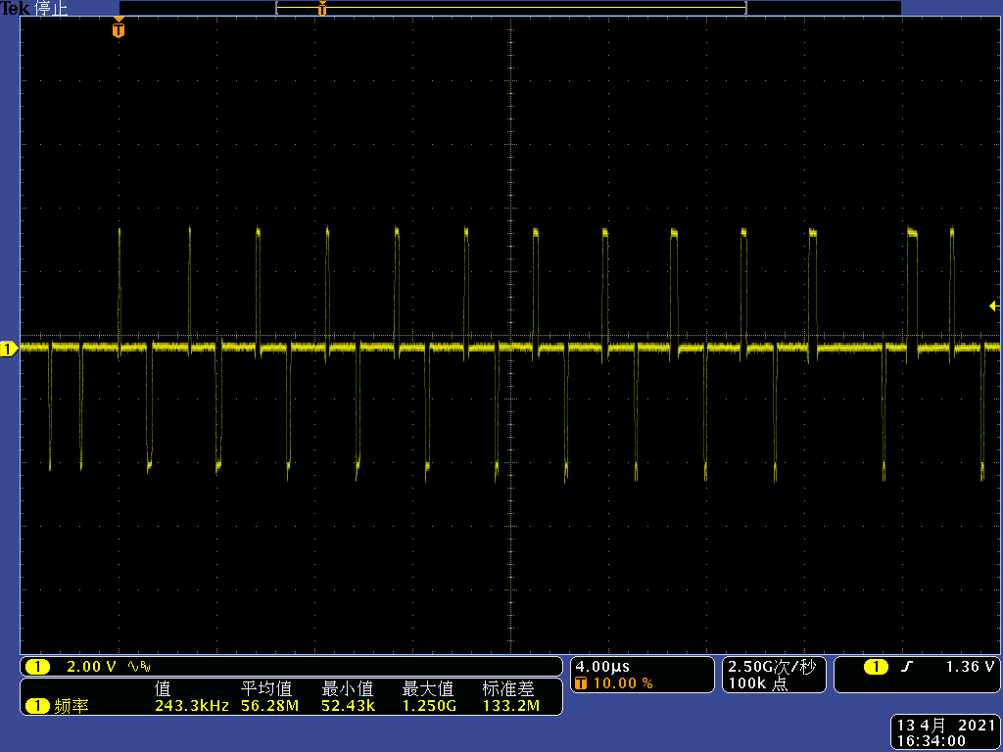

1. When L3 and L4 use 100Ω@100M,3A magnetic bead, C61 and C62 use 1NF capacitor, use the oscilloscope clamp on both ends of the horn to see the waveform as follows

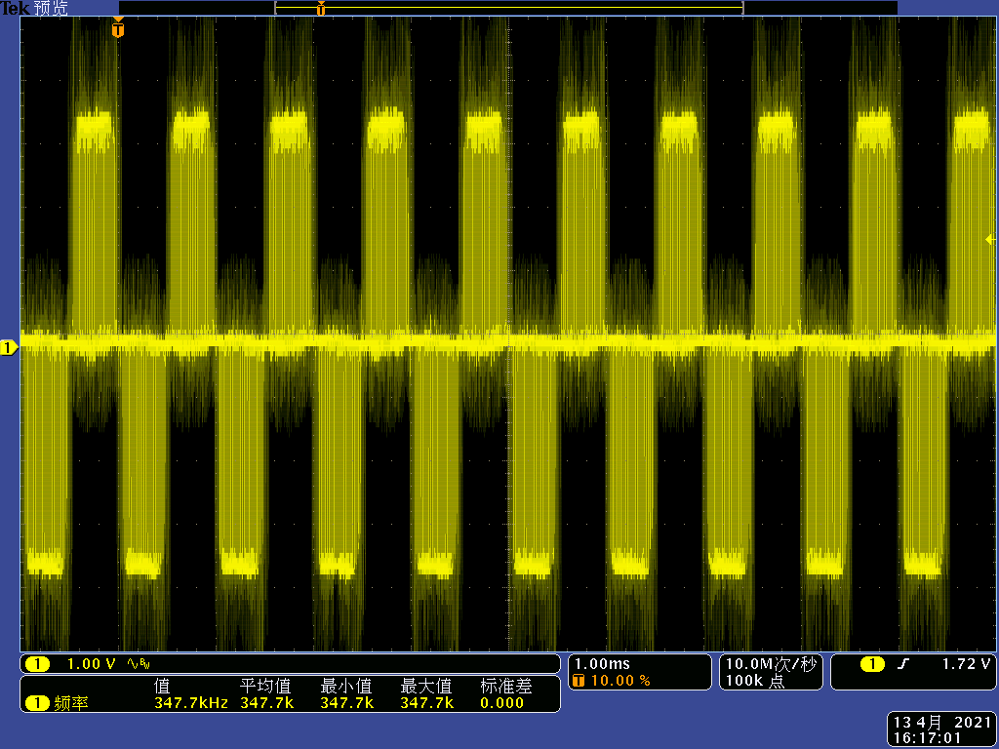

The image below is a magnified view of the image above

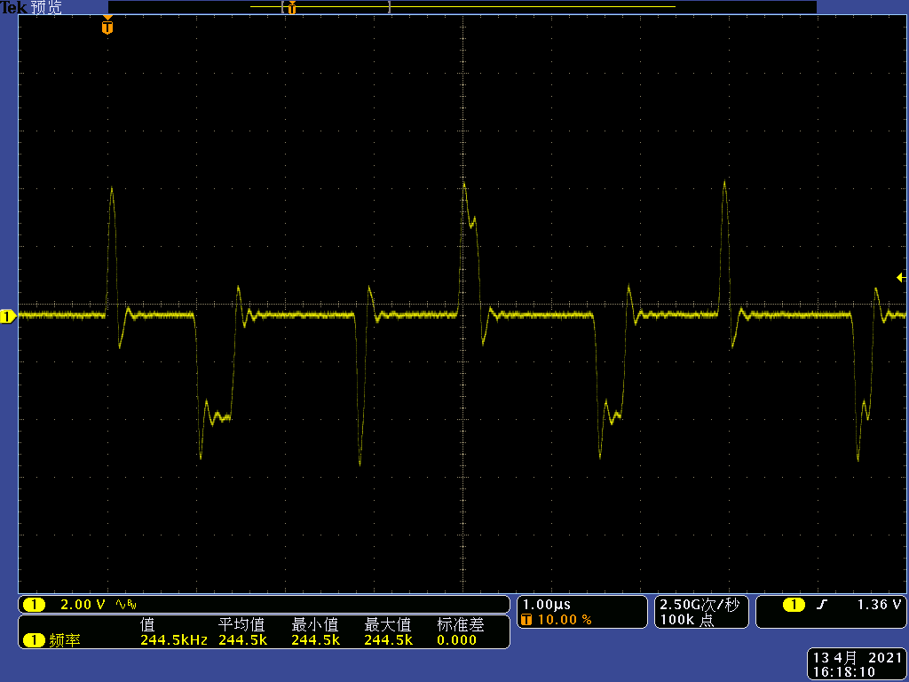

1. In addition, we would like to confirm how to configure MCLK, BCLK and WCLK.At present, the oscilloscope measurement shows that MCLK is 11.28m, BCLK is 1.41m, and WCLK is 44K.