ABSTRACT

Electromagnetic interference (EMI) is an unwanted disturbance caused in an electrical circuit by electromagnetic radiation emitted from an external source. The disturbance may interrupt, obstruct, or otherwise degrade the effective performance of the circuit.

Electromagnetic compatibility (EMC) is concerned with the unintentional generation, propagation and reception of electromagnetic energy which may cause unwanted effects such as Electromagnetic Interference (EMI) or even physical damage in operational equipment. The goal of EMC is the correct operation of different equipment in a common electromagnetic environment.

Three Key Elements of EMC

1. Emission: This is the noise that a source or aggressor produces
2. Susceptibility: This is the ability of a device or system to receive the noise from the source. This is called the victim.
3. Immunity: This is the opposite of susceptibility, as it is the ability of the victim to reject or be unperturbed by the noise from the source

The Basics

In today’s automotive audio applications, space has become a premium, and engineers are often required to minimize hardware content such as enclosures and shielding, while suppressing EMI / noise through other means such as better segregation at the circuit level. Smaller space and higher functionality require high-density PCBs, and the use of smaller packaging on small PCB design rules makes EMI even more of a concern. EMI encompasses two aspects. Emissions refer to the scope to which equipment generates radiated noise. Susceptibility is the scope to which equipment is affected by emissions generated from other electromagnetic waves. The degree to which a designer controls unintended emissions may make the task of susceptibility easier. Emissions are generally classified as radiated and conducted emissions.

Radiated emissions leave a circuit board, trace, or wire, and propagate through the air in the form of electromagnetic waves to interfere with a nearby receiver. It is important to note that a "receiver" refers to any circuit whose operation can be affected adversely by the reception of electromagnetic energy – such as a PCB trace or even the lead of an IC. Conducted emissions refer to energy which escapes, or is conducted, out of a circuit through wires or cables. Conducted emissions may cause problems directly or may present themselves as radiated emissions.

Layout Guidelines

The following few sections of this document are going to focus specifically on the application of the TAS6424-Q1 2.1-MHz Digital Input 4-Channel Automotive Class-D Audio Amplifier ([SLOS870A](http://www.ti.com/lit/ds/symlink/tas6424-q1.pdf)). The TAS6424-Q1 device is a Four-channel digital input Class-D audio amplifier designed for use in automotive head units and external amplifier modules. The device provides four channels at 27 W into 4 Ω at 10% THD+N and 45 W into 2 Ω at 10% THD+N from a 14.4-V supply and 75 W into 4 Ω at 10% THD+N from a 25-V supply. The Class-D topology dramatically improves efficiency over traditional linear amplifier solutions. The output switching frequency can be set either above the AM band, which eliminates the AM-band interference and reduces output filtering and cost, or below AM band to optimize efficiency.

The pinout of the TAS6424-Q1 was selected to provide flow through layout with all high-power connections on the right side, and all low-power signals and supply decoupling on the left side. The device associated EVM, [TAS6424Q1EVM](http://www.ti.com/tool/tas6424q1evm), is also represented in the datasheets application example and was designed with EMI in mind.

Figure 1 shows the area for the components in the application example (also see the [Typical Applications section of the datasheet](http://www.ti.com/lit/ds/symlink/tas6424-q1.pdf)).

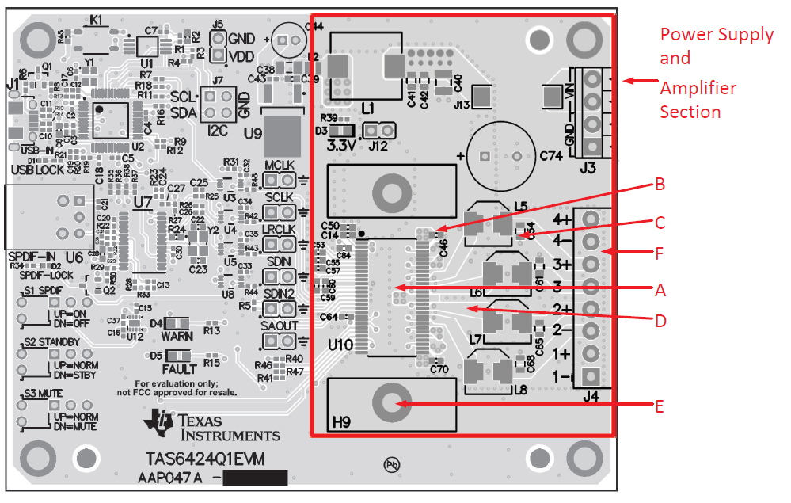

Figure 1

The TAS6424-Q1 EVM uses a four-layer PCB, where the copper thickness was selected as 70μm to specifically optimize power loss. Further, the small value of the output filter was selected to enable a smaller design size and, in this case, the low height of the inductor enables double-sided mounting.

The following recommendations are intended to highlight the key areas of influence in executing a sound design for good EMI performance. Further, the EVM PCB shown in Figure 1 is the actual basis for these layout guidelines.

**General Electrical Connection of Thermal pad and Heat Sink**

In the case of the Figure 1 PCB, the TAS6424-Q1 device is packaged within a 56-pin HSSOP (DKQ) PowerPAD package with the exposed thermal pad up. With the DKQ package, the heat sink is connected directly to the thermal pad of the TAS6424-Q1, all of which must also be connected to ground. This thermal pad and heat sink combination must not be connected to any other electrical node other than ground.

**General Device and PCB Design for EMI Considerations**

Automotive-level EMI performance depends on both careful integrated circuit design and good system-level design. It is very important that controlling sources of electromagnetic interference (EMI) was a major consideration in all aspects of the system design. The device design has minimal parasitic inductances because of the short leads on the package which reduces the EMI that results from current passing from the die to the system PCB. Further, each channel also operates at a different phase and the design also incorporates circuitry that optimizes output transitions that can cause EMI.

From a PCB design perspective in optimizing EMI performance, a solid ground layer plane is recommended in all designs, as a good reference for a PCB design the fulfills the CISPR25 level 5 requirements, please reference the [TAS6424-Q1 EVM layout](http://www.ti.com/lit/ug/slou453/slou453.pdf).

**General Guidelines as Related to the Design TAS6424-Q1 EVM**

The EVM layout is optimized for both low noise and EMC performance. The TAS6424-Q1 device itself has an exposed thermal pad that faces up, away from the PCB, and so the layout must usually consider an external heat sink.

1. First and foremost, always ask the Audio Applications engineering team to review your schematic and layout as early in the design process as possible.
2. Try to always use a 4-layer PCB design
3. Remember to consider all traces that are buried in the inner layers
4. Please ensure that any HF filter capacitors are as close to the output connector as possible
5. Try to minimize as much as possible the number of signal vias on the board, while also ensuring that you have very good ground vias on the board
6. Try to avoid crossing traces as much as possible
7. Using a ground plane, A (refer to Figure 1), on the same side as the device pins helps reduce EMI by providing a very-low loop impedance for any high-frequency switching current.
8. Note that the decoupling capacitors on PVDD, B, are very close to the device with the ground return close to the ground pins.
9. Also note that the ground connections for the capacitors in the LC filter, C, have a direct path back to the device and also the ground return for each channel is the shared. This direct path allows for improved common mode EMI rejection.
10. Please ensure that the traces from the output pins to the inductors, D, have the shortest trace possible to allow for the smallest loop of large switching currents.
11. Regarding the heat-sink, ensure that the heat-sink mounting screws, E, are as close to the device as possible to keep the loop short from the package to ground.
12. Ensuring that there are many vias, F, stitching together the ground planes can help to create a shield to isolate the amplifier and power supply.
13. When conducting EMI testing on a 2.1MHz switching amplifier, like the TAS6424-Q1, please ensure that the test board is enclosed in grounded chassis just as it would be in an actual application.
14. Please use the attached schematic and layout check-list as a general reference when working through your final design and for component completeness.

**Design Schematic-Layout Checklist**

**Write down how many devices**

* **U1 🡪 Ux counts = ______**
* **LDO counts = ______**
* **Switching Regulators = ________**
* **Number of connectors =________**

**LDO#1 Check**

* **LDO#1-total current-enough? = ______**
* **Resistors for correct voltage setting if not fixed LDO =_______**
* **Input capacitance enough =________**
* **Output capacitance enough =_______**
* **Decoupling caps =_______**
* **Need voltage supervisor or POR? = ________**
* **POR-reset assertion high or low? Correct polarity? =______**
* **Power dissipated ((Vin-Vout)*Imax) =_______**
* **Enough area for heat dissipation? =_________**
* **Trace wide enough to carry current =________**
* **VIAS for thermal relief go through all of the layers? =______**
* **Cut and paste this section with the above check boxes for the numbers of LDO written in the first section**

**Switching Regulators (SR#1) Check**

* **SR#1-total current-enough? = ______**
* **Choosing output filter with enough current rating on L = ______**
* **Make sure output filter LC cut-off frequency is correct = ________**
* **Input capacitance enough =________**
* **Output capacitance enough =_______**
* **Decoupling caps =_______**
* **SR#1 switching frequency =_______**
* **Class-D amp switching frequencies =___________ _____________ _______________**
* **Other SR switching frequencies =___________ _____________ _____________**
* **Make sure switching frequency is at least 50kHz away from class-D amp and other SR =________**
* **Follow recommended layout from SR data sheet =_______**
* **Isolate ground return =______**
* **Enough area for heat dissipation? =_________**
* **Trace wide enough to carry current =________**
* **VIAS for thermal relief goes through all of the layers? =______**
* **Cut and paste this section with the above check boxes for the numbers of SR written in the first section**

**I2C bus check**

* **SDA from TAS1020 goes to SDA of U1-UXx = ______**
* **SCL from TAS1020 goes to SCL of U1-Ux = ______**
* **SDA from connector goes to SDA of U1-Ux =________**
* **SCL from connector goes to SCL of U1-Ux =________**
* **Pull-up resistor for SDA is 10kOhm =_________**
* **Pull-up resistor for SCL is 10kOhm =______**
* **If SDA connected to the mother board, still need 10kOhm resistor =________**
* **If SCL connected to the mother board, still need 10kOhm resistor =________**
* **Don’t need series resistor on SDC and SCL =______________**
* **If there are several devices with I2C control on the same board, make sure they don’t have the same I2C address. Write down their I2C addresses =____________________________**

**I2S bus check**

* **MCLK (SCLK-System Clock) from connector goes to MCLK (SCLK) of U1-UXx = ______**
* **SCLK (BCLK-Bit Clock) from connector goes to SCLK (BCLK) of U1-Ux = ______**
* **LRCLK from connector goes to LRCLK of U1-Ux =________**
* **SDIN from connector goes to SDIN of U1-Ux =________**
* **MCLK from master device goes to MCLK of U1-Ux =_________**
* **SCLK (BCLK-Bit Clock) from master device goes to SCLK (BCLK) of U1-Ux = ______**
* **LRCLK from master device goes to LRCLK of U1-Ux =________**
* **SDIN from master device goes to SDIN of U1-Ux =________**
* **Series resistor on MCLK from master device goes to MCLK is 50ohm =_________**
* **Series resistor on SCLK (BCLK-Bit Clock) from master device goes to SCLK (BCLK) is 50ohm = ______**
* **Series resistor on LRCLK from master device goes to LRCLK is 50ohm =________**
* **Series resistor on SDIN from master device goes to SDIN is 50ohm =________**
* **Good ground separation between clocks =__________________________________________**
* **Short distances between master and slave devices or connector and slave devices =____________________**
* **If more than 2-layer, burry the signals in inner layer (signal layer) =___________________**
* **If only 2-layer, try to route on one layer or minimize vias on clock signals =________________________**

**Switches, relays and muxes Check**

* **DPDT switch #1. Make sure label on/off, enable/disable, etc have the correct logic =___________**
* **Write down all the DPDT switches and check the above =_____________________________________**
* **Write down all the relays and check the above =___________________________________________**
* **2-1, 3-1, 4-2, etc. … write down each selection of muxes and check the correct assertion =___________________________________**
* **2-1, 3-1, 4-2, etc. … write down each selection of muxes and check the correct routing =___________________________________**

**LEDs Check**

* **Make sure the polarity is correct =___________**
* **Write down all the LEDs and check the above =_____________________________________**

**Input Connectors Check**

* **Is the correct connector selected =_____________**
* **Power and ground pins are connected to the correct pins of the devices =___________**
* **Pins can handle input current =_____________________________________**
* **Signals are connected to the correct pins on the devices =___________________________________**
* **Signals are connected to the correct pins on other board or external inputs =___________________________________**
* **Connectors have enough ground pins =___________________________________**
* **Check for signal swapping =__________________________**
* **Check for orientation =_____________________**
* **3.5mm jack, check for L&R pins =______________**

**Output Connectors Check**

* **Is the correct connector selected =________________**
* **Speaker output pins are connected to the correct pins of the devices =___________**
* **Pins can handle output current =_____________________________________**
* **Signals are connected to the correct pins on the devices =___________________________________**
* **Signals are connected to the correct pins on other board or external outputs =___________________________________**
* **Connectors have enough ground pins =___________________________________**
* **Check for signal swapping =__________________________**
* **Check for orientation =_____________________**
* **3.5mm jack, check for L&R pins =______________**

**Device #1 Check**

* **Power and ground pins are connected to the correct polarity =___________**
* **Traces can handle current =_____________________________________**
* **Signals are connected to the correct pins on the devices =___________________________________**
* **Signals are connected to the correct pins on connectors =___________________________________**
* **Pad down devices have ground vias show through the other layers =___________________________________**
* **Check for signal swapping =__________________________**
* **Check for logic pins with correct assertion =_____________________**
* **Check for correct pull-up/down on the discrete pins =____________________**
* **Thermal vias show through all the layers =____________**
* **Cut and paste this section with the above check boxes for the numbers of devices written in the first section**