1 : How do I select resistance ?

V-SYNC and H-SYNC connector 806 ohm and 1.4k ohm Resistance in spec page 15

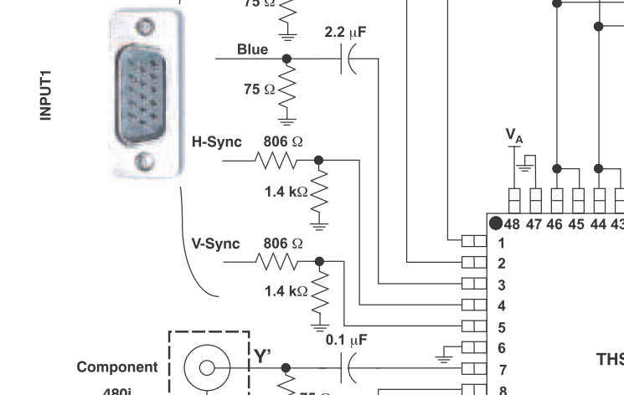

But EVM use 100 ohm and 75 ohm Resistance

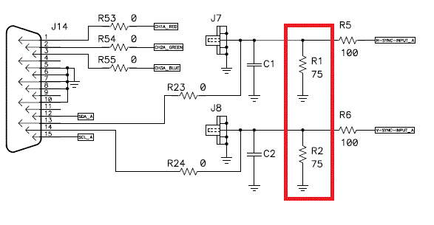

2 : How to use Pin14 to adjust H-SYNC / V-SYNC threshold ? 