TLV320AIC3110 开启HPL&HPR环出导致ADC录音噪声

1. 主SOC上面挂载1颗TLV芯片作为录音 & 环出功能；

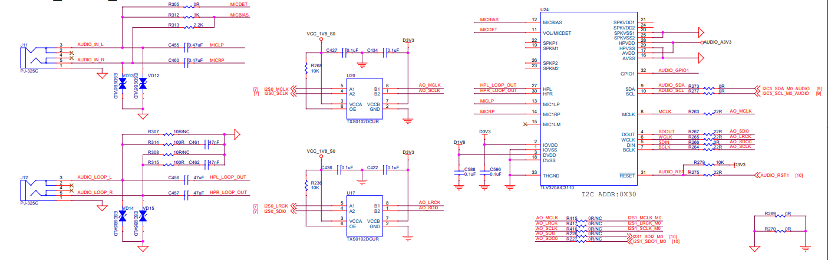

1. 使用的kernel版本为5.10.66 aarch64 GNU/Linux。
2. 使用的时钟频率(MCLK)为12000000。
3. 用kernel内置的tlv320aic31xx驱动调试单独录音（ADC）、环出（LOOP）功能正常。但是如果同时开启录音和环出，则环出会对录音功能产生影响，ADC录音出来的音频文件有很大的噪声。麻烦帮忙分析原因。下面是2种情况下的寄存器值（page0, page1）：
4. 单独开启录音功能（附件test_ok.wav），环出关闭

amixer -c 3 cget name='HP Left Switch'

numid=17,iface=MIXER,name='HP Left Switch'

; type=BOOLEAN,access=rw------,values=1

: values=off

page0:

No size specified (using byte-data access)

0 1 2 3 4 5 6 7 8 9 a b c d e f 0123456789abcdef

00: 00 00 01 56 03 11 08 00 00 00 00 08 02 00 80 80 ..?V???....??.??

10: 08 00 08 02 80 80 04 00 00 00 01 00 00 00 08 00 ?.?????...?...?.

20: 00 00 00 00 00 00 00 0a 00 00 00 00 00 00 00 00 .......?........

30: 00 00 00 02 32 12 03 02 02 11 10 00 01 08 00 14 ...?2??????.??.?

40: 0c 00 00 00 6f 38 00 00 00 00 00 ee 10 d8 7e e3 ?...o8.....???~?

50: 00 00 00 00 00 00 00 00 7f 00 00 00 00 00 00 00 ........?.......

60: 00 00 00 00 00 00 00 00 00 00 00 00 00 00 00 00 ................

70: 00 00 00 00 00 00 00 00 00 00 00 00 00 00 00 00 ................

80: 00 00 00 00 00 00 00 00 00 00 00 00 00 00 00 00 ................

90: 00 00 00 00 00 00 00 00 00 00 00 00 00 00 00 00 ................

a0: 00 00 00 00 00 00 00 00 00 00 00 00 00 00 00 00 ................

b0: 00 00 00 00 00 00 00 00 00 00 00 00 00 00 00 00 ................

c0: 00 00 00 00 00 00 00 00 00 00 00 00 00 00 00 00 ................

d0: 00 00 00 00 00 00 00 00 00 00 00 00 00 00 00 00 ................

e0: 00 00 00 00 00 00 00 00 00 00 00 00 00 00 00 00 ................

f0: 00 00 00 00 00 00 00 00 00 00 00 00 00 00 00 00 ................

page1:

No size specified (using byte-data access)

0 1 2 3 4 5 6 7 8 9 a b c d e f 0123456789abcdef

00: 01 00 00 00 00 00 00 00 00 00 00 00 00 00 00 00 ?...............

10: 00 00 00 00 00 00 00 00 00 00 00 00 00 00 00 16 ...............?

20: 06 3e 00 32 00 00 7f 7f 06 06 00 00 20 86 02 80 ?>.2..????.. ???

30: a0 00 00 00 00 00 00 00 00 00 00 00 00 00 00 00 ?...............

40: 00 00 00 00 00 00 00 00 00 00 00 00 00 00 00 00 ................

50: 00 00 00 00 00 00 00 00 00 00 00 00 00 00 00 00 ................

60: 00 00 00 00 00 00 00 00 00 00 00 00 00 00 00 00 ................

70: 00 00 00 00 00 00 00 00 00 00 00 00 00 00 00 00 ................

80: 00 00 00 00 00 00 00 00 00 00 00 00 00 00 00 00 ................

90: 00 00 00 00 00 00 00 00 00 00 00 00 00 00 00 00 ................

a0: 00 00 00 00 00 00 00 00 00 00 00 00 00 00 00 00 ................

b0: 00 00 00 00 00 00 00 00 00 00 00 00 00 00 00 00 ................

c0: 00 00 00 00 00 00 00 00 00 00 00 00 00 00 00 00 ................

d0: 00 00 00 00 00 00 00 00 00 00 00 00 00 00 00 00 ................

e0: 00 00 00 00 00 00 00 00 00 00 00 00 00 00 00 00 ................

f0: 00 00 00 00 00 00 00 00 00 00 00 00 00 00 00 00 ................

1. 同时开启录音和环出功能(附件test_err.wav是录音文件)

amixer -c 3 cget name='HP Left Switch'

numid=17,iface=MIXER,name='HP Left Switch'

; type=BOOLEAN,access=rw------,values=1

: values=on

page0:

No size specified (using byte-data access)

0 1 2 3 4 5 6 7 8 9 a b c d e f 0123456789abcdef

00: 00 00 01 56 03 91 08 00 00 00 00 88 82 00 80 80 ..?V???....??.??

10: 08 00 88 82 80 80 04 00 00 00 01 00 00 00 88 00 ?.?????...?...?.

20: 00 00 00 00 00 22 00 00 00 00 00 00 00 00 00 00 ....."..........

30: 00 00 00 02 32 12 03 02 02 11 10 00 01 08 00 14 ...?2??????.??.?

40: 0c 00 00 00 6f 38 00 00 00 00 00 ee 10 d8 7e e3 ?...o8.....???~?

50: 00 00 00 00 00 00 00 00 7f 00 00 00 00 00 00 00 ........?.......

60: 00 00 00 00 00 00 00 00 00 00 00 00 00 00 00 00 ................

70: 00 00 00 00 00 00 00 00 00 00 00 00 00 00 00 00 ................

80: 00 00 00 00 00 00 00 00 00 00 00 00 00 00 00 00 ................

90: 00 00 00 00 00 00 00 00 00 00 00 00 00 00 00 00 ................

a0: 00 00 00 00 00 00 00 00 00 00 00 00 00 00 00 00 ................

b0: 00 00 00 00 00 00 00 00 00 00 00 00 00 00 00 00 ................

c0: 00 00 00 00 00 00 00 00 00 00 00 00 00 00 00 00 ................

d0: 00 00 00 00 00 00 00 00 00 00 00 00 00 00 00 00 ................

e0: 00 00 00 00 00 00 00 00 00 00 00 00 00 00 00 00 ................

f0: 00 00 00 00 00 00 00 00 00 00 00 00 00 00 00 00 ................

page1:

No size specified (using byte-data access)

0 1 2 3 4 5 6 7 8 9 a b c d e f 0123456789abcdef

00: 01 00 00 00 00 00 00 00 00 00 00 00 00 00 00 00 ?...............

10: 00 00 00 00 00 00 00 00 00 00 00 00 00 00 00 d6 ...............?

20: 06 3e 00 32 80 80 7f 7f 07 07 00 00 20 86 02 80 ?>.2??????.. ???

30: a0 00 00 00 00 00 00 00 00 00 00 00 00 00 00 00 ?...............

40: 00 00 00 00 00 00 00 00 00 00 00 00 00 00 00 00 ................

50: 00 00 00 00 00 00 00 00 00 00 00 00 00 00 00 00 ................

60: 00 00 00 00 00 00 00 00 00 00 00 00 00 00 00 00 ................

70: 00 00 00 00 00 00 00 00 00 00 00 00 00 00 00 00 ................

80: 00 00 00 00 00 00 00 00 00 00 00 00 00 00 00 00 ................

90: 00 00 00 00 00 00 00 00 00 00 00 00 00 00 00 00 ................

a0: 00 00 00 00 00 00 00 00 00 00 00 00 00 00 00 00 ................

b0: 00 00 00 00 00 00 00 00 00 00 00 00 00 00 00 00 ................

c0: 00 00 00 00 00 00 00 00 00 00 00 00 00 00 00 00 ................

d0: 00 00 00 00 00 00 00 00 00 00 00 00 00 00 00 00 ................

e0: 00 00 00 00 00 00 00 00 00 00 00 00 00 00 00 00 ................

f0: 00 00 00 00 00 00 00 00 00 00 00 00 00 00 00 00 ................