When the customer is debugging the TPA2038D1, the 5v power supply can be used to drive the 4Ω horn, and the output power can be normally produced. When driving the 8Ω horn, the output power is very low, help to look at the problem.
- When driving the 4Ω horn, the gain is 6db, the current waveform is as follows, and the average current is 250ma.
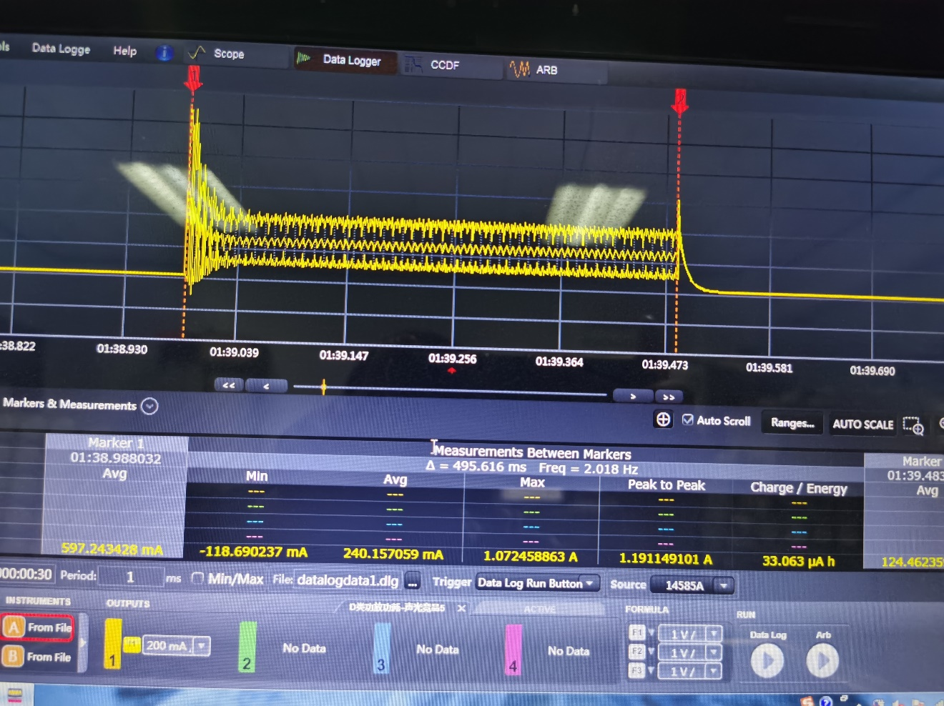

- When driving the 8Ω horn, the output power is still very small, and the average current is only 50ma.
First, I adjusted the gain to 12db, then the gain to 6db at 4Ω, and the output power did not reach the power at 4Ω. Then I reduced RIN and increased CIN, but neither of them had any effect.
I want the average current of the op amp to reach 180ma.
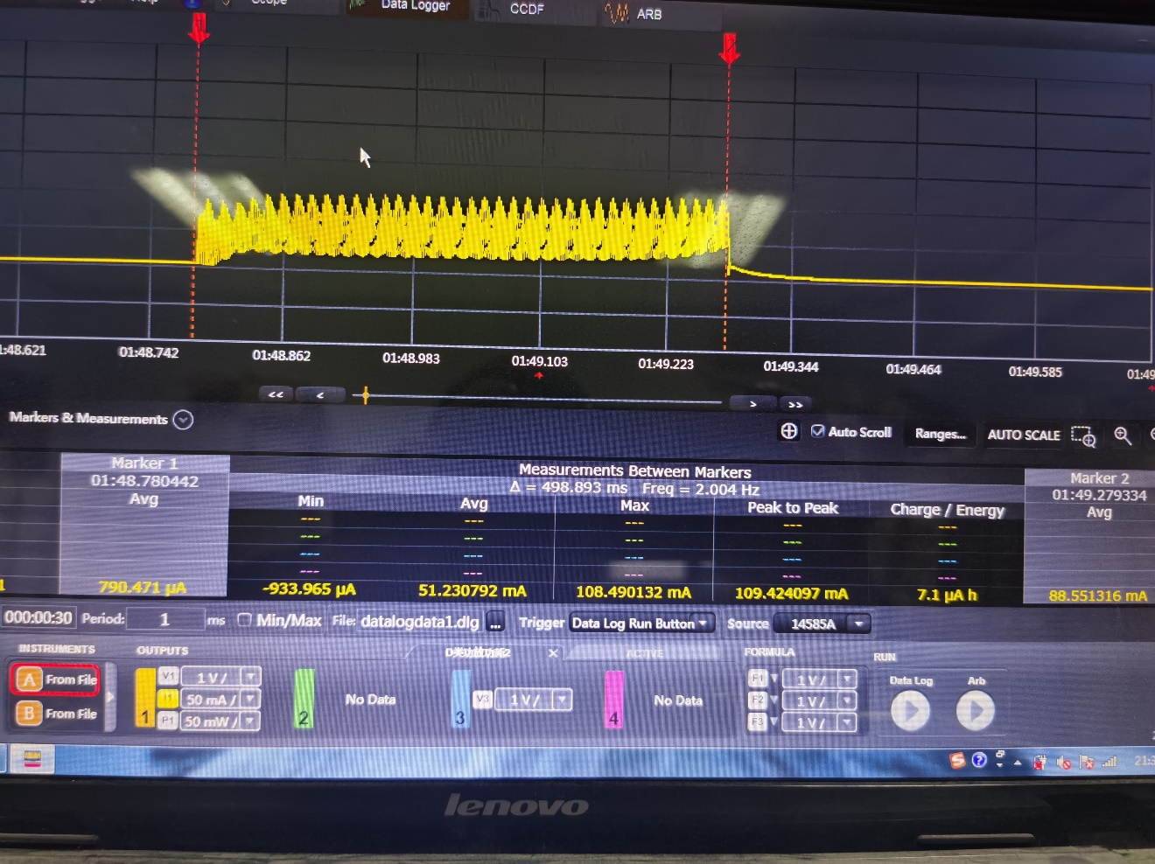
- Our driving mode is single-end signal input, the principle is as follows:
