Hardware condition
- PVCC 12V
- Plimit 0.8V
- Speaker 2W/4Ω
- LC filter : 22uH//1uF

Ch1: OUTNR
Ch2: OUTPR
M: Ch1-Ch2
Ch3: input signal of TPA3110D2

A.10Hz
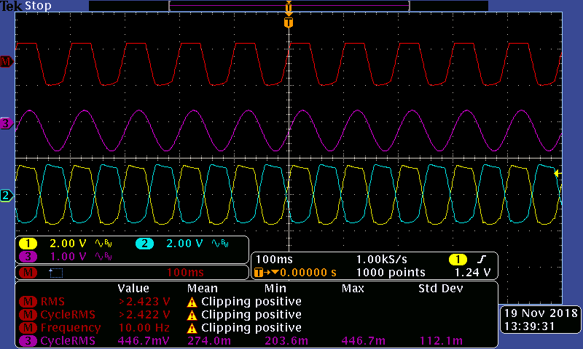
Output Waveform has been cut off

B. 100Hz
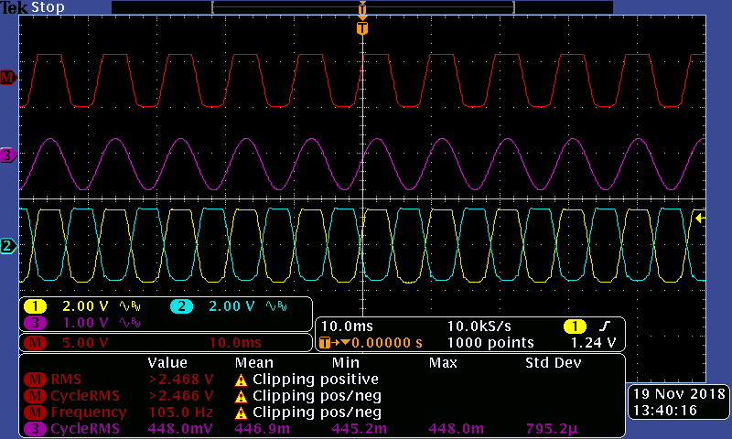

C.1KHz
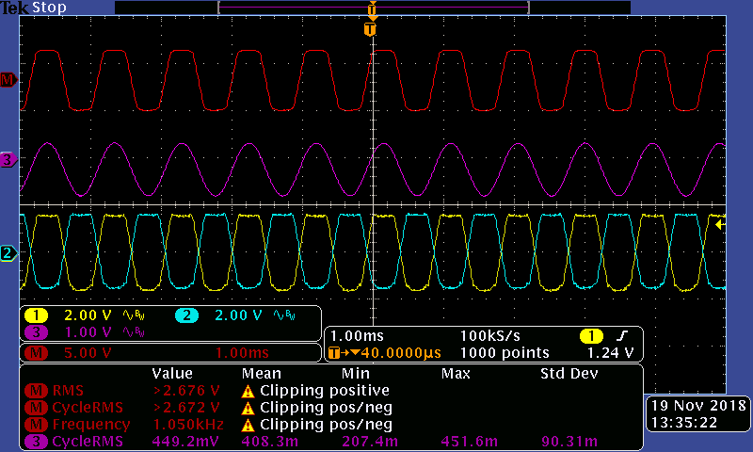

D.11KHz
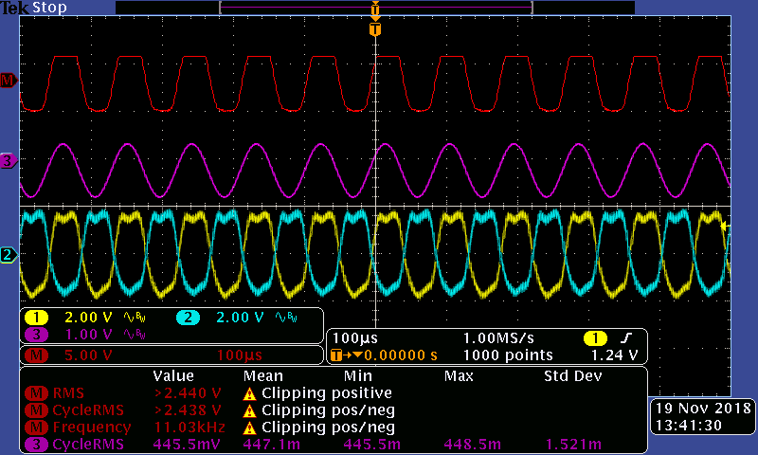

E.22KHz
