First, on the AP setup side, you should also select a weighted filter.

- It has been weighted when testing

Second, I think the noise is coming from the input. You can short-circuit all audio inputs to GND via a 1uF capacitor and check again. This avoids the effects of input noise.

- I have tried shorting the 200R resistor R4201 to ground (as shown in the figure below) and reducing the noise floor to 90uV. But shorting the C4211 (10uF) to ground noise does not change, how can I improve the front-end input noise?

Illustration, schematic

The description is automatically generated

The audio input layout should follow Datasheet 7.3.1 single-ended analog inputs.

——The following is the layout of the DB2 amplifier input,

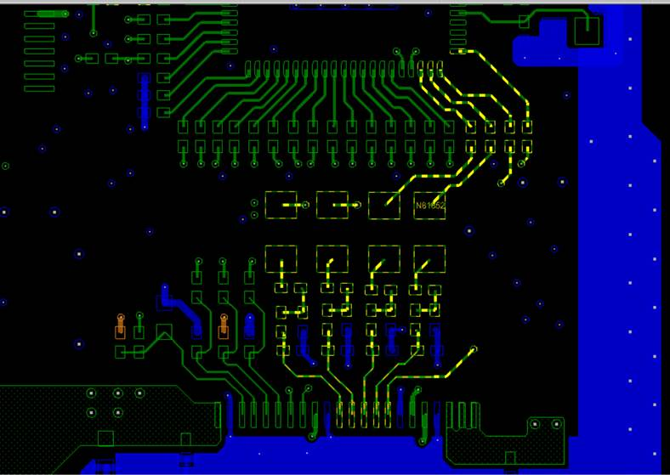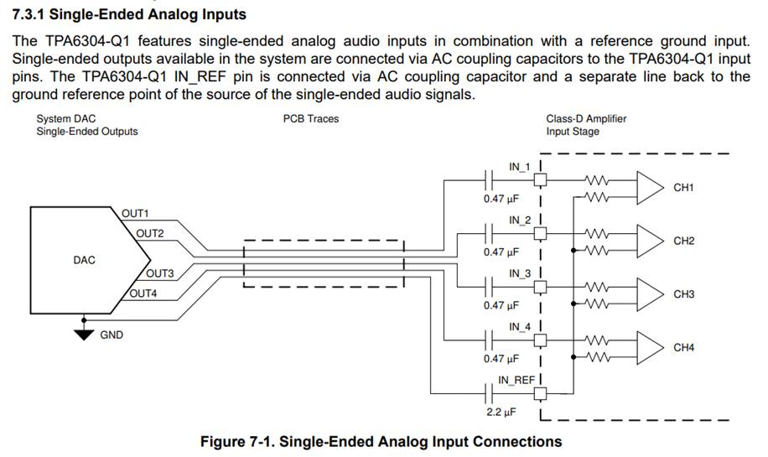

The 1.5K and 7.5Kohm resistors on the inputs can be removed, which may introduce the risk of bursting noise.

——This is the reference circuit provided by the DSP supplier, and it was actually found that there is pop sound, which has been solved by mute amplifier

The upper limit of 10uF DC at the input is too large, and 1uF will do.

- Replacing 10uF with 1uF in the test did not reduce the noise floor.

To sum up, the only way to reduce the noise floor is to ground the resistor R402 at the input of the power amplifier, trouble to provide modification suggestions, thank you.