Issue description :
Once power up, unmute PCM1754, not initiate I2S, they can hear noise from the speaker. If they disable TPA6211, they can hear nothing

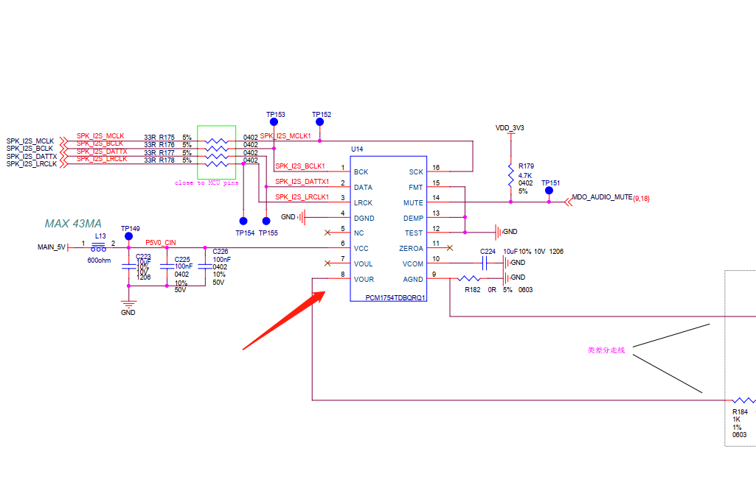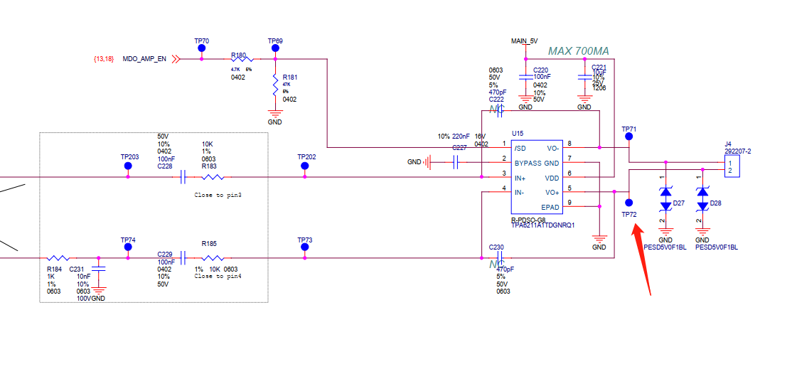

Yellow line is TP72 TEST WAVEFORM, blue one is pcm1754 pin8 output. You can see both signal has noise.
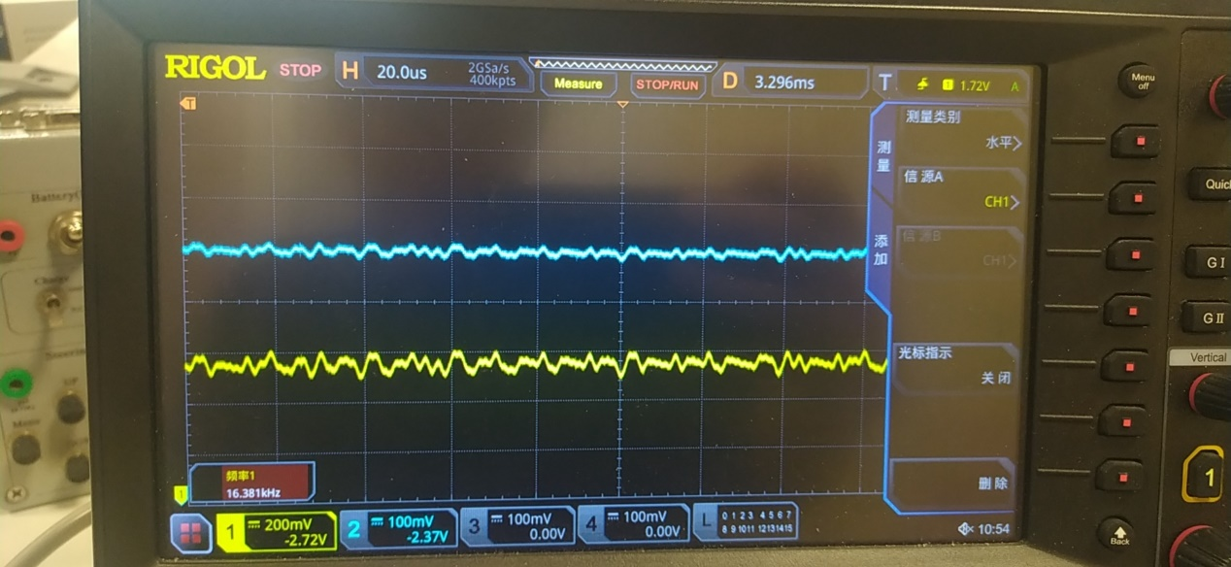
LRCK
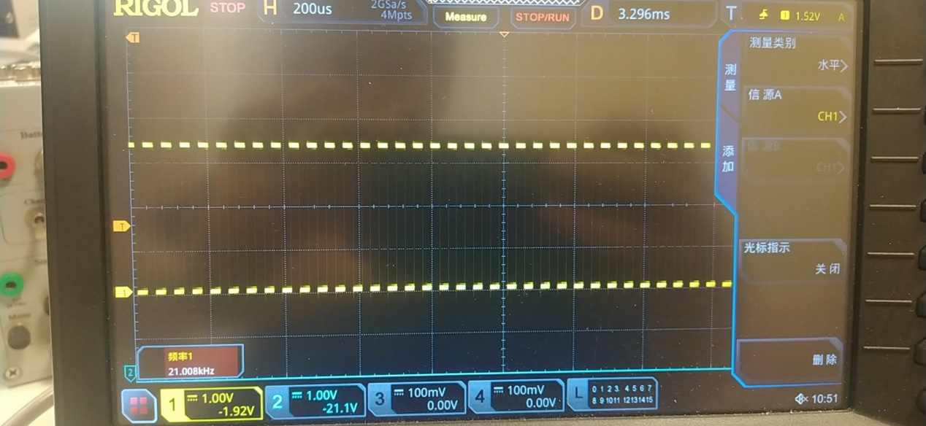

DATA

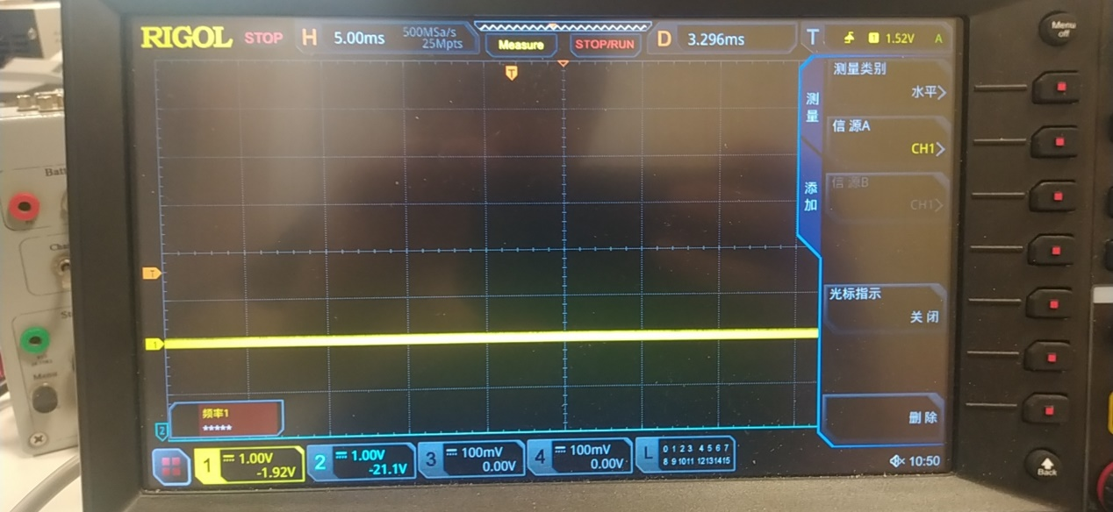

BCK
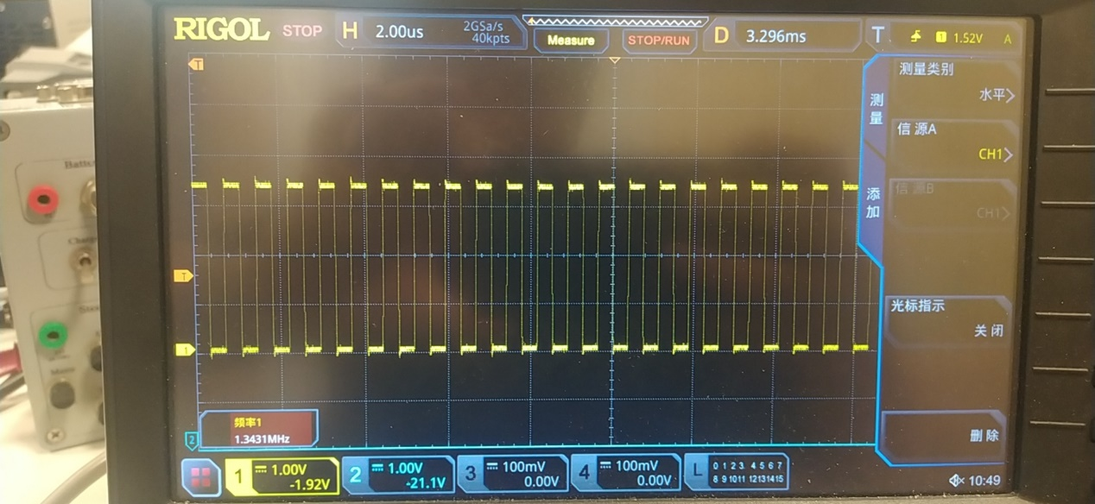
SCK

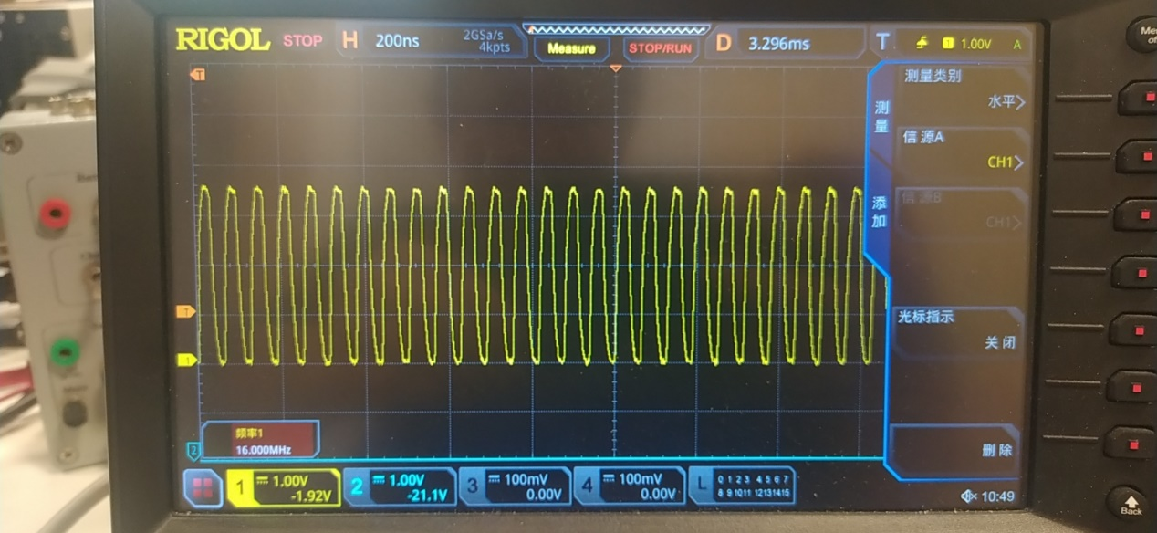
If TP74 is tied to GND, the test waveform is as below. no more noise
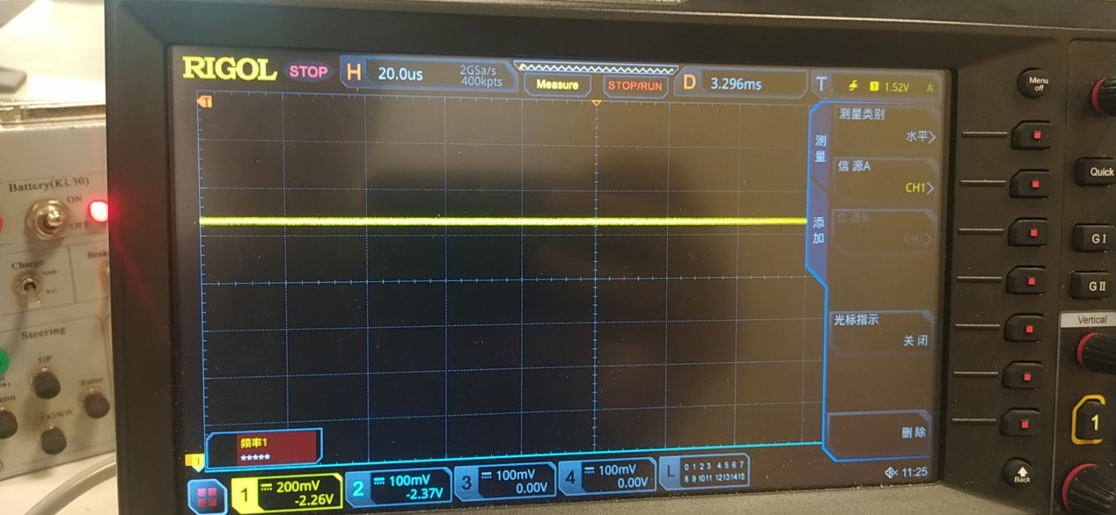

If TP74 is not tied to GND, the blue one is pcm1754 pin8 and yellow one is TPA6211 output

The green one is LRCK and yellow one is BCL
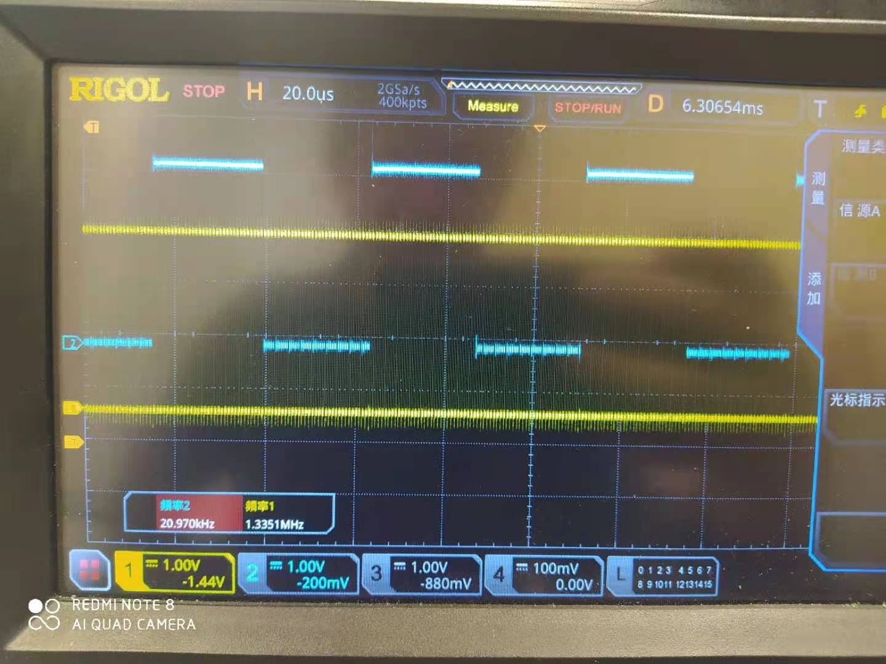

Yellow one is BCk, green one is LRCK and pink one is DATA.
