The customer use TAS5538+TAS5342/52.

Below are the waveforms of **TAS5538 PWM output** and **TAS5342 output**. (1kHz signal is added to the input)

Normal case

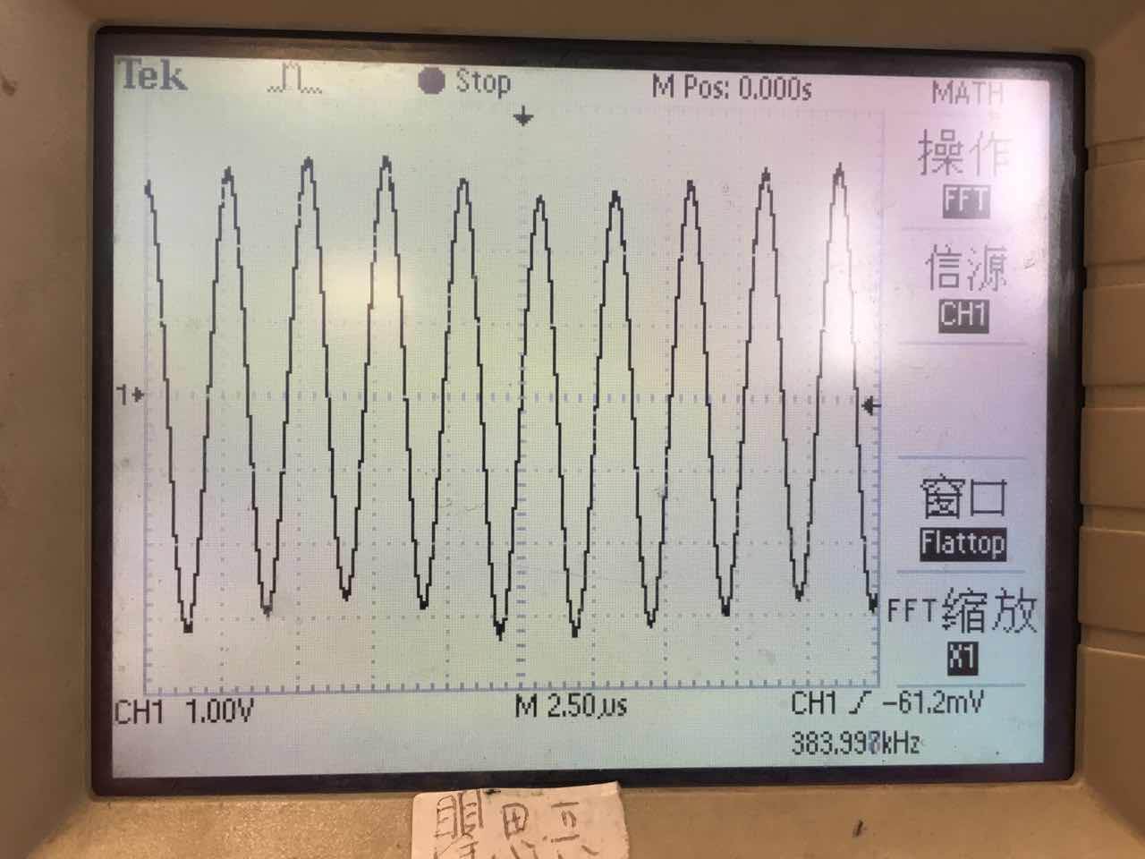

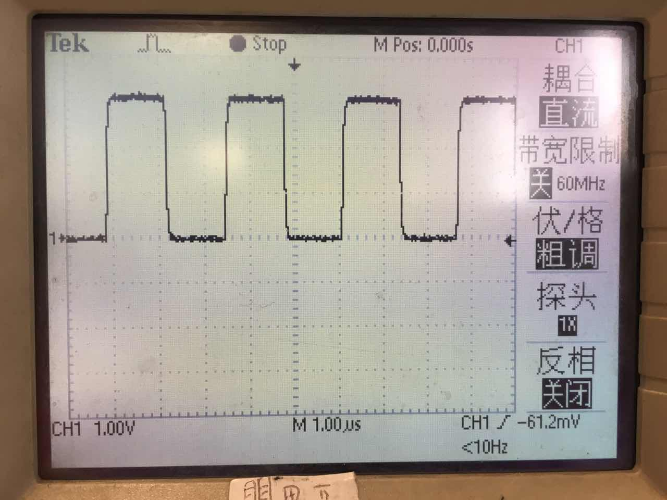

Issued case:

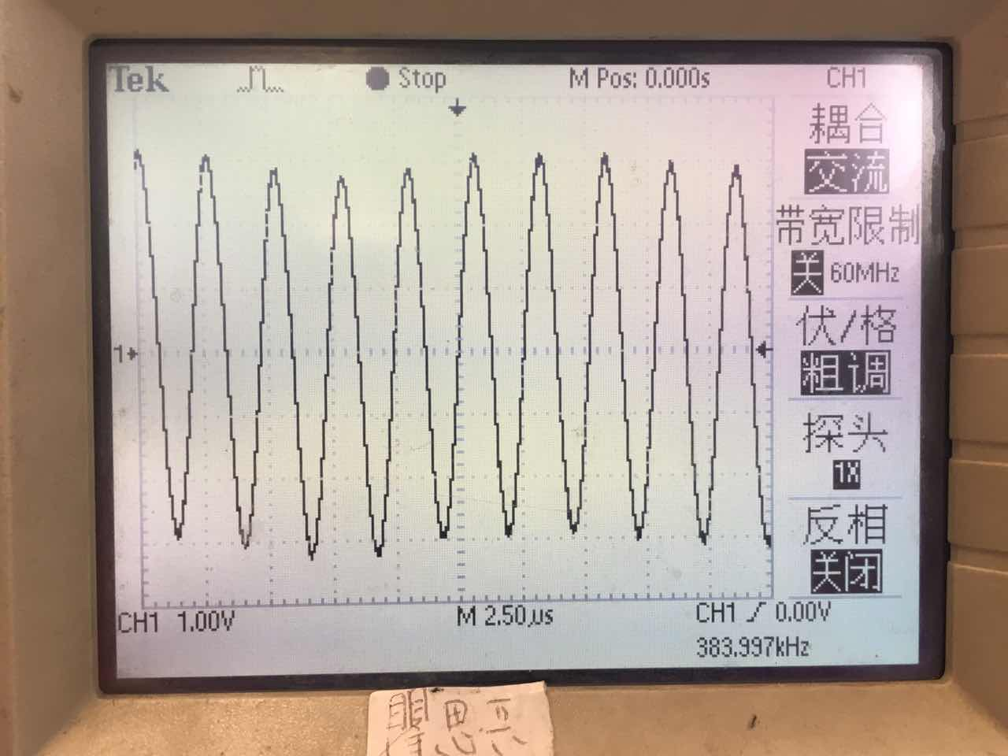

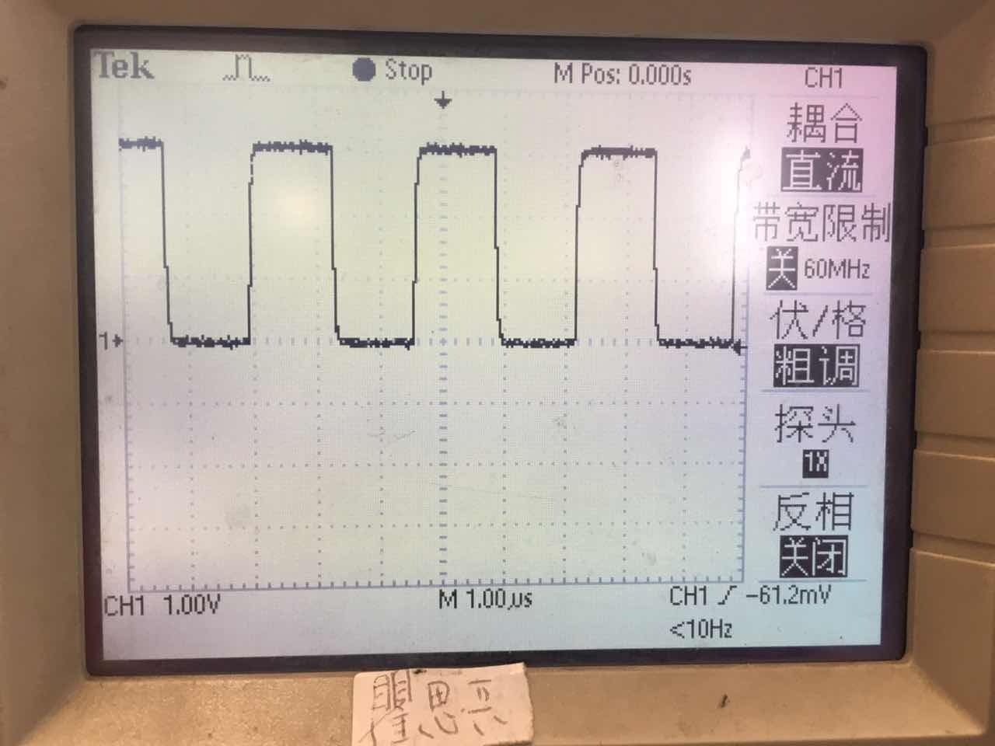

I have also checked the two outputs of TAS5342, but almost the same.

Normal case (the upper curve is Ch1-Ch2)

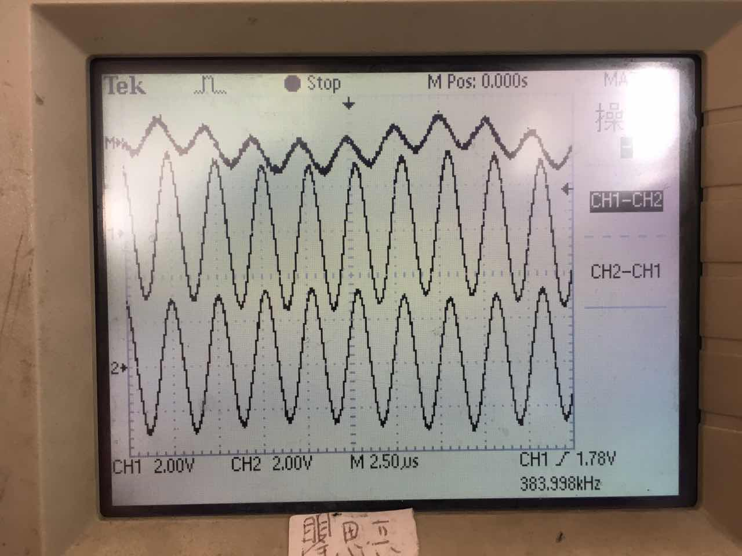

Issued case (the upper curve is Ch1-Ch2)

