Fail case:
In the two protocol master, the protocol master of the time master is connected to
the protocol slave.
CH1:time master PA TX
CH2:time slave PA TX
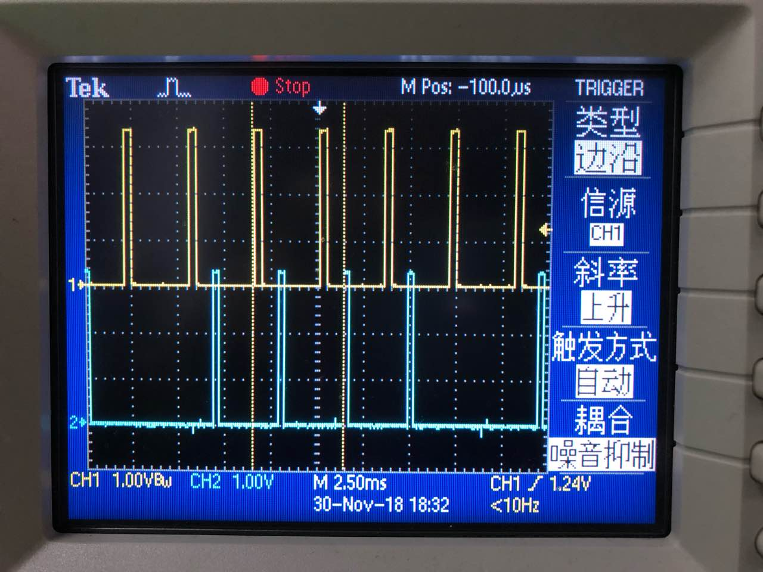

CH1:time master PA TX
CH2:time master PA RX
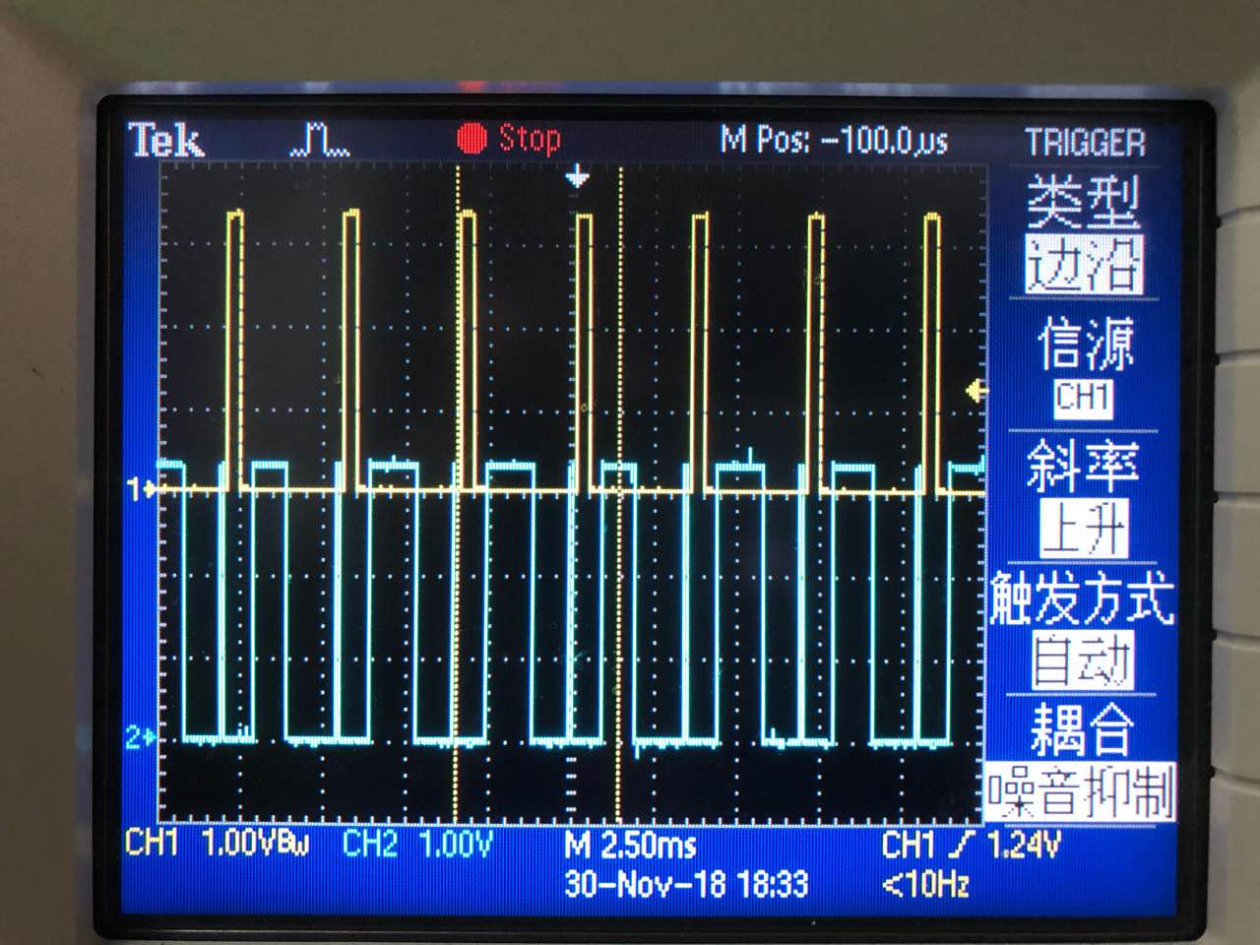

CH1:time master PA TX
CH2:time Slave PA RX
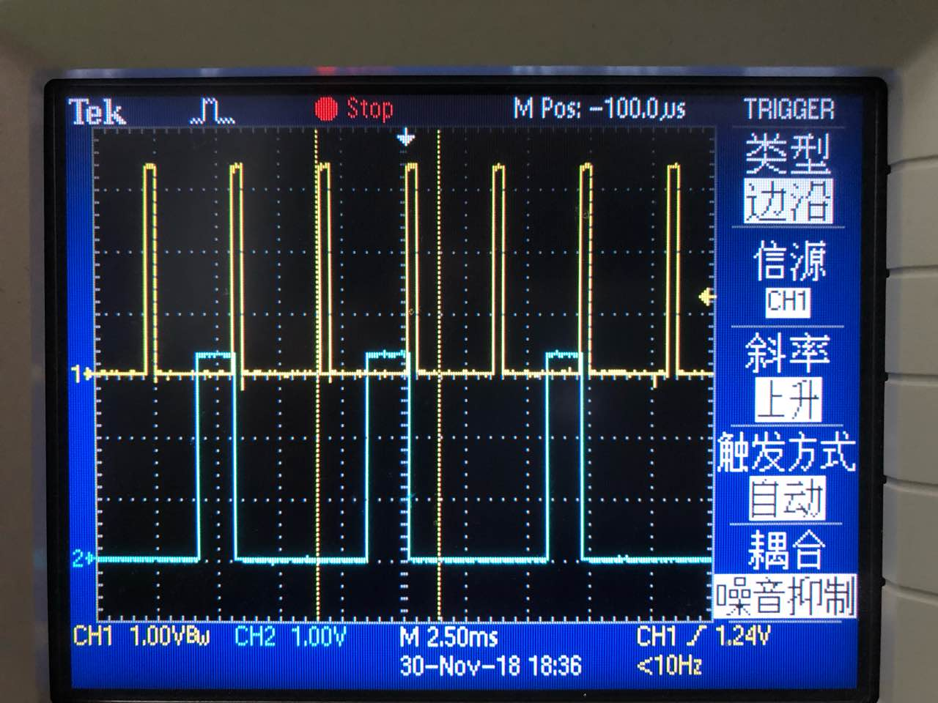

Working case
In the two protocol master, the protocol master of the time slave is connected to
the protocol slave.
CH1:time master PA TX
CH2:time slave PA TX
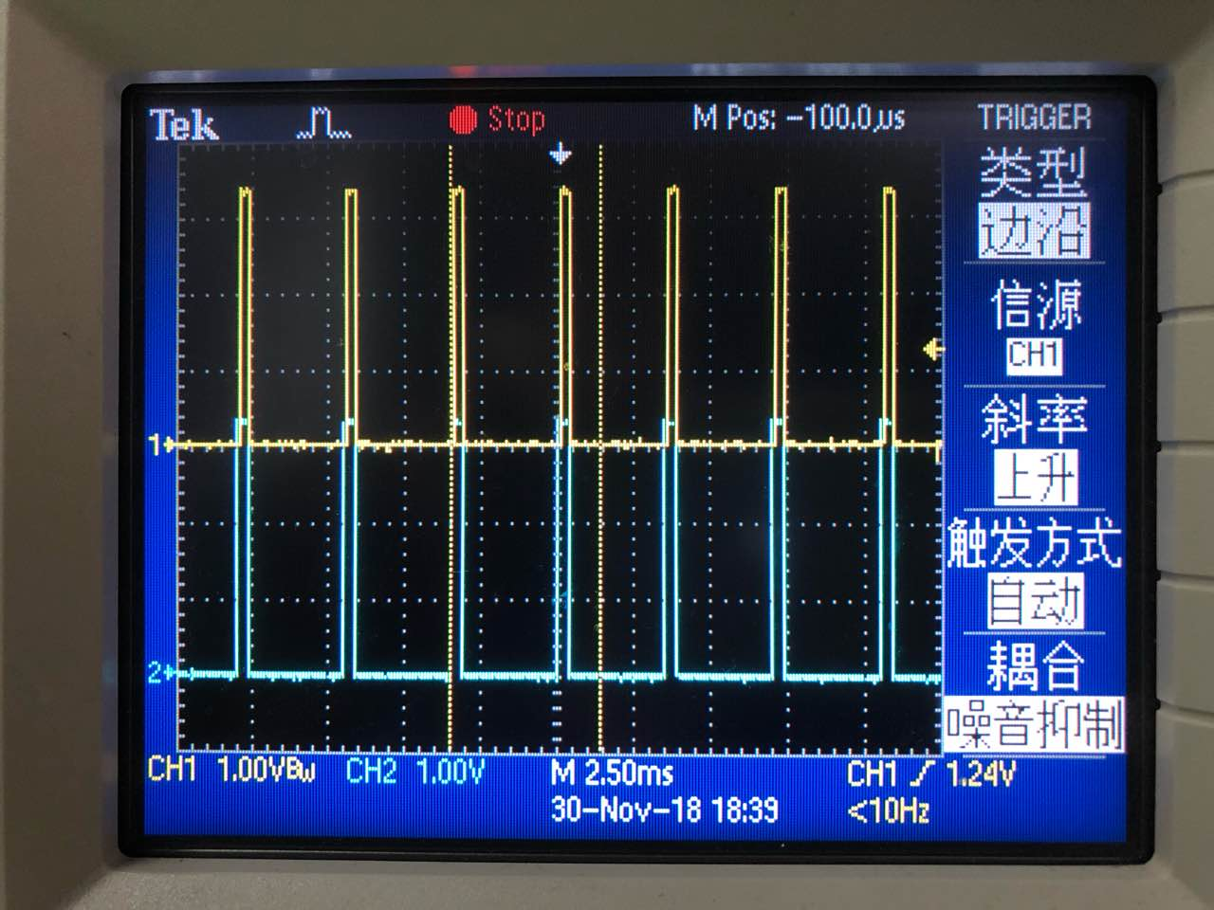

CH1:time master PA TX
CH2:time master PA RX
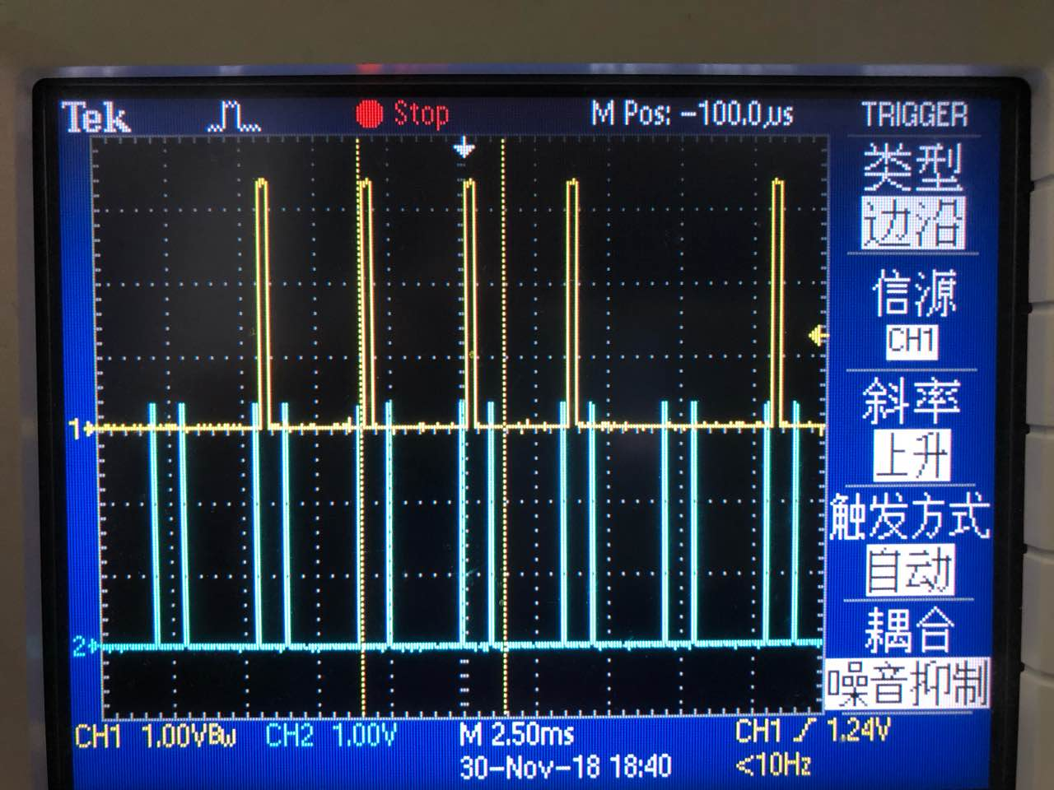

CH1:time master PA TX
CH2:time Slave PA RX
