CC8520 protocol master time master and time slave synchronization problem?
Dear all:
After the two protocol master are rebooted, the time slave is not connected, it will interfere with the time master, although there is a connection synchronization signal. Once the time slave is connected, it will not interfere with the time master, even if the time slave is disconnected again. Is this a bug or what is wrong with my settings?please help me.Thanks!
Figure 1
Time master is interrupted by time slave.
CH1:Time slave PA Tx signal(Never connected ) ,
CH2:Time master PA Rx signal (Connected)
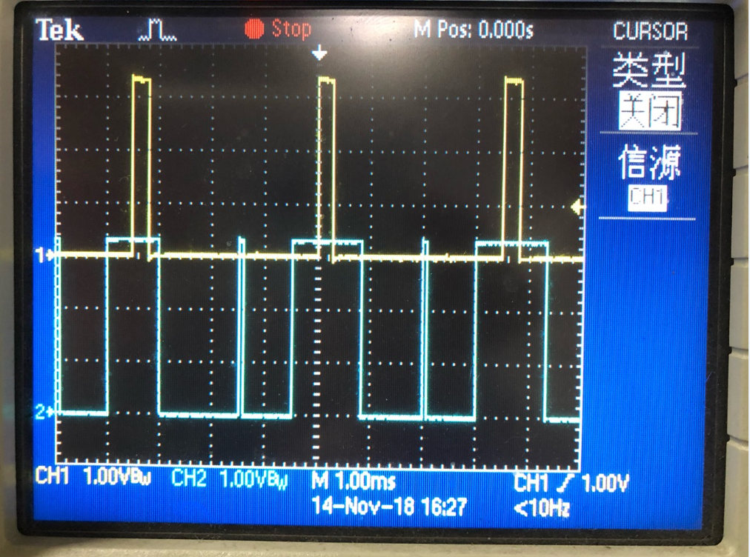
Figure 2
Time master is not interfered by time slave.
CH1:Time slave PA Tx signal(Connected ) ,
CH2:Time master PA Rx signal (Connected)
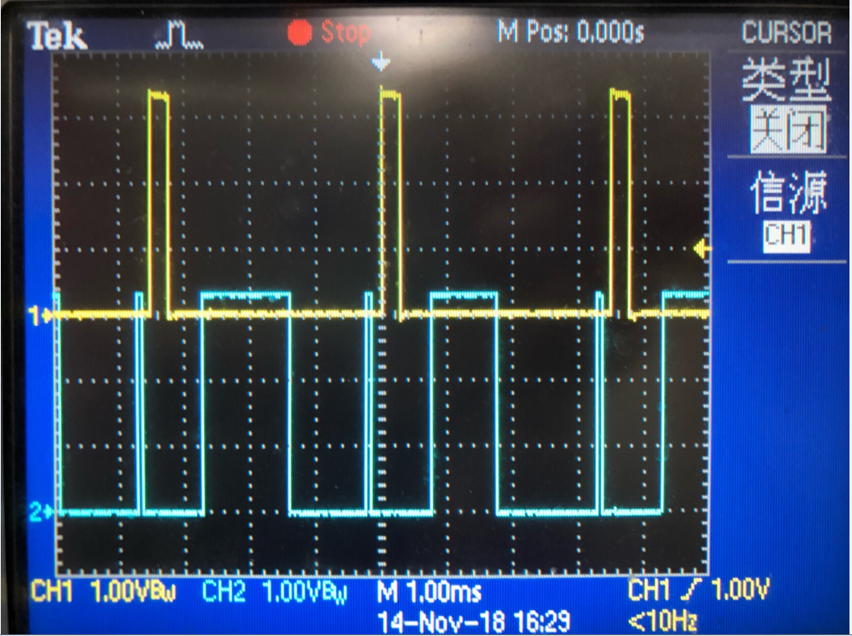

PPW config:
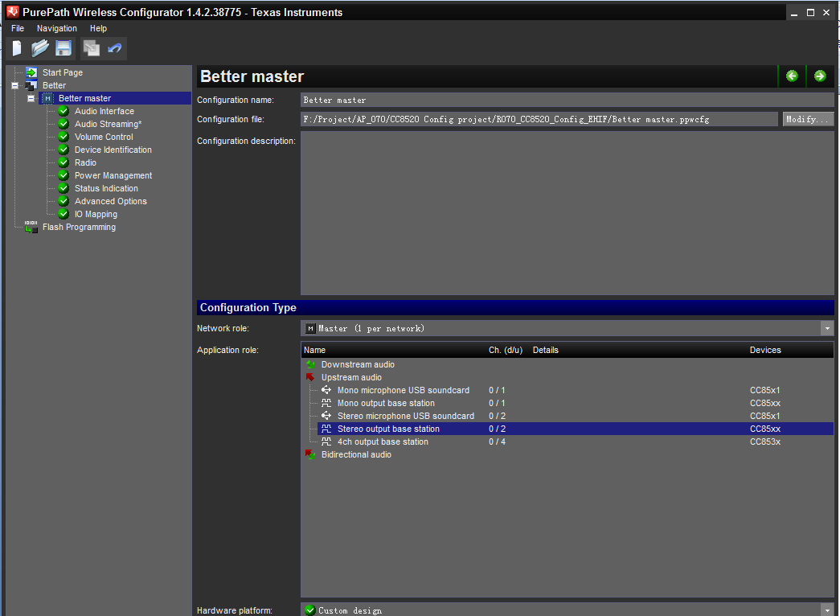

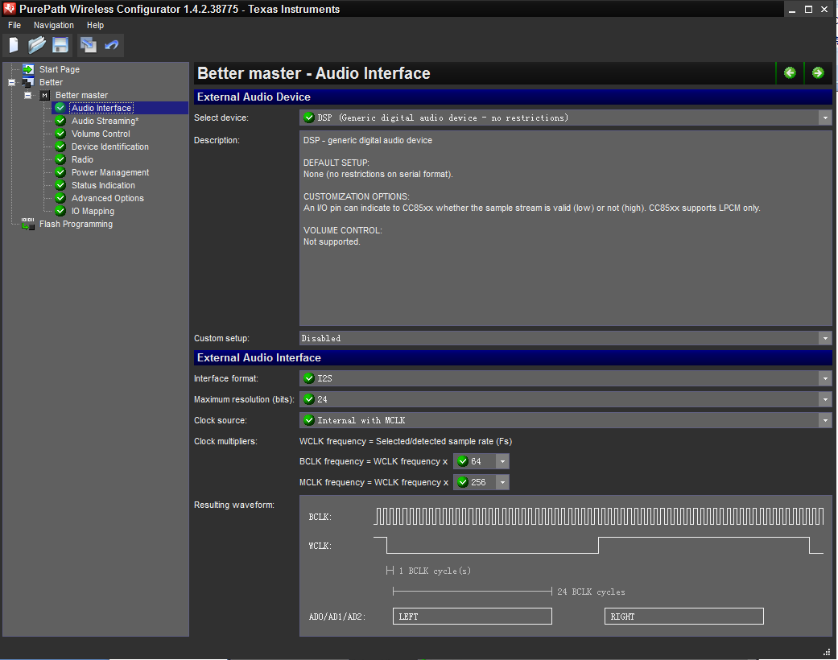

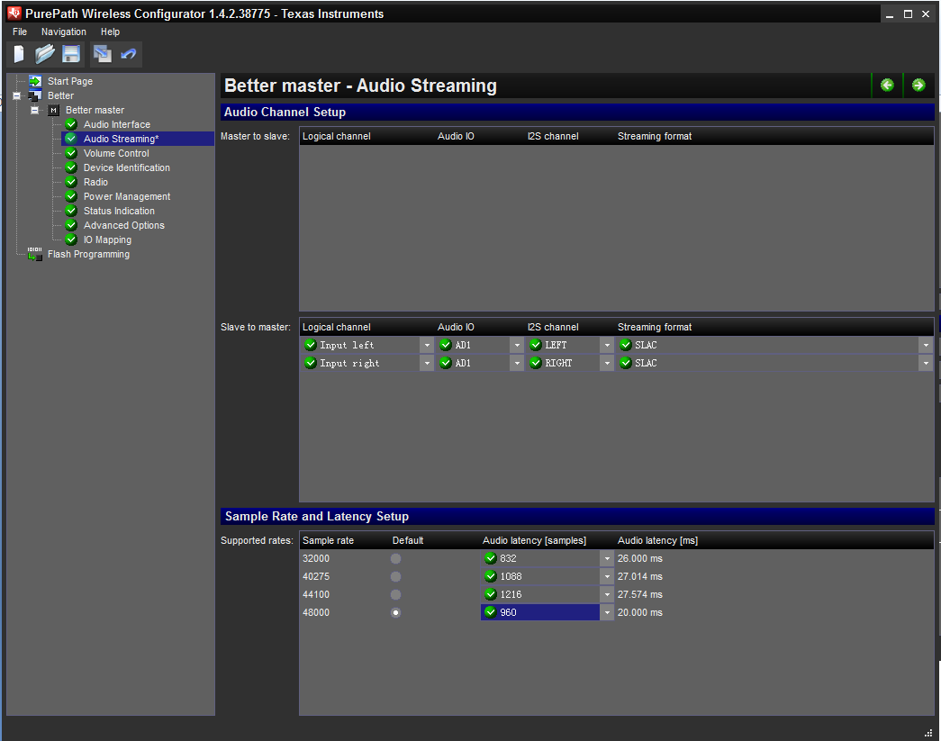

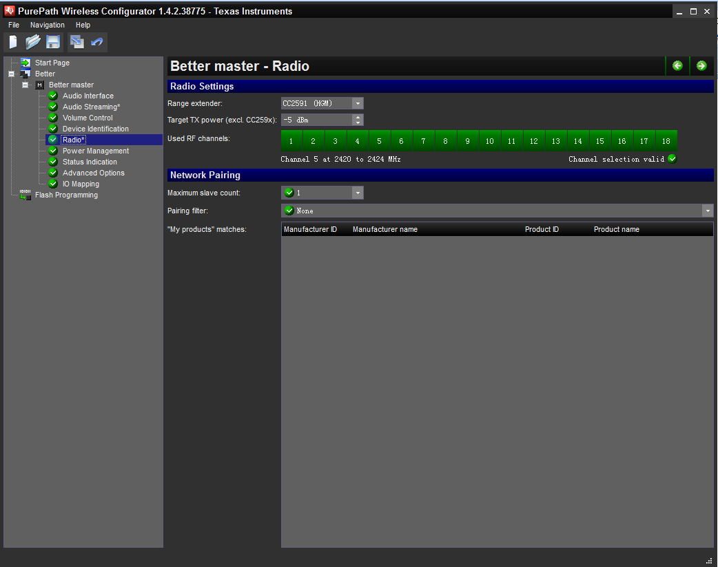
Time master
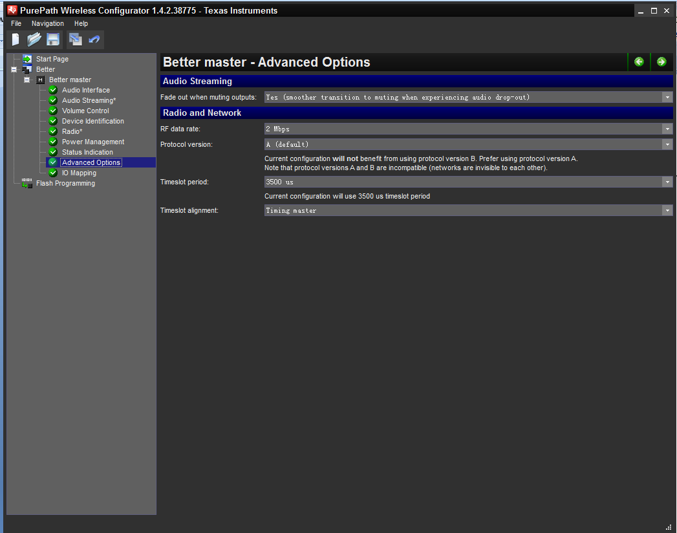

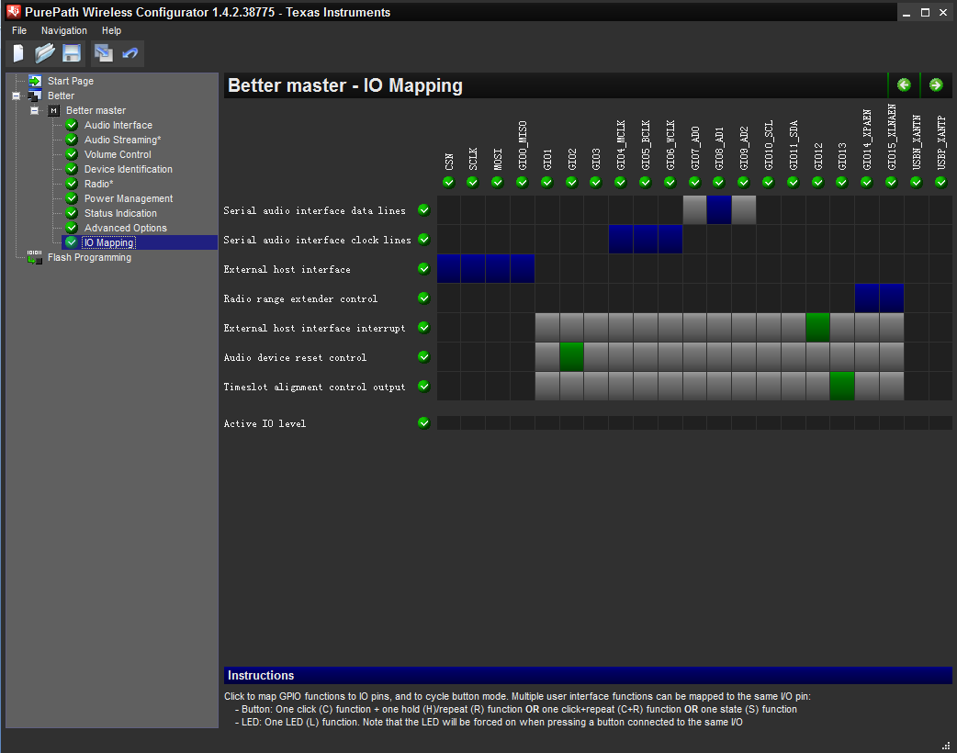

Time slave
