E2E Community issues/rectifications:
Hi,
We are developing a project around TRF7970A RFID IC to detect ISO15693, ISO1444A and ISO1444B tags.
For that we made and populated the PCB from TI website (EZ430-TRF7970A) as a single PCB and it is working fine. Figure1:
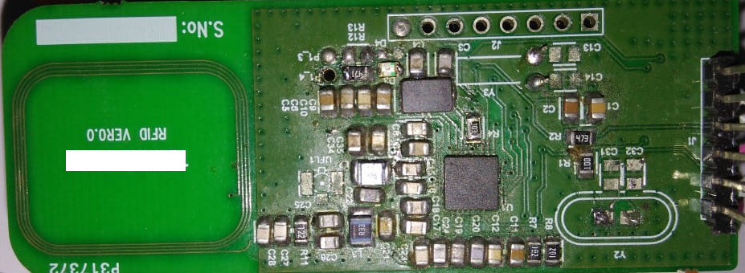

It will detects ISO15693 Tags, ISO1444A and ISO1444B Tags. So it is working fine.

Now we are in final phase of the product.We selected one torch lite shaped box made up of ABS plastic.

For that at we divided above PCB into two separate PCBs to fit into the box.
one is main board:
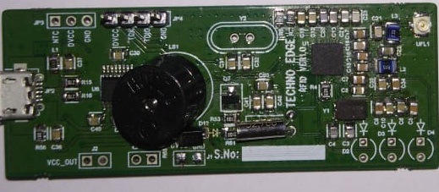

Second one is Antenna Board as shown in below figure:
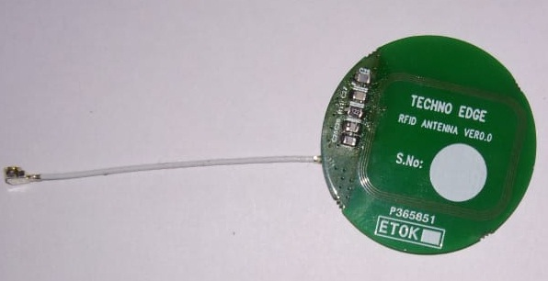

We made connection between main pcb and antenna pcb with one 50mm coaxial cable using UFL connecters.
Even after using same firmware ,pcb and bom, it is not detecting any tags as it is working with single PCB.

So What could be the reason the problem ?
Where can we check?
Please support in this
Satya.ch

