7.3.1.2.4 JESD204B Lane Multiplexer

To facilitate high speed signal PCB routing, the DAC3xJ8x includes an internal JESD204B lane multiplexer to allow user to select the associated SERDES RX lanes for data transfer. The JESD204B lane multiplexer can multiplex any of the external SERDES RX lanes to the internal JESD204B data lanes.

The number of internal JESD204B digital lane used depends on the L (number of JESD204B lanes) being programmed on the JESD204B block. For L = 1, JESD204B block only registers JESD204B lane 0. For L = 2, JESD204B block registers JESD204B lane 0 and lane 1. For L = 4, JESD204B block register JESD204B lane 0, lane 1, lane 2, and lane 3. For L = 8, the JESD204B block registers all JESD204B lanes from lane 0 to lane 7. Figure TBD shows the block diagram for JESD204B Lane Multiplexer.

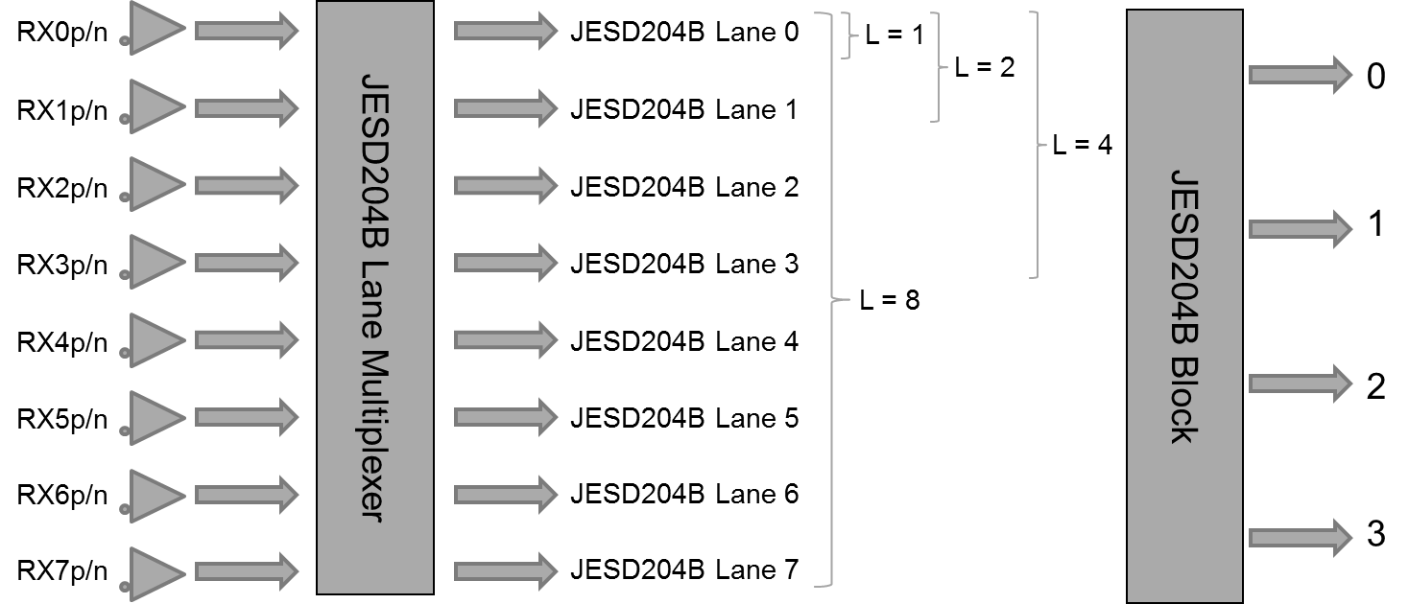

Any of the physical RX lanes can be routed to the internal JESD204B lane as long as the number of physical RX lanes matches the JESD204B digital lanes. Note that RX0p/n to RX3p/n SERDES lanes are in the RW0 SERDES block while RX4p/n to RX7p/n SERDES lanes are in the RW1 SERDES block. The associated SERDES RX lanes and SERDES block must be enabled according to the multiplexer selection.

