To check for proper SYSREF timing, run the DAC in NCO only mode and synchronize the NCO blocks to SYSREF. If SYSREF is present, the NCO will be unstable.
NOTE: For this test, the SYSREF frequency cannot be a whole integer multiple of the NCO frequency for this test.

- Program the NCO frequency and the NCO data rate. Program the following registers:

Set Config2 to 0x2052
Set Config31 to 0x3120
Set Config47 to 5

- Issue a SIF SYNC by writing the following:

Set Config31to 0x3320
Set Config31 to 0x3322
Set Config31 to 0x3320

- There should now be a solid output at the NCO frequency.

Set Config 31 to 0x3320

- Set the LMK to send continuous SYSREF pulses. The output should now be many pulses as the NCO will constantly reset as shown below.

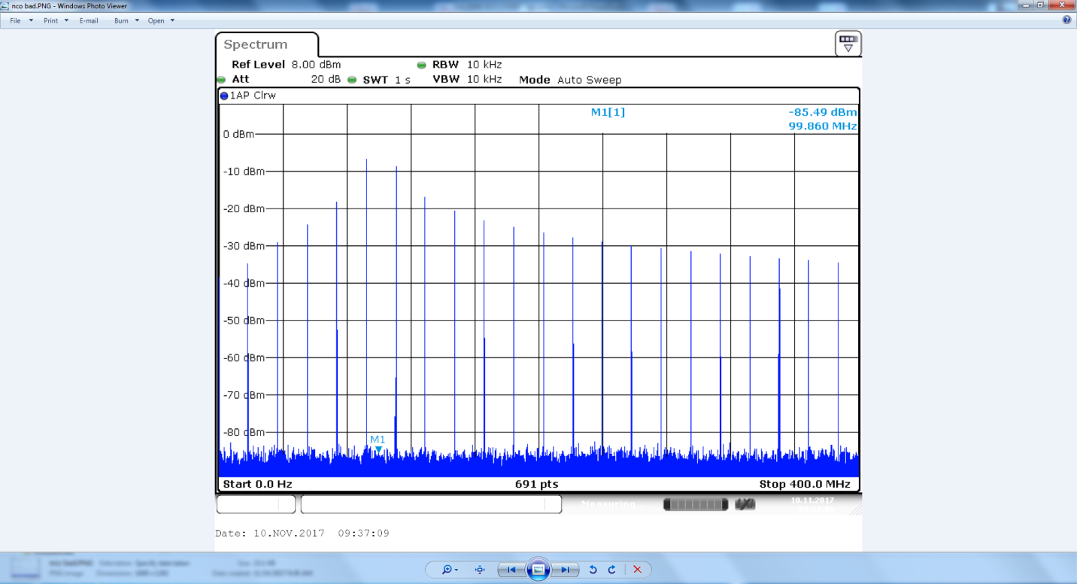
If the SYSREF input is not received properly by the DAC, the output in this test will look as a single tone, as shown below. In this case the problem is usually there is only one SYSREF pulse (AC coupled SYSREF), or the amplitude of SYSREF is too low and or the common mode is wrong (DC coupled SYSREF).
