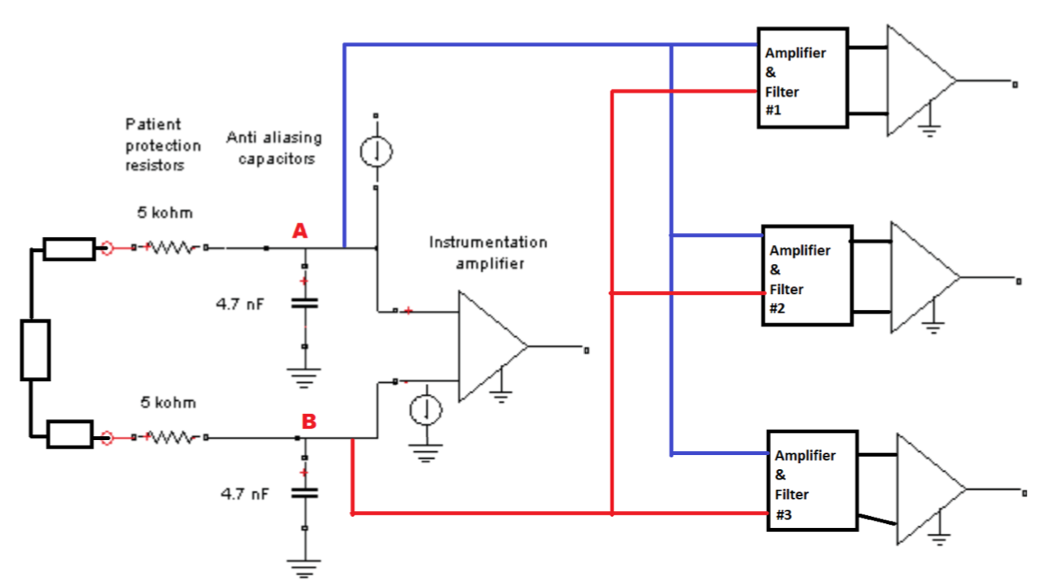

Fig. 1. Simplified diagram of a single electrode connection to the circuit

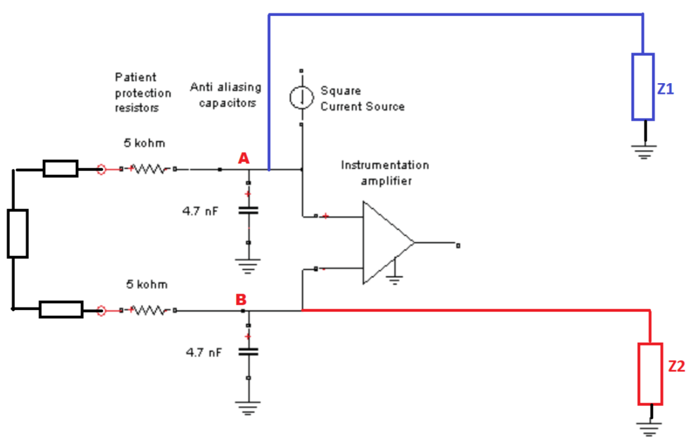

Fig. 2. Equivalent diagram to Fig. 1 in which filters and amplifiers are considered as equivalent resistors