How to fix python scripting tool in Windows 10:
- Download the x86 version of Python 2.7:
  - https://www.python.org/downloads/release/python-2716/
  - 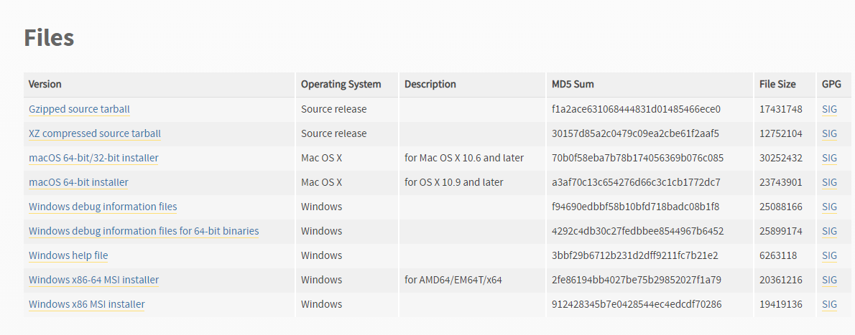
- Disable the Windows “App execution aliases”
  - Go to “Apps and Features” menu in windows (Press START button, type “Apps and Features”, press enter)
  - Select “App execution aliases”
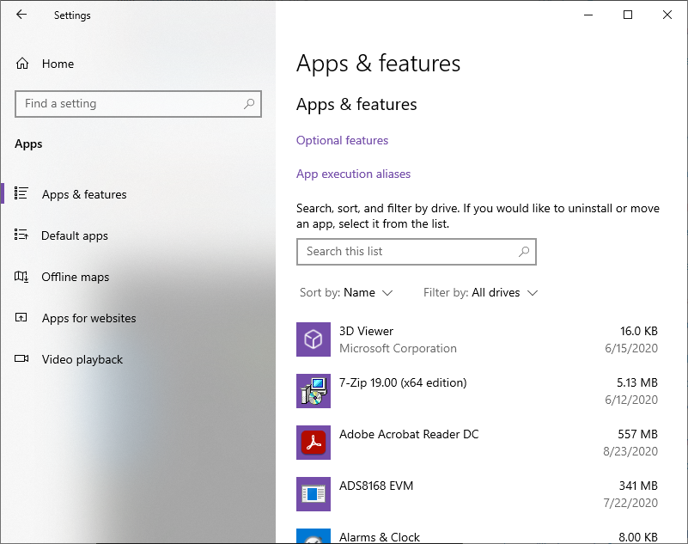

  - Uncheck all the python values
