Configuration to collect raw IBP data from ProSim 8 ( simulation tool for IBP sensor)
Objective: to measure the IBP sensor signal generated from proSim 8 with an oscilloscope in order to quantify the sensor signal variation.
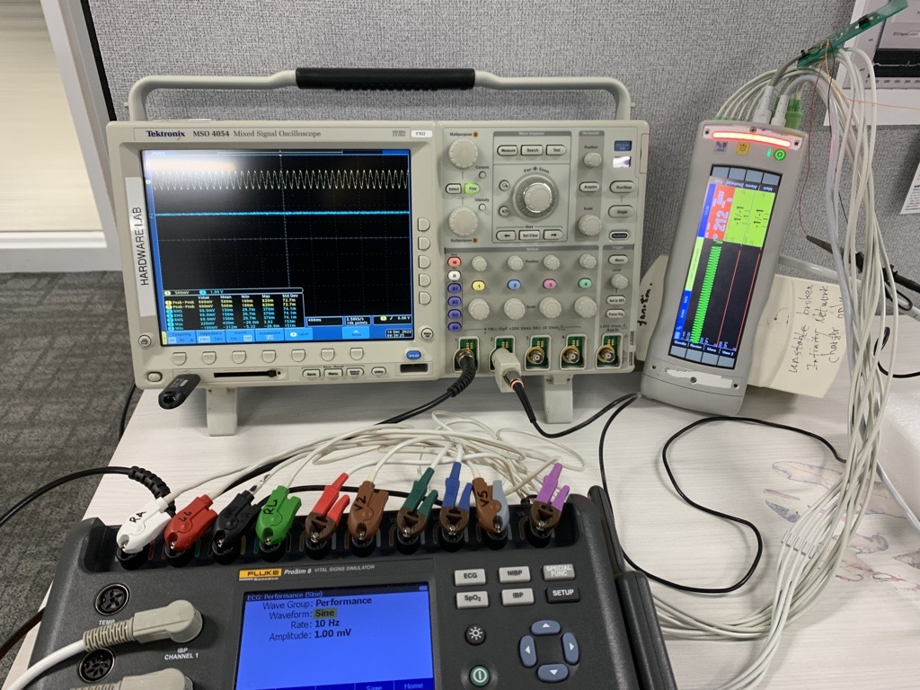
Bryan: Would you resolve the following issues I encountered:

- How to setup a fixture to probe resistive bridge Signal from pin 1 & pin 4.
- Signal from pin 1 & pin 4 shall demonstrate follow the transducer sensitivity changes

