For information regarding the Xilinx product guide for the JESD204B IP, go to the following link below.

<https://www.xilinx.com/support/documentation/ip_documentation/jesd204/v7_1/pg066-jesd204.pdf>

The customer can create example designs that are generated using Vivado.

Since the firmware created for the TSW14J10EVM to use HSDC pro requires a lot of source code normally not required by a customer, this firmware is usually not a good starting point, but can be used as a reference.

The best starting point “ALWAYS” is to generate the core for the device and configuration they require. Then open the “Example Design” in vivado (pg066 describes this).

This creates a tailored example design and demo testbench using the configuration of the IP you have generated.

As for the JESD204 IP example design.

1)      Open Vivado and create a project.

2)      Configure and add a JESD204 IP (I created my_jesd204_tx).

3)      Right click on the IP under “Design Sources” and select “Open IP Example Design”

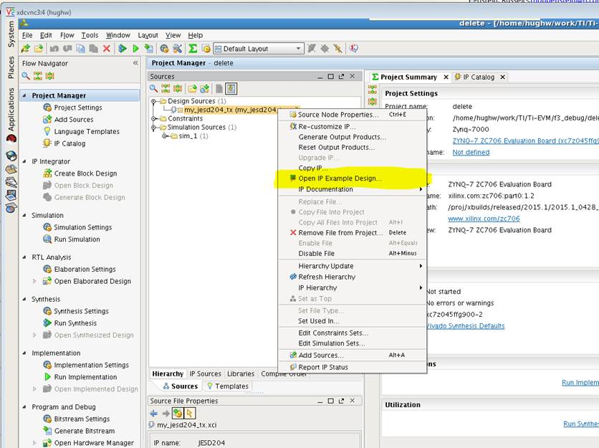

This will create an example design and demo testbench that shows the IP running with the configuration you have generated.

You would not need to do very much to this to get it running with your 38J84 in 442 mode.

Please see Chapters 5 and 6 in

<http://www.xilinx.com/support/documentation/ip_documentation/jesd204/v6_2/pg066-jesd204.pdf>

For much more detail.