INSTALLING TI ADC SPI 5p2 ON A WINDOWS 7 OPERATING SYSTEM
The installer for this software will not work properly when running in a Windows 7 computer. The following steps must be followed prior to installation.
- Connect the EVM to the computer using the USB cable. It will show a message saying that the device driver is not found. This can be checked by going to Control Panel/Device Manager and it will show it under “Other devices”
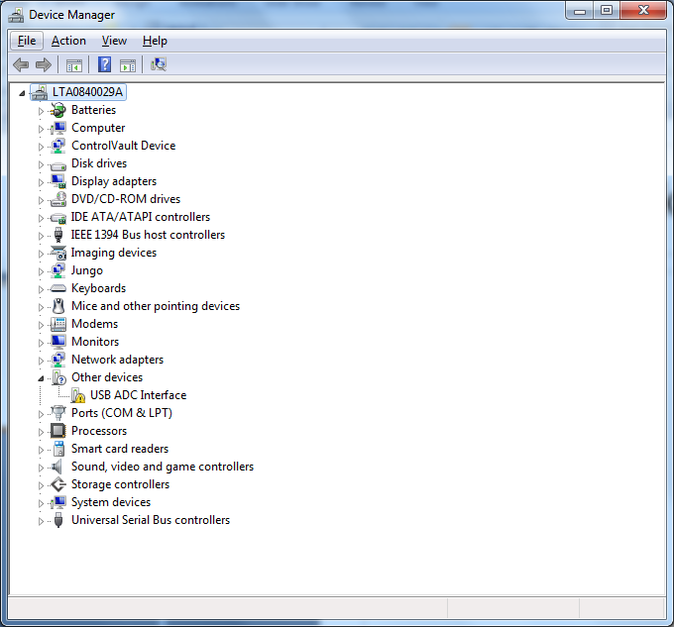

- Download and install the D2XX drivers from ftdichip.com for Windows. Make sure you download the one for your system type (32/64 bit).

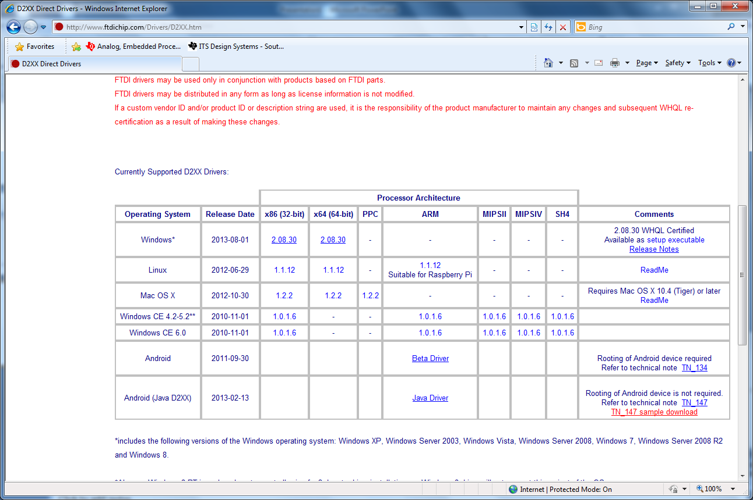

- Update the driver from the USB ADC INTERFACE (right click and then select PROPERTIES). Click on “Browse my computer for driver software”, “Let me pick from a list of device drivers on my computer”, “Universal Serial Bus controllers”, look for “FTDI” on the manufacturer column and then select “USB Serial Converter”. If different versions available, select the one just installed. Click “Next”.
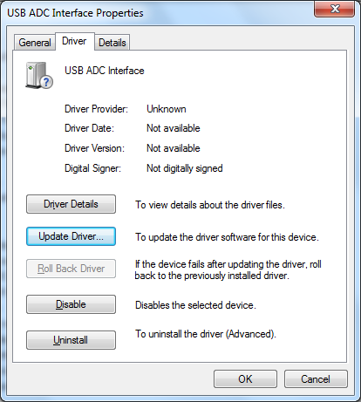
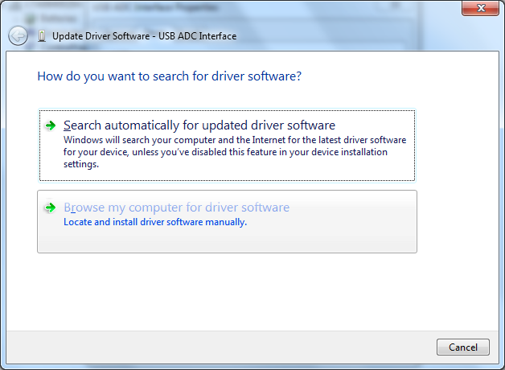
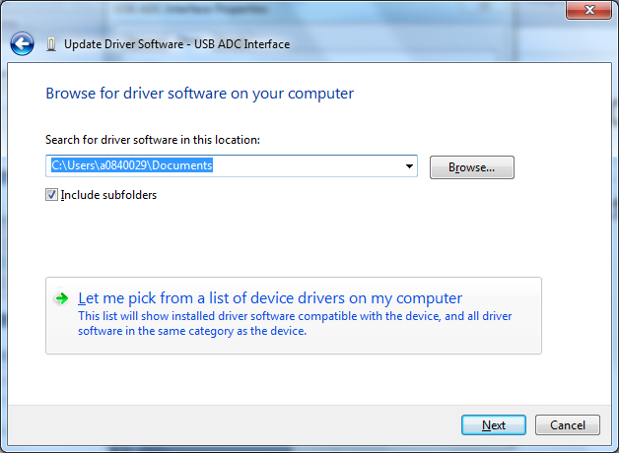
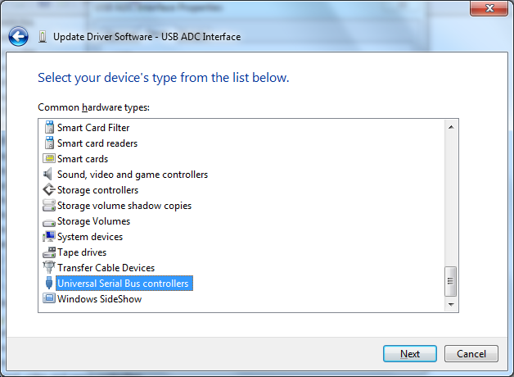
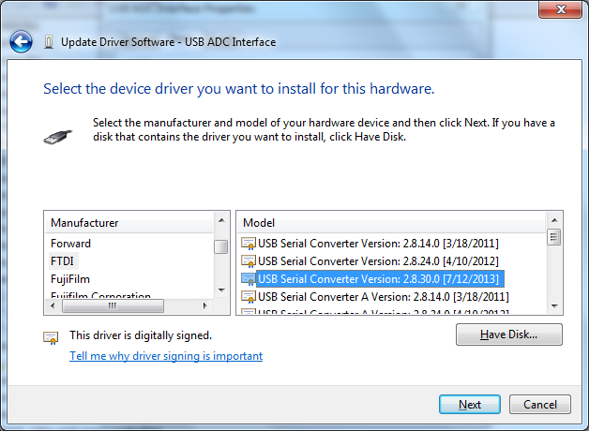

- The driver should be successfully installed now.
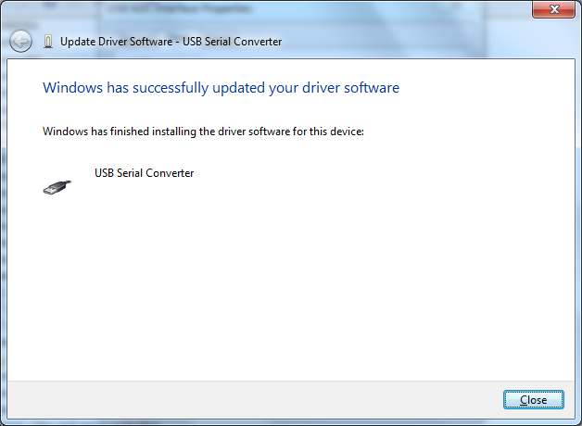
- Go back to Device Manager. There should be 2 USB serial devices installed. One of them is still the unrecognized one under “Other devices”. Right click on “USB Serial Converter” under “Universal Serial Bus controllers” and select “Properties”.
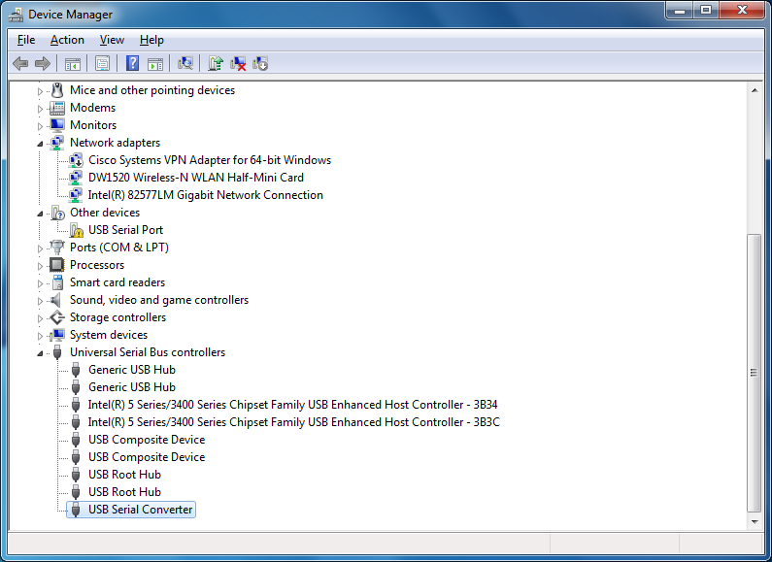

- Under “Properties”, select the “Advanced” tab and uncheck the “Load VCP” box. Click “OK”.
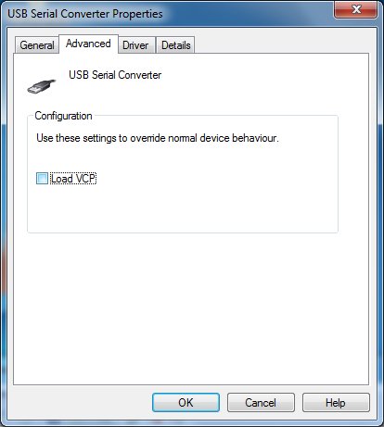
- Disconnect the USB cable from the EVM and connect it again. Now the Device Manager should NOT show the “USB Serial Port” under “Other devices”. The TI ADC SPI 5p2 software can now be properly installed.

