DAC37J84 EVM Screenshots
Step1:
- EVM Clocking Mode: Onboard
- Then i am executed as per Step4
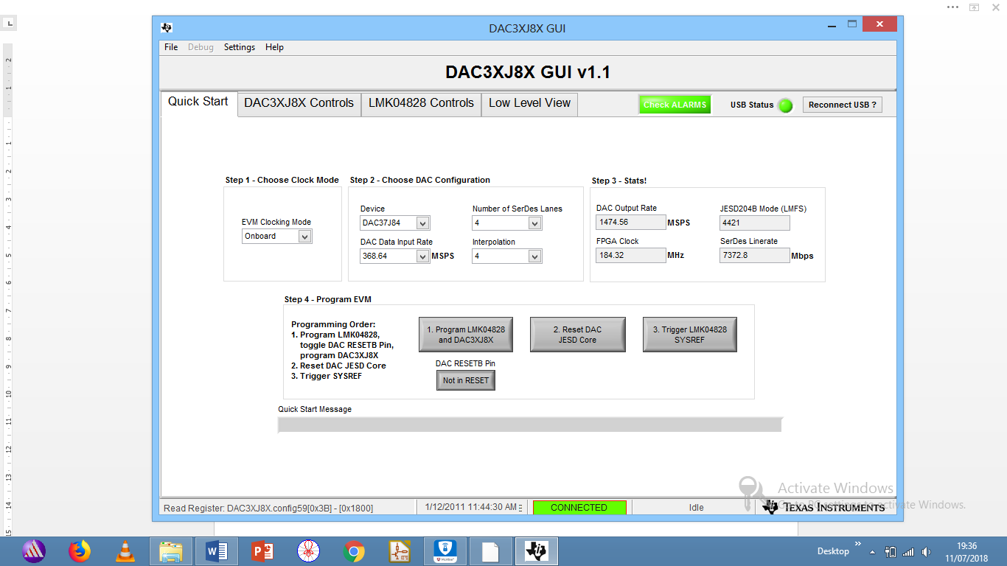
Step2:
- Then as per your instructions Enable Const Input
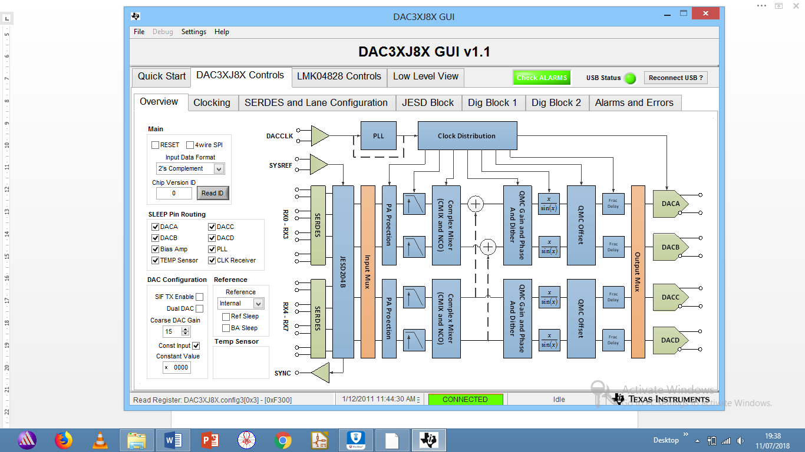

Step3:
- Enable: Mixer Block En
- Coarse Mixer Select : Bypass
- NCO Enable
- DAC Output Rate (SPS) : 1474.56
- Frequency (Hz) : 5MHz (Both AB & CD)
- SIF SYNC : Enable
- Update NCO

