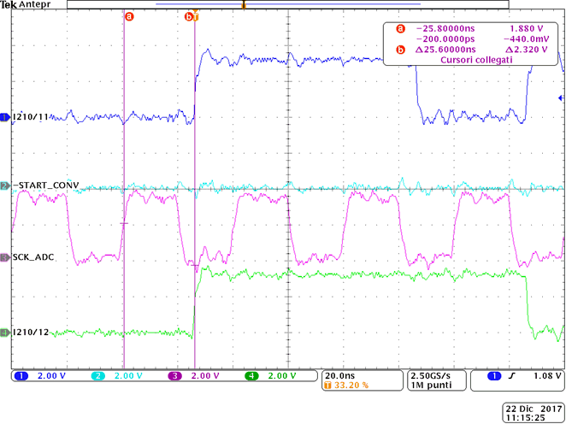
CH1 = pin 11 del ADS7251 (SDO1)
CH2 = pin 9 del ADS7251 (-CS)
CH3 = pin 10 del ADS7251 (SCLK)
CH4 = pin 12 del ADS7251 (SDO2)
Connected to FPGA

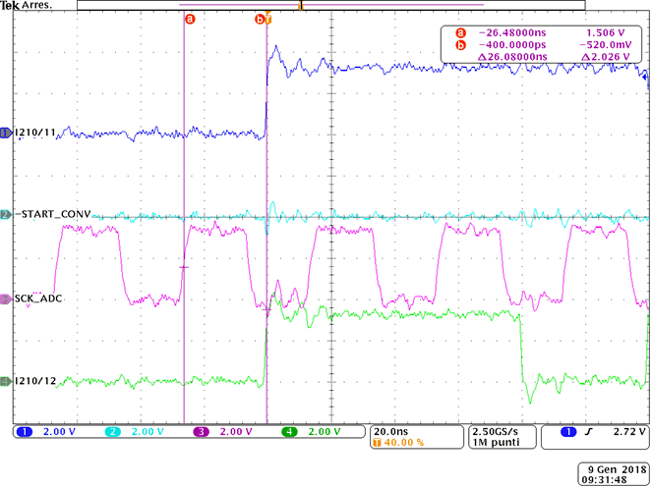
Unconnected

