**HW Design**



**Yellow – Clock**

**Green – SDO**

**Red – CS**

**Every time data read out are not the same. Captured 4 readout as below:**

1. **The first 16 clock, read out 01111100 10000000**

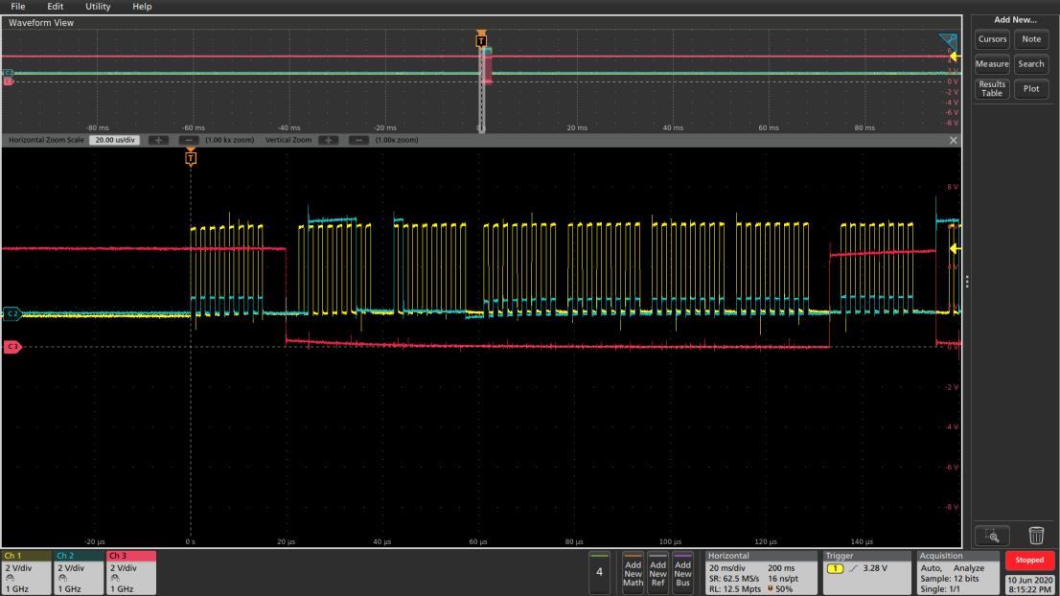

1. **The first 16 clock, read out 10000000 10000000**

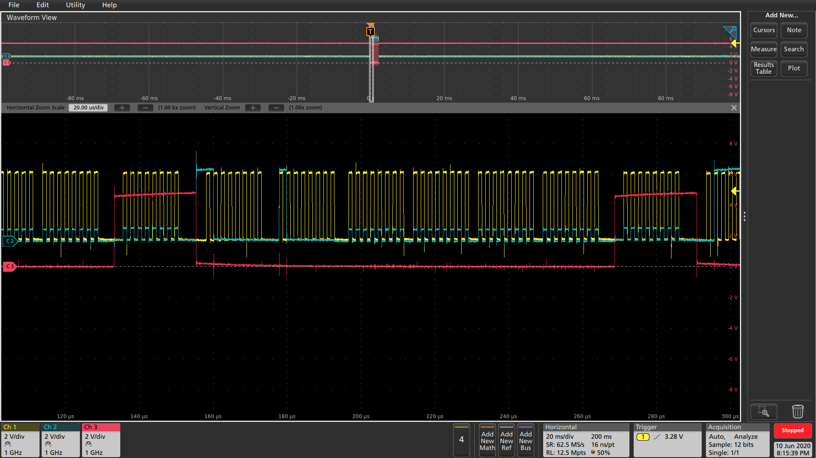

1. **The first 16 clock, read out 01111101 11000000**

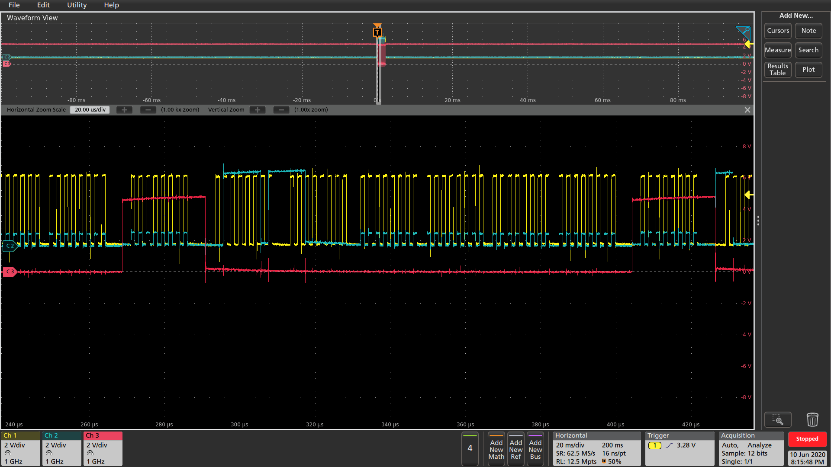

1. **The first 16 clock, read out 10000000 00110000**

