Problems: our machine will restart when pressing some key.

(A)Findings about signal.

FIG-1~4 is measured when we keep pressing the key between R3 and C2.

(1) interrupt signal(KBIRQ)

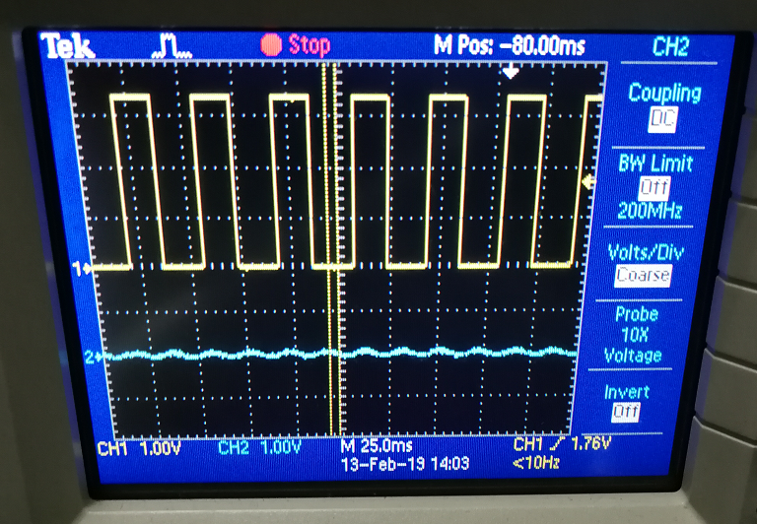

FIG-1 in Normal PCB

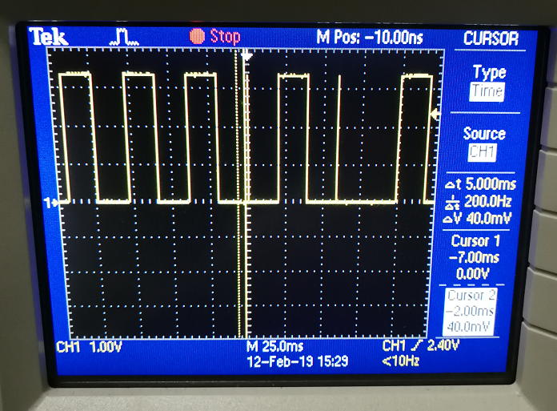

FIG-2 in Abnormal PCB

(2) Keypad signal (R3 and GND)

In Normal PCB and abnormal PCB, the waveform of R3 is similar

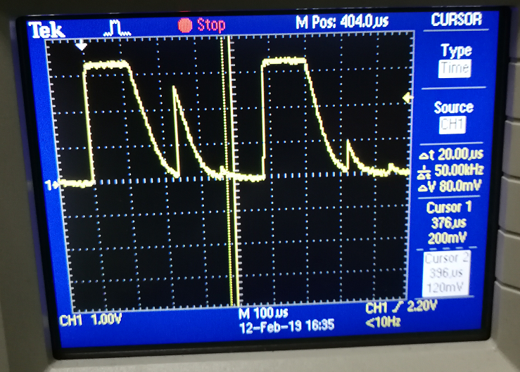

FIG-3

(3) KBIRQ and R3

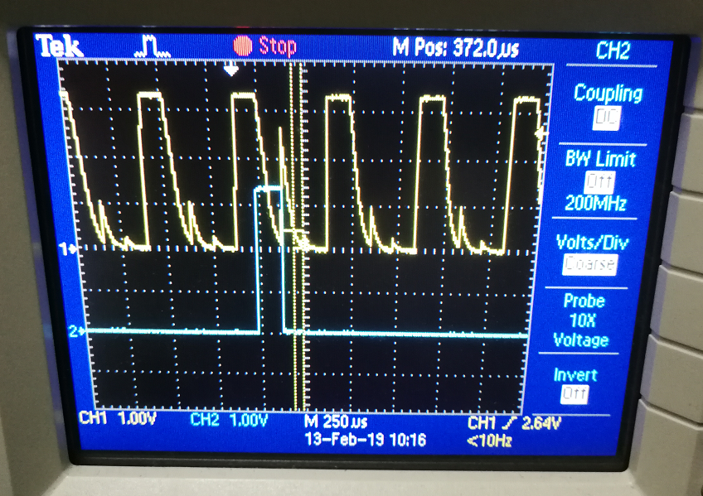

FIG-4

Yellow:R3 Blue: KBIRQ

KBIRQ is changed from H to L when meeting an extra pulse in R3, then we can see an extra pulse in KBIRQ

(4) the ROW signal

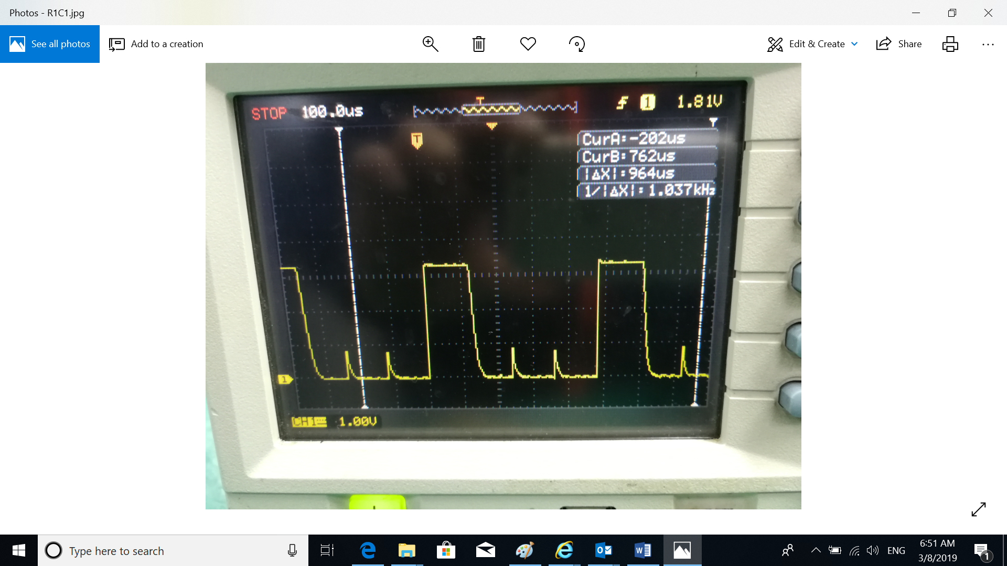

FIG-6

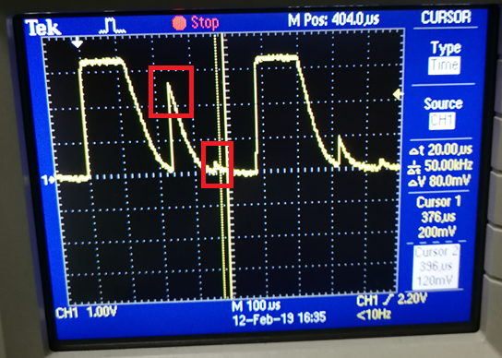

FIG-7

Use same key, If we set it between R1C1, the waveform of R1 and GND is good (FIG-6) when it’s pressed, but if we set it between R3C2, the waveform of R3 and GND is bad(FIG-7) when it’s pressed.

(B) Circuit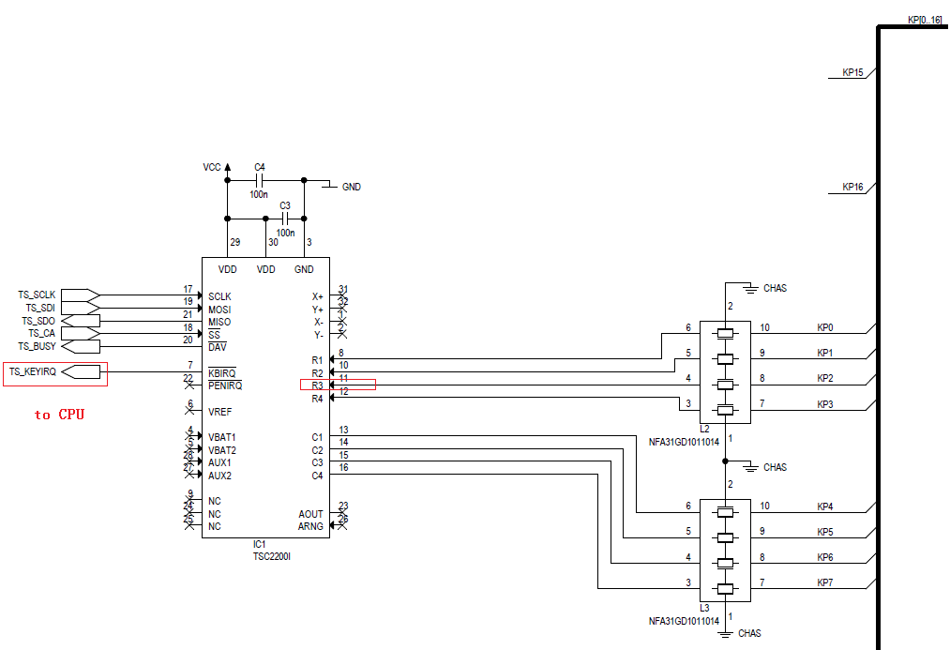

FIG-8 the circuit

The capacitor between VDD and GND is not big enough, but we have checked, if we change a capacitor between VCC and GND to 10uF, the signals are not improved.

(C) PCB layout

Our PCB is 6 layer PCB.

Layer 1 Top layer(RED)

Layer 2 inner layer GND

Layer 3 inner layer Signal 1(BLUE)

Layer 4 inner layer Signal 2(YELLOW)

Layer 5 inner layer Power

Layer 6 Bottom layer

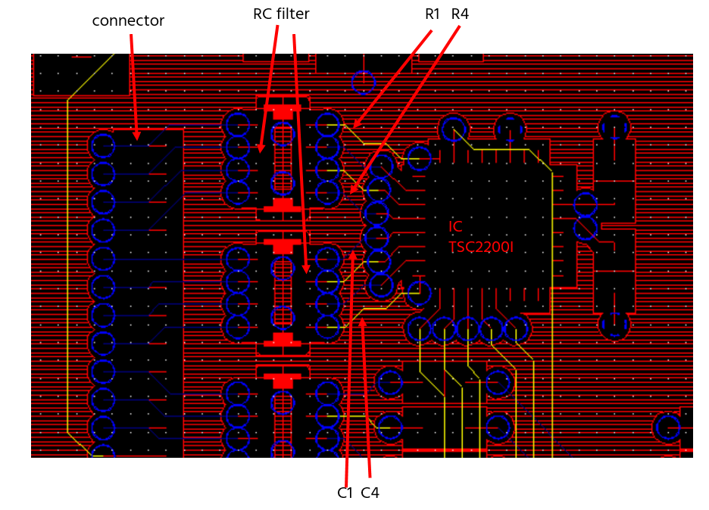

FIG-9 the trace of R and C

From connector to IC TSC2200I(both is in TOP layer),

R1/R3/C2/C4 is from TOP layer(connector )-> Layer 3(Signal 1) -> TOP layer(RC filter) -> Layer 4(Signal 2) -> TOP layer(IC TSC2200I) ,

R2/R4/C1/C3 is from TOP layer(connector )-> Layer 3(Signal 1) -> TOP layer(RC filter) -> Layer 3(Signal 1) -> TOP layer(IC TSC2200I)

Note： thermal pad of IC TSC2200I is not connected to digital GND.