10%
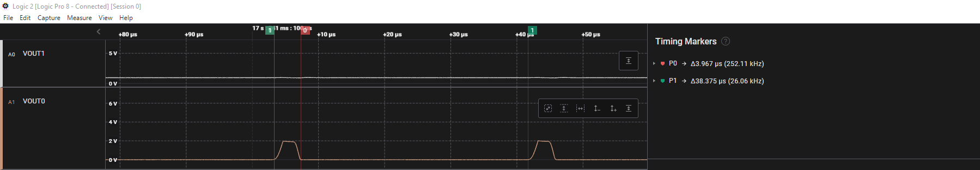

20%
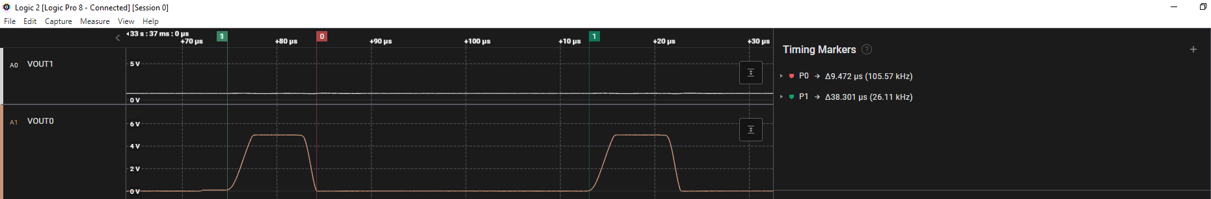
30%
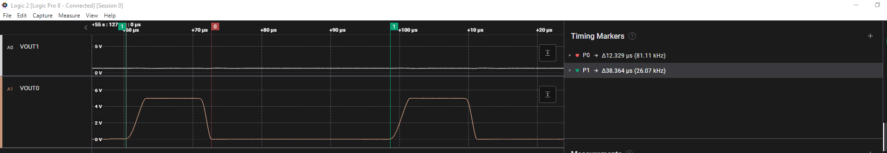
40%
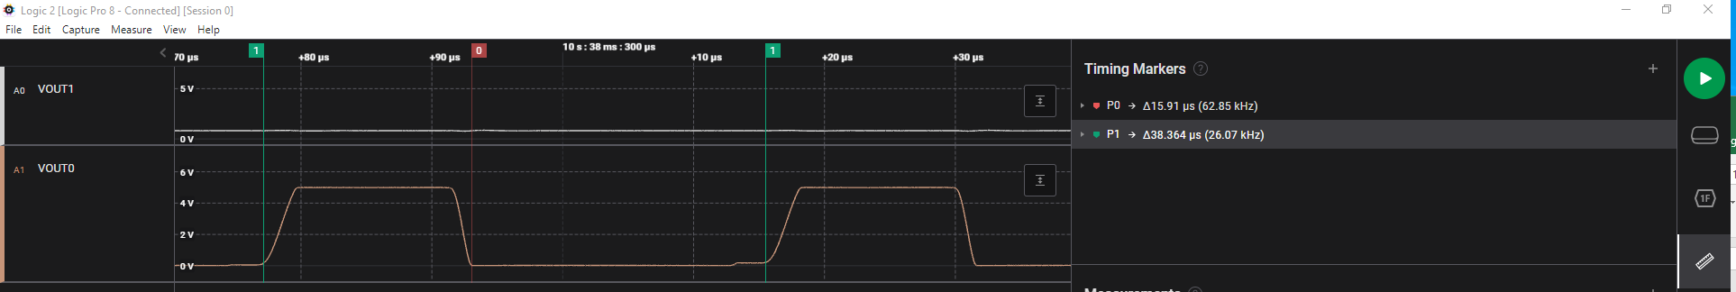
50%
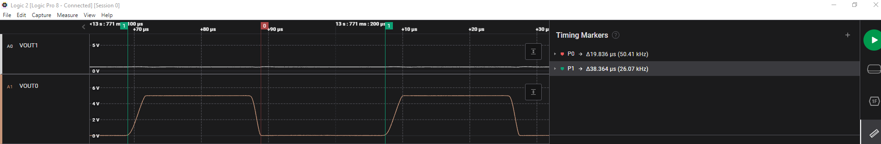
60%
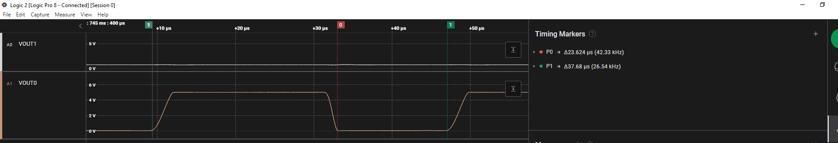
70%
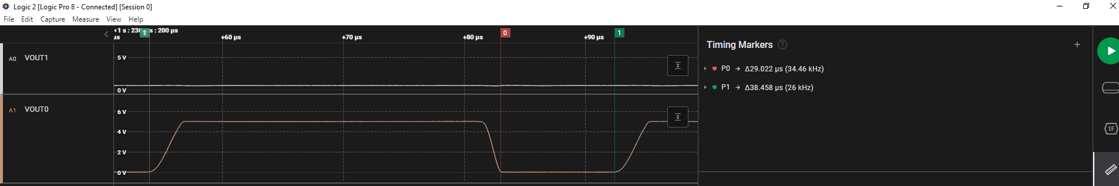
80%
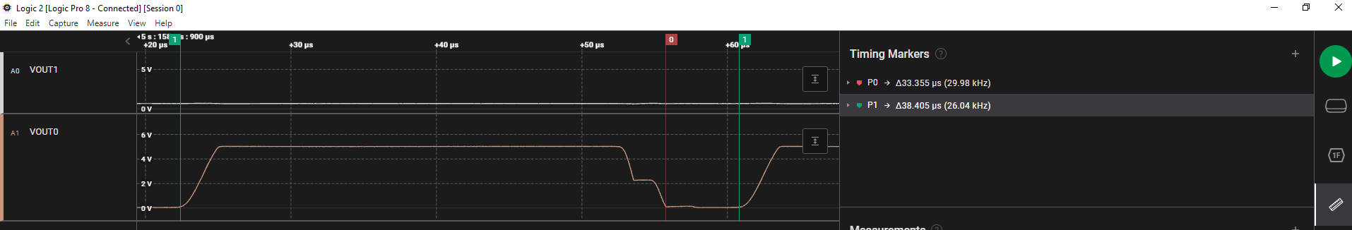
90%
