The EMC-current method actually tests the exceedance data: Through the data frequency analysis, the radiation source is superimposed by 1.7M frequency doubling points.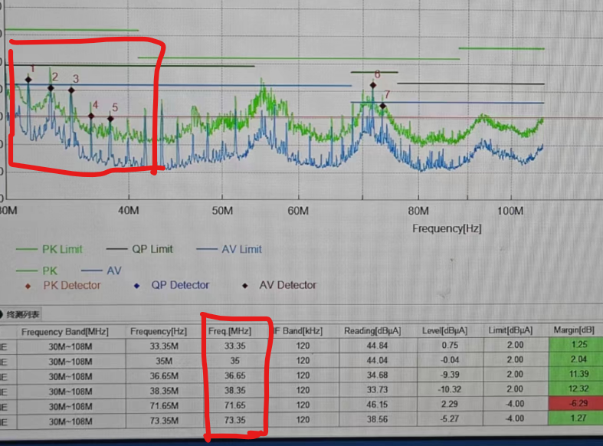
1. Spectrograph near field detection:
1) Working state: The sample is connected to the power supply, the startup state, and the camera.
State diagram:

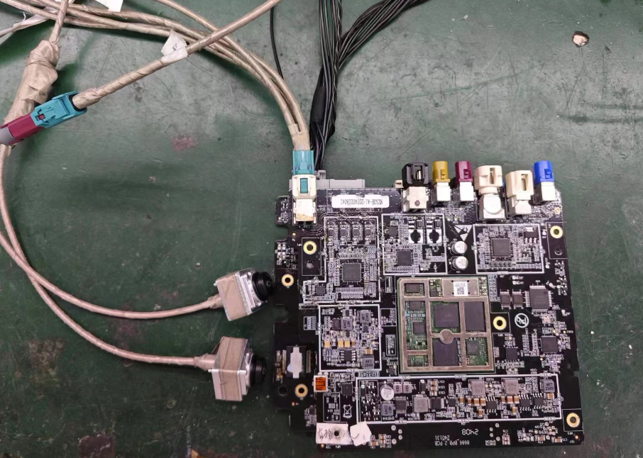
Test point：
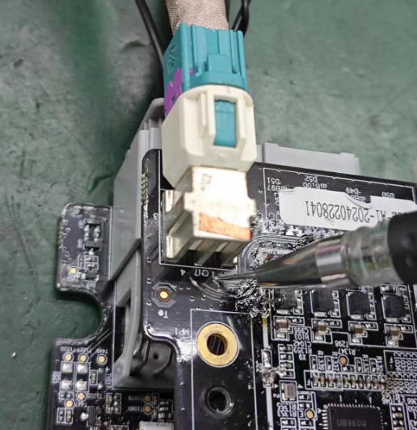
Test data ：
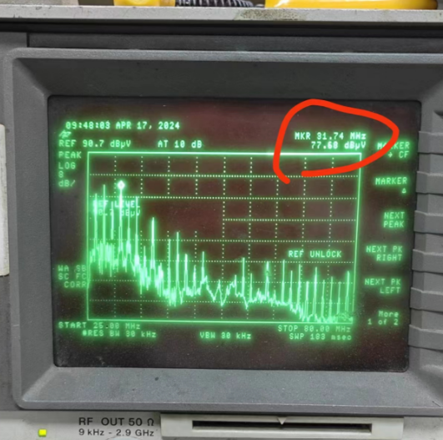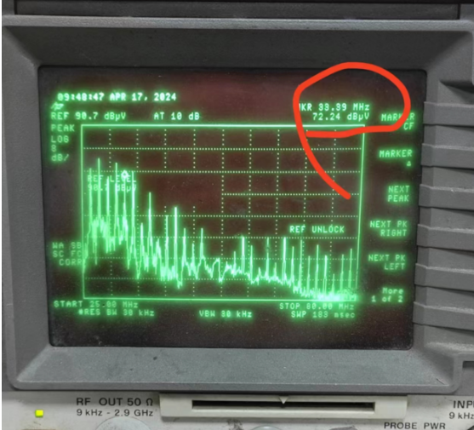

Conclusion: The near field detection is relatively high, the difference frequency is about 1.7MHz, so it can be judged that the measured near field is consistent with the actual measured frequency
1) Working state: The sample is connected to the power supply, the startup state, no camera.
State diagram:

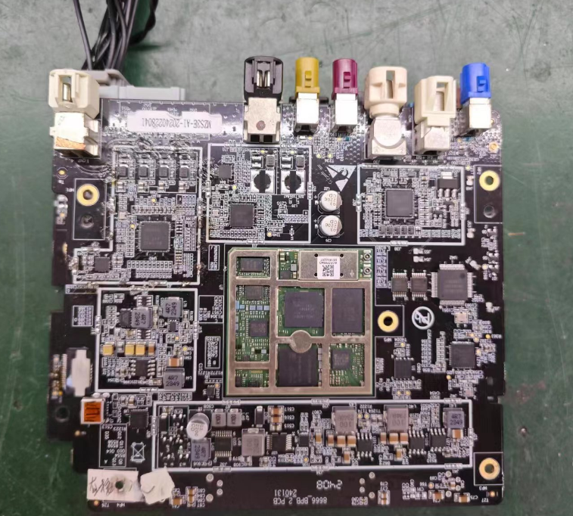
测试点：
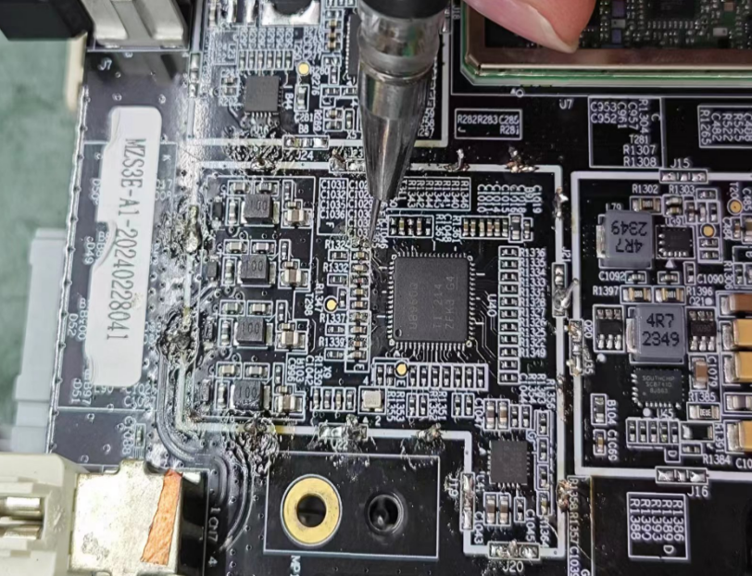
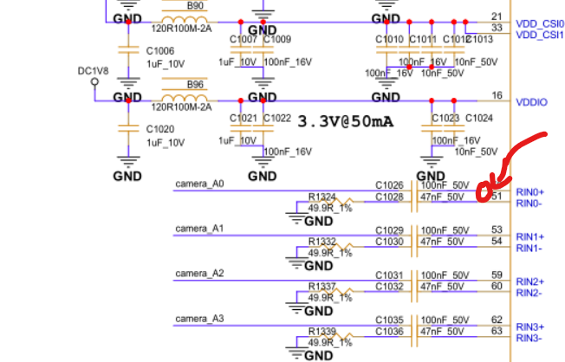
近场数据：
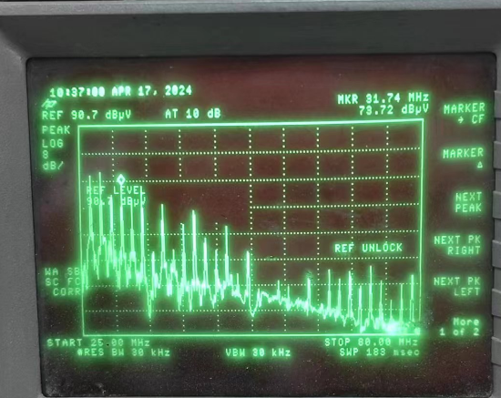
Conclusion: Without the camera, these interference points can still be detected in the decoding circuit, so these frequency points are not generated by the camera, and are brought to the PCB through the wire harness
1) Working state: The sample is connected to the power supply, the startup state, no camera
Difference: Remove the C1026 capacitor.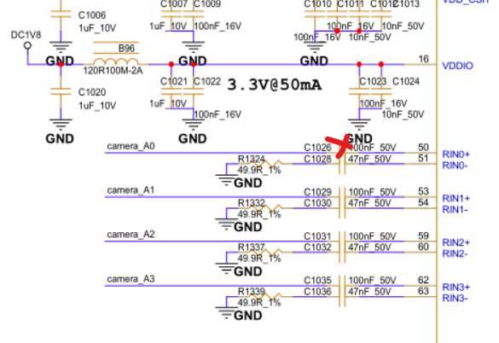
Test point test data
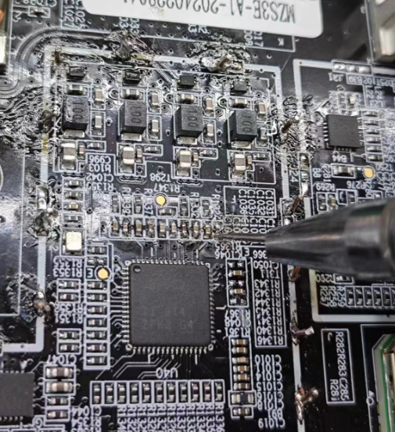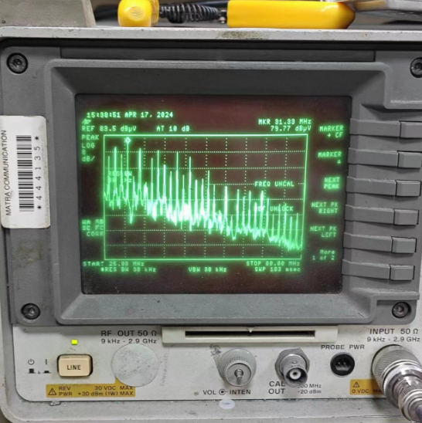
Test point test data
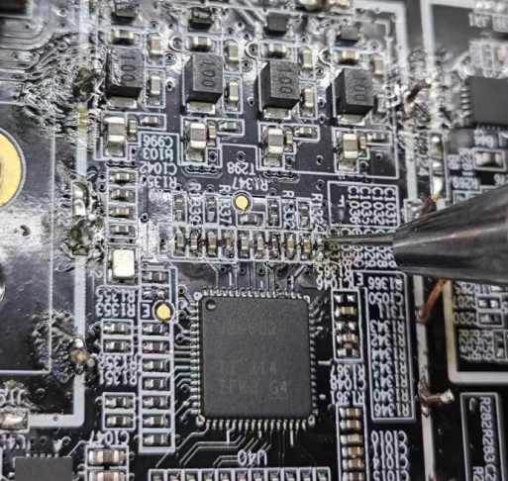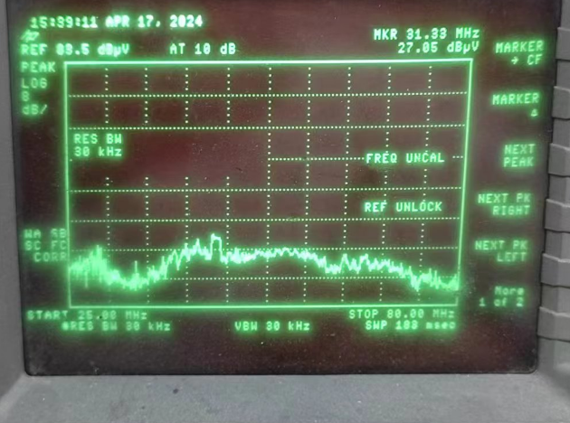
Test point
Test point test data

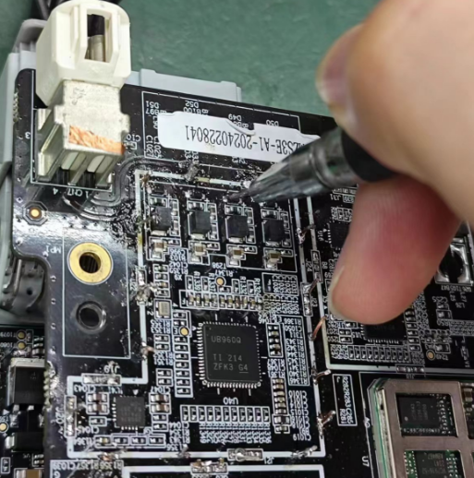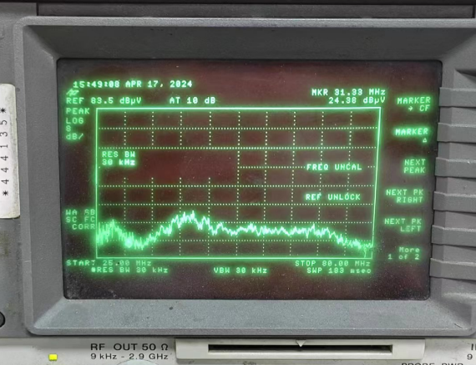
Test point test data
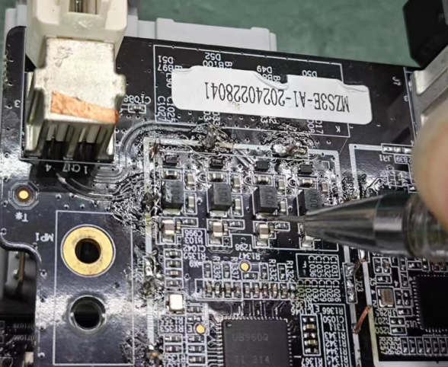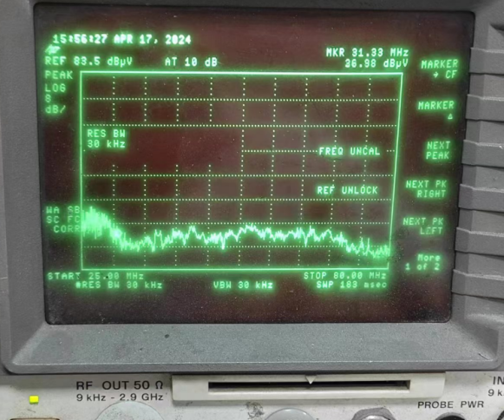

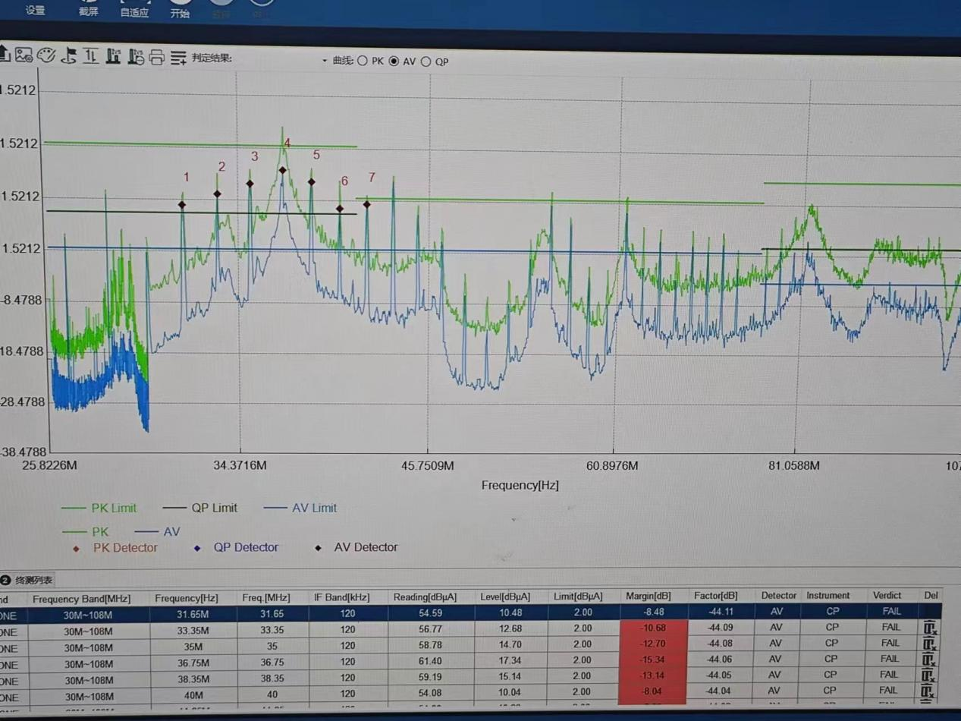
Conclusion: The capacitor of C1026 was removed, and in the welding check near the IO pin of T960, it was found that the energy of 31.33MHz frequency point was still very high. In the other T290T292 T294T296 welding check and D49-D52 TVS tube, the L84 L86 L90 L93 position of the inductor was no longer available. Therefore, it can be proved that similar 31.33MHz frequency points are generated inside the T960 chip and brought out through the wiring and wiring harness, resulting in the actual excessive EMC current method.

