How to fix python scripting tool in Windows 10:

1. Download the x86 version of Python 2.7:
   1. <https://www.python.org/downloads/release/python-2716/>
   2. 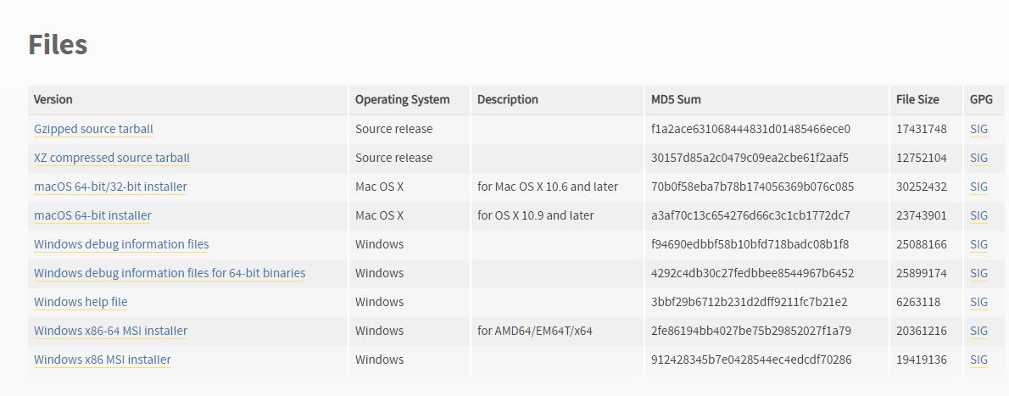
2. Disable the Windows “App execution aliases”
   1. Go to “Apps and Features” menu in windows (Press START button, type “Apps and Features”, press enter)
   2. Select “App execution aliases”

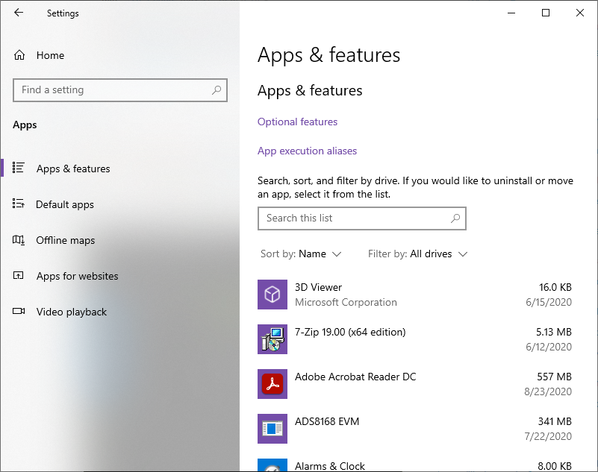

* 1. Uncheck all the python values

